

VET Training Practices
Project name: Green Agritainment: VET strategies for Edutainment in European Agritourism
Acronym: Agritainment
Project Number: Project 2024-1-IE01-KA220-VET-000254134

Prepared by:


Contents
1. Introduction 9
2. Exercises for teaching educational skills about the green transition for kids, mini-games and green practices in the agritourism sector 9
Exercise 1: Designing a Sensory Discovery Corner with Seasonal Farm Products 10
Exercise 2: Design a Farm-to-Table Matching Game 11
Exercise 3: Creating a Herb-Scent Trail 12
Exercise 4: Little Agripreneurs – Create a Mini Farm Stand Simulation 13
Exercise 5: Agritourism Detective – The Farm Sorting 14
Exercise 6: “Sun Power Relay” – A Movement-Based 15
Exercise 7: Nature Bingo Walk 17
Exercise 8: “Eco-Instruments” – Creating Music with Reused Natural & Farm Materials 17
Exercise 9: Water Watchers – Tourist Edition 18
Exercise 10: Compost Champions – Farm Café Edition 19
Exercise 11: “Seed to Snack” – Tracing Food Origins with Children 20
Exercise 12: Agritourist Explorer 21
Exercise 13: Taste Trek – From Farm to Tourist Table 22
Exercise 14: Build-a-Room 23
Exercise 15: Design a Nature-Based Wellness Activity for Children 23
Exercise 16: Farm Photo Safari – Observing Nature with New Eyes 24
Exercise 17: The Local Food Map – Exploring the Taste of Our Land 25
Exercise 18: Story Stones – Sharing Rural Tales with Kids 26
Exercise 19: Agritourism Kids’ Newsroom 27
Exercise 20: The Green Pledge Tree – A Farm Commitment Wall for Kids 28
3. Exercises for teaching comedian-inspired speech methods for teaching the green transition in farm visits 29
Exercise 1: Map the communication style of your agritourism workers 33
Exercise 2: Define your edutainment goals 34
Exercise 3: Map the emotions of your travel-learner experience. 35
Exercise 4: Can you learn how to use comedy style communication? 37
Exercise 5: Segment your edutainment goals 38
Exercise 6: Focus on the audience 39
Exercise 7: The customer-learner. Reframe your target persona. The customer is learning in any case. 42
Exercise 8: Attract customers you want through effective titles of edutainment activities 44
Exercise 9: Customers you have and customers you want 45
Exercise 10: Facilitate a group discussion on specific motivations leading to your agritourism 48
Exercise 11: Knowledge of the technicalities behind your key product; Environmental awareness and knowledge concerning your key products 50
Exercise 12: Comedy-based speech. Techniques of personifications 51
Exercise 13: Comedy-bridges and metaphor-based effective sentences 53
Exercise 14: Build the persona of your product based on sensory based approach 55
Exercise 15: Use exaggeration and taste expectations as comes-based mechanism 57
Exercise 16: Build your persona. Build your character. 58
Exercise 17: The technique of quotation 61
Exercise 18: Aprosdoketon and other surprise techniques 61
Exercise 19: Comedy and pain 63
Exercise 20: Comedy and cognitive dissonance 64
Exercise 21: The Final Speech 68
4. Exercises for creating green-transition inspired group games in educational setting in agritourism and hospitality 69
Exercise 1: The Eco-Choice Challenge 71
Exercise 2: The Green Hospitality Dilemma Game 73
Exercise 3: The Carbon Footprint Line-Up 74
Exercise 4: The Sustainability Auction 76
Exercise 5: The Green Negotiation Table 77
Exercise 6: The Eco-Story Circle 79
Exercise 7: The Zero-Waste Relay 80
Exercise 8: The Green Menu Puzzle 81
Exercise 9: The Green Challenge Quiz Show 82
Exercise 10: The Sustainable Farm Day Simulation 83
Exercise 11: The Green Budget Challenge 84
Exercise 12: The Eco-Escape Challenge 85
Exercise 13: The Eco-Pitch Challenge 86
Exercise 14: The Green Service Roleplay 87
Exercise 15: The Sustainability Jigsaw 88
Exercise 16: The Eco-Scavenger Hunt 89
Exercise 17: The Green Crisis Team Challenge 90
Exercise 18: The Eco-Chain Reaction 91
Exercise 19: The Sustainability Hot Seat 92
Exercise 20: The Green Commitment Circle 93
5. Exercises for teaching how to create agritainment activities for people with disabilities; with a dedicated activities for mental and physical disabilities 94
Exercise 1: Nature in Senses – Guided Sensory Garden Tour for Cognitive Wellness 95
Exercise 2: Farm Friends Connection: Guided Animal Interaction for Mental Wellness 96
Exercise 3: Growing for All – Inclusive Container Gardening 97
Exercise 4: Creative Roots – Agricultural Craft Station for Inclusive Agritainment 98
Exercise 5: Inclusive Harvesting Experience for People with Disabilities 99
Exercise 6: From Soil to Song – Inclusive Farm-to-Table Storytime & Music Workshop 100
Exercise 7: Build-a-Bug Hotel – Pollinator Paradise 101
Exercise 8: Growing Joy – Daily Agritainment Experience for All Abilities 102
Exercise 9: Farm-to-Table Inclusive Cooking Class 103
Exercise 10: Hands of Nature – Eco-Crafting for All 104
Exercise 11: Voices of the Farm – Inclusive Agritourism Media Training 105
Exercise 12: Farm Tales on Stage – Agricultural-Themed Performance Workshop 108
Exercise 13: Feathered Friends – Crafting and Hanging Bird Feeders for All Abilities 109
Exercise 14: Hay Bale Adventure – Inclusive Obstacle Fun on the Farm 110
Exercise 15: Dough-Making Delight – Organic Baking for All Abilities 111
Exercise 16: Labeling & Packaging Organic Baked Goods 112
Exercise 17: Music & Movement – Bread Dance! 113
Exercise 18: Inclusive Exploration in the Cornfield 114
Exercise 19: A Bingo & Memory Game Adventure 115
Exercise 20: Buzz and Beyond – Exploring the World of Bees 116
6. Exercises for performing education about green hospitality through the use of edutainment 117
Exercise 1: Introduction to Green Hospitality in Agritourism 118
Exercise 2: Sustainable Resource Management 119
Exercise 3: Echo-friendly Accommodation Practices 121
Exercise 4: Green Marketing Strategies 121
Exercise 5: Sustainable Food Practices 122
Exercise 6: Renewable Energy Solutions 123
Exercise 7: Eco-friendly Transportation 124
Exercise 8: Community Engagement and Education 126
Exercise 9: Green Event Planning 127
Exercise 10: Water Conservation Techniques 128
Exercise 11: Waste Management Strategies 129
Exercise 12: Bio-diversity Conservation 130
Exercise 13: Green Building Design 131
Exercise 14: Sustainable Landscaping 132
Exercise 15: Green Hospitality Certification 133
Exercise 16: Sustainable Tourism Practices 135
Exercise 17: Green Hospitality Technology 136
Exercise 18: Guest Engagement in Green Practices 137
Exercise 19: Financial Benefits of Green Hospitality 139
Exercise 20: Continuous Improvement in Green Hospitality 140
7. Exercises for performing edutainment activities in agritourism sectors concerning environmental and cultural sustainability also referring to historical elements of places 141
Exercise 1: Mapping Local Identity through Cultural and Historical Symbols 142
Exercise 2: Heritage in Focus: Designing Agritourism Photo Story Stations 143
Exercise 3: Crafting Heritage – Integrating Traditional Crafts into Sustainable Agritourism 144
Exercise 4: Zero-Waste Heritage Cooking in Agritourism 145
Exercise 5: Footsteps of Heritage – Designing an Eco‑Cultural Walking Route 146
Exercise 6: Green Branding – Designing a Sustainable Identity for Agritourism 147
Exercise 7: The Taste of the Village – Local Food, People, and Stories 148
Exercise 8: Memories from Nature – Creating Sustainable Souvenirs 148
Exercise 9: Modular Herb Garden & Ethnobotany Showcase – “A Place of Aroma, Memory & Meaning” 149
Exercise 10: Local Legend Storyteller – “The Voice of Tradition” 150
Exercise 11: Designing the Sustainable Guest Room – “A Room Full of Stories” 151
Exercise 12: Photo Story – “A Day in the Village Through the Tourist’s Eyes” 152
Exercise 13: Cultural Farmer’s Basket – “Taste & Tales of Our Heritage” 153
Exercise 14: Farming Time Capsule – “Voices from the Land” 153
Exercise 15: Edible Time Machine – A Historical Farm Tasting Journey 155
Exercise 16: Outdoor Cooking with Local Products – “Taste of the Region” 155
Exercise 17: Tourist Info Center Simulation – “Welcoming Guests as Regional Ambassadors” 156
Exercise 18: Wild Forest Fruits and Social Enterprise – “From Foraging to Sustainable Business” 157
Exercise 19: Cultural Calendar & Seasonal Events – “A Year in Our Village” 158
Exercise 20 – Pop-Up Heritage Game Corner: “Guess, Touch, Taste” 159
8. Annexes 160
Annex 1 160
Annex 2 160
Annex 3 161
Annex 4 162
Annex 5 165
Annex 6 166
Annex 7 169
Annex 8 169
Annex 9 170
Annex 10 172
Annex 11 174
Annex 12 174
Annex 13 176
Annex 14 178
Annex 15 179
Annex 16 180
Annex 17 180
Annex 18 181
Annex 19 183
Annex 20 184
Annex 21 185
Annex 22 186
Annex 23 187
Annex 24 188
Annex 25 188
Annex 26 189
Annex 27 189
Annex 28 190
Annex 29 190
Annex 30 192
Annex 31 193
Annex 32 193
Annex 33 194
Annex 34 195
Annex 35 195
Annex 36 196
Annex 37 197
Annex 38 198
Annex 39 200
Annex 40 201
Annex 41 202
Annex 42 203
Annex 43 204
Annex 44 207
Annex 45 209
Annex 46 209
Annex 47 210
Annex 48 212
Annex 49 212
Annex 50 219
Annex 51 220
Annex 52 221
Annex 53 223
Annex 54 225
Annex 55 225
Annex 56 226
Annex 57 229
Annex 58 231
Annex 59 232
Annex 60 234
Annex 61 235
Annex 62 236
Annex 63 237
Annex 64 238
Annex 65 240
Annex 66 241
Annex 67 242
Annex 68 244
Annex 69 246
Annex 70 248
Annex 71 249
Annex 72 251
Annex 73 252
Annex 74 254
Annex 75 255
Annex 76 257
Annex 77 258
Annex 78 260
Annex 79 261
Annex 80 263
Annex 81 265
Annex 82 266
Annex 83 268
Annex 84 269
Annex 85 271
Annex 86 272
Annex 87 275
Annex 88 276
Annex 89 277
Annex 90 278
Annex 91 278
Annex 92 280
Annex 93 281
Annex 94 282
Annex 95 285
Annex 96 286
Annex 97 288
Annex 98 289
Annex 99 292
Annex 100 293
Annex 101 294
Annex 102 295
Annex 103 296
Annex 104 297
Annex 105 299
Annex 106 300
Annex 107 301

Introduction
This handbook is developed under the Erasmus+ KA220-VET project "Green Agritainment: VET Strategies for Edutainment in European Agritourism." It is designed particularly for VET trainers so that they can prepare to train agritourism personnel in preparing and organizing educational entertainment—"agritainment"—activities for families and children visiting their farms.
The exercises in this manual are intended as structured training modules for VET trainers to implement within workshops or courses in a bid to enhance the competences of agritourism workers. These workers will then be able to prepare and lead basic, interactive, sustainability-focused micro-activities that are timed to capture the real rhythm and produce of their agritourism venture.
The approach of this handbook reflects the importance of integrating sustainability into everyday agritourism practice and recognizes that well-planned educational activities can enhance the visitor experience while promoting environmental values. Activities are designed to engage families with nature, food systems, and rural life in a meaningful way.

Exercises for teaching educational skills about the green transition for kids, mini-games and green practices in the agritourism sector
This chapter includes a collection of 20 guided training exercises to help VET trainers provide capacity-building training for agritourism employees. The exercises are designed to facilitate VET trainers in making their trainees sensitive about creating short, efficient learning activities for farm children to inform awareness toward sustainability and establishing a tighter connection between tourists and countryside life.
The focus of the chapter is to give VET trainers immediately applicable techniques that demonstrate how edutainment can be used as an environmental education resource and as a value-added service in agritourism. Each activity familiarizes staff with a specific kind of activity they can use—e.g., food discovery games, sensory exercises, storytelling materials, or seasonal nature activities—intended for the everyday context of a farm.
The chapter obeys the GreenComp model of sustainability skills and advocates for the development of skills such as progressing nature, systems thinking, adaptability, and joint action. Through the execution of such exercises, VET trainers empower agritourism workers to increase their self-confidence and ability to make a positive contribution towards the green transformation by providing their services

Exercise 1: Designing a Sensory Discovery Corner with Seasonal Farm Products
Learning outcome: To support the capacity to design a self-guided, sensory-based corner that introduces children to local and seasonal farm products through touch, smell, and visual prompts.
Target age group: 4–8 years
Requirements:
- Flipchart or poster for visual introduction
- Printed ingredient cards with photographs and names of seasonal farm products
- Template labels (e.g., "Smell This", "Touch and Guess")
- Actual farm items (optional): herbs, fruit, bread, etc.
- Printed planning kit (blank cards, signs, layout sketch sheet)
- Annex 1: Worksheet template
Step | Instructions | Time | Resources needed
1 | The VET trainer introduces the idea of a Discovery Corner—a multi-sensory display space that encourages children to interact with local food items using their senses. The trainer explains that this activity supports environmental education by focusing on what grows when, and how food feels, smells, and looks. The trainer emphasizes that this setup can be a permanent or mobile station that sparks curiosity and learning without needing constant staff presence. | 10 min | Flipchart or visual aids
2 | The trainer demonstrates a sample corner using printed ingredient cards and sensory prompts. Each card shows a food item (e.g., orange, thyme, bread), and prompt signs encourage sensory engagement. The trainer explains how to pair each visual with real items (optional), and models how signs like “Guess What This Is” or “Can You Smell It?” help children explore independently. | 15 min | Ingredient cards, prompt signs, real food samples (optional)
3 | Small groups receive a printed planning kit and work together to design a Discovery Corner adapted to their own farm. They select 3–5 seasonal items, sketch their layout, and decide where and how to place signs and ingredients. Trainers guide them in considering: location, age suitability, and seasonality. | 25 min | Blank cards, sign templates, layout sketch sheets
4 | Each participant completes a worksheet outlining how they would implement the Discovery Corner at their site. They note seasonal item choices, sign ideas, target age group, and a location plan. The trainer provides feedback to ensure the design is realistic and replicable. | 10 min | Worksheet (Annex 1)
Evaluation methodology: Each participant reflects on how the activity stimulates the senses and brings joy (positive emotions), teaches about seasonality and food literacy (education), leverages local materials to foster sustainability (sustainability), and enhances the quality of the visitor experience (valorization). They complete a feasible action plan for implementing the corner at their farm.

Exercise 2: Design a Farm-to-Table Matching Game
Learning Outcome: To develop the capacity to design and implement a fun matching game that teaches children in the age group of 6–9 the relationship between raw farm products and familiar food items.
Target age group: 6–9 years
Requirements:
- Sample card set: ingredient cards + matching product cards
- Printed card
- Glue sticks, scissors, markers
- Annex 2: Planning worksheet
Step | Instructions | Time | Resources needed
1 | The trainer explains the concept of Farm-to-Table Match Game, in which children learn more as they play and are exposed to farm products. They learn where common foods come from by linking raw materials (wheat, olives, grapes) with end products (bread, olive oil, juice). | 10 min | Flipchart with food chain examples
2 | The trainer illustrates how to play the game using a sample set of matching cards: ingredient cards on one side and product cards on the other. Children are invited to match and explain why. The instructor illustrates short child-friendly questions like: "What is this made of?" and "Which food grows on trees?" | 10 min | Sample printed cards (ingredient/product pairs)
3 | All the participants are provided with a printed template of a card and create their own matching game with products of their own farm. They draw or paste pictures of 4–6 local ingredients and what products they make from them. Cards are kept simple and kid-friendly. | 25 min | Card templates (Annex 2), scissors, glue, markers
4 | Participants complete the planning worksheet, identifying when and where they will use the game on their farm, and reflect on how it engages children. The trainer checks that each plan fits local context and time constraints. | 15 min | Planning worksheet (Annex 2)
Evaluation methodology: Each participant explains how the game arouses curiosity (positive emotions), presents food origins (learning), motivates appreciation for local crops (sustainability), and values the farm tour (valorization). A plan for utilizing the game on their crops and visitors is outlined.

Exercise 3: Creating a Herb-Scent Trail
Learning Outcome: to support the capacity to plan and deliver a sensory learning trail which presents children in the 5–9 age group with known farm herbs using scent, touch, and observation to increase environmental awareness and plant identification.
Requirements:
- Flipchart or poster with herb examples
- Herb samples (fresh cuttings or potted plants: e.g., mint, oregano, thyme)
- Printed name/image cards for identification
- Prompt signs (e.g., “Smell Me!”, “Guess the Herb!”, “Which one grows wild?”)
- Printed card templates for planning (Annex 3)
- Sketch paper and pens
Step | Instructions | Time | Resources needed
1 | Trainer introduces the idea of a Herb-Scent Trail, where children visit herbs on the farm through the sense of smell, touch, and visual hints. It's given as a simple but effective method of raising plant awareness and respect for the environment. The trainer explains how a trail with just 3 herbs can be effective for visitors. | 10 min | Flipchart, printed visual examples
2 | The trainer demonstrates a mini-trail using 2–3 herb pots or cuttings. Each is paired with an identification card (name + image) and a fun prompt sign (e.g., “Sniff me,” “Touch and Guess”). The trainer models how to engage children: “Which smells stronger?”, “Where have you seen this before?”, “Can we eat it?” | 15 min | Real herbs (or visual substitutes), printed cards, sample prompts
3 | Participants select herbs that are relevant to their farm. They complete a planning sheet upon which they list the herbs, add an interesting fact about each, and sketch where the trail could go (e.g., down a walkway, along a garden). The trainer provides information on the ethical and safe use of plants. | 20 min | Printed card templates (Annex 3), paper, pens/markers
4 | Participants present their herb trail ideas to the group briefly. The trainer provides guidance on signage suitable to varying ages and on placement safety. | 10 min | Drafts and sketches
Evaluation methodology: Each participant reflects on how the herb trail fosters curiosity and calm (positive emotions), encourages naming and sensory learning (education), promotes appreciation of natural farm resources (sustainability), and enriches the site’s interactive value (valorization). Each one finalizes their trail plan and identifies next steps.

Exercise 4: Little Agripreneurs – Create a Mini Farm Stand Simulation
Learning Outcome: To support the capacity to design and facilitate a role-playing activity that introduces children aged 6- 10 years old to local entrepreneurship, food production, and tourism through a simulated farm stand experience.
Requirements:
- Sample play money or tokens
- Reusable product labels
- Toy or real mini farm products (e.g., herbs, eggs, mini jars, bread rolls, fruit)
- Cardboard boxes/crates for market stall setup
- Price tags and branding cards
- Printable shopping bags or recycled bags
- Annex 4: Mini-Market Toolkit & Planning Guide
Step | Instructions | Time | Resources needed
1 | The trainer explains the concept of a farm stand as part of agritourism—how farms often sell homemade products to visitors. This introduces the idea of children role-playing as local producers, enhancing understanding of local food economy and tourism. | 10 min | Flipchart, visual examples
2 | The trainer sets up a sample stall and models how children can pretend to be farmers selling their products. Roles include “seller,” “buyer,” and “shop assistant.” Trainers demonstrate how to use props like tokens, bags, and signs to make it realistic and fun. | 15 min | Props (e.g., labeled items, coins, fake money), signs, stall boxes
3 | Participants work in small groups to design their own farm stand game setup, choosing what to “sell,” how to price it, and how to involve children in setting up, buying, and selling. They reflect on how to explain sustainability, pricing, and local branding. | 20 min | Paper, pens
4 | Trainer hands out a mini-market simulation kit with printable item cards, price tags, blank logos, and game instructions. Participants are encouraged to adapt it to their own product offerings (e.g., olive oil, honey, lavender soap). | 5 min | Annex 4 printables
Evaluation methodology: Each participant identifies how this simulation promotes economic literacy in children (education), connects farm identity to tourist experience (valorization), fosters creativity and confidence (positive emotions), and emphasizes sustainability in local production and purchasing (sustainability). They create a short action plan to implement or pilot the simulation during family visits or school tours.

Exercise 5: Agritourism Detective – The Farm Sorting
Learning Outcome: To support the capacity to guide children in critically thinking about waste and materials by identifying which items belong in the visitor zones (e.g., guest rooms, picnic area) vs. production zones (e.g., animal barn, fields), while reinforcing sustainability.
Target age group: 5–9 years
Requirements:
- Flipchart or visual board: “Tourist Zone” vs. “Farm Zone”
- Real or replica props: e.g., towel, olive branch, snack wrapper, hay, reusable water bottle, plastic spoon
- Detective badges or hats (optional for role play)
- Annex 5: Agritourism Sorting Labels & Planning Sheet
Step | Instructions | Time | Resources needed
1 | The trainer introduces the challenge: children are now “Eco-Detectives” tasked with sorting items found around a tourist farm. Some belong to the guest areas, others to farm operations. Kids will help make the site cleaner and greener. | 10 min | Flipchart
2 | The trainer presents a “mystery basket” with mixed objects. Children (or participants) help place each item under either “Tourist Zone” or “Farm Zone” — sparking dialogue: “Where would a guest find this?” “Does this help the farm or the visitor?” “Can we reuse it?” | 15 min | Basket of mixed props, zone signs
3 | Participants choose 6–8 items that are realistic for their farm. They plan how they’d introduce the role play and how to connect it to the tourist experience — e.g., “Why is waste sorting important in the farm café or B&B?”. | 20 min | Planning worksheet (Annex 5), paper, pens
4 | Optional: Each participant creates a mini-story or scenario (e.g., “A messy picnic!” or “Mystery in the Olive Grove”) to make the game more immersive | 5 min | Paper, markers
Evaluation methodology: Each participant states how Agritourism Detective game provokes curiosity and critical thinking through role-play (positive emotions), teaches about sorting of materials and zones (education), raises awareness of sustainable practices in tourist and farm settings (sustainability), and enhances farm tourism's learning experience by relating sorting to real guest experiences (valorization). They provide a plan for zone structure, object selection, and child engagement in delivery.

Exercise 6: “Sun Power Relay” – A Movement-Based
Learning Outcome: to enable the capacity to teach energy flow and sustainability concepts through movement-based group games introduced in the context of an agritourism facility.
Target age group: 6–10 years
Requirements:
- Flipchart with energy flow diagram (Sun → Plant → etc.)
- Printed Energy Role Cards
- Soft ball or similar object to use as energy
- Planning worksheet
- Annex 7: Role cards and reflection questions
Step | Instructions | Time | Resources needed
1 | The trainer introduces the activity's core concept: solar energy as the driver of life and sustainability. Using a flipchart, the trainer presents a simple energy chain (e.g., Sun → Plant → Animal → Human → Solar Panel), emphasizing how this flow connects natural and technological systems. The trainer explains how children can grasp these abstract ideas through movement and play, especially during outdoor visits. | 10 min | Flipchart or simple diagram
2 | The trainer invites five volunteers to participate in a role-play relay. Each receives a printed Energy Role Card (e.g., Sun, Plant, Animal, Human, Solar Panel) and stands in line to pass an energy object (like a soft ball). Each player acts out their role: the Sun shines (hands up), the Plant grows (stretch upward), the Animal chews, the Human cooks or farms, and the Solar Panel absorbs energy. This visualization supports understanding of energy flow in an active, memorable way. | 15 min | Printed cards, ball, path markers
3 | Each participant chooses 3–5 roles that are relevant to their own agritourism setting. For example, if there are no animals, they might skip that role. They sketch a quick setup of their planned activity space and draft a simple child-friendly script explaining energy movement. This personalization ensures the activity can be easily implemented on-site. | 20 min | Planning sheet, pens
4 | To support future implementation, the trainer hands out reusable materials, including role cards and child reflection questions. These tools help reinforce key sustainability concepts and provide ready-to-use content for education visits. | 5 min | Annex 6 tools
Evaluation methodology: Each participant reflects on how the relay encourages movement and fun (positive feelings), learns about energy flow (learning), demonstrates solar power (sustainability), and has memorable learning experience (valorization). A delivery plan tailored to their environment is provided.

Exercise 7: Nature Bingo Walk
Learning Outcome: to enable child-led exploration of biodiversity through observation-based bingo activities tailored to the natural features of the agritourism site.
Requirements:
- Flipchart
- Outdoor walkable space (e.g., herb path, orchard row)
- Annex 8: Bingo cards and instruction guide
Step | Instructions | Time | Resources needed
1 | Trainer introduces the Nature Bingo concept and its alignment with sustainability and rural identity education. The trainer explains how simple outdoor games can be powerful tools to build children’s environmental literacy. A sample Nature Bingo Card is presented, showing common rural items such as bees, watering cans, olive trees, or compost bins. The trainer emphasizes how the game promotes observation skills, curiosity, and appreciation for nature. | 20 min | Flipchart
2 | Agritourism workers select a walkable area at their facility (e.g., vineyard, herb trail, orchard path) and design their own bingo walk. Each participant then drafts a short plan describing how the activity will be introduced and delivered during a child’s visit. | 20 min | Planning sheet, pen
3 | Trainer distributes pre-designed bingo cards and laminated versions (optional) with a simple instruction guide for future use. These cards are reusable and easy to adapt for different age groups and seasons. | 5 min | Annex 7 materials
Evaluation methodology: All participants explain how the game enhances attention and enjoyment (good feelings), triggers knowledge of biodiversity (learning), offers natural cycles (sustainability), and awakens new areas of the territory (valorization). They outline a walk plan with their farm.

Exercise 8: “Eco-Instruments” – Creating Music with Reused Natural & Farm Materials
Learning Outcome: to enable the development of creative reuse and environmental responsibility through music-making activities using natural and recycled farm materials.
Requirements:
- Flipchart for introduction of reuse and creativity
- Sample eco-instruments: shaker, drum, wind chime
- Collection of natural/reused materials (e.g., sticks, seeds, cans, piece of cloth)
- Annex 9: Eco-Instrument Inspiration Sheet
Step | Instructions | Time | Resources needed
1 | The trainer introduces the concept of creative reuse as a sustainability skill and explains how children can explore environmental responsibility and sound through making musical instruments from reused or natural farm materials. Examples include bottle shakers, stick chimes, or can drums. The trainer emphasizes the value of combining creativity with nature awareness and recycling. | 20 min | Flipchart, example instruments
2 | The trainer presents 1–2 simple eco-instruments and demonstrates how to build them. They explain how to ensure materials are safe, easy to use, and engaging for children. Ideas include filling a plastic bottle with seeds to make a shaker or stretching fabric over a tin to create a drum. The trainer also shows how to explain these to children using simple language and movement. | 20 min | Materials from the list
3 | The trainer distributes the ready-to-use Eco-Instrument Inspiration Sheet (Annex 9) that includes basic instructions for replicating the instruments during children’s visits. | 5 min | Annex 8
Evaluation methodology: Participants illustrate how music-making enhances participation (positive feelings), finds sound and materials (learning), fosters creative reuse (sustainability), and infuses farm learning with originality (valorization). They determine what instruments to employ.

Exercise 9: Water Watchers – Tourist Edition
Learning Outcome: To enable agritourism workers to design and facilitate a fun, child-led eco-tour that highlights water-saving practices in tourist areas of the farm, fostering both education and entertainment for visiting children.
Requirements:
- Flipchart and sample site map showing water-saving areas
- Printable Water Tour Cards with kid-friendly prompts
- Planning worksheet for activity setup
Step | Instructions | Time | Resources needed
1 | VET trainer introduces the idea of creating child-led water tours in guest spaces. Trainees brainstorm where tourists interact with water systems on their farm (e.g., B&Bs, gardens). | 10 min | Flipchart
2 | Trainer models a tour using the Guest Water Walk Cards, playing the role of a child. Agritourism workers experience what the activity feels like from a child’s perspective (fun, curious, hands-on). | 10 min | Annex 9 cards, water-saving props
3 | Small groups of trainees select tourist zones from their own farms and design a mini water-walk for children (2–3 stops). They script fun prompts like “What does this barrel collect?” or “Why mulch here?”. | 15 min | Planning sheet (Annex 9)
4 | VET trainer distributes reusable resources and gives feedback. Participants finalize their plan to use the walk with real child visitors during tours, workshops, or family days. | 5 min | Printable cards and sheets
Evaluation methodology: Each participant explains how the Guest Water Walk creates interest and pride in children (positive emotions), enables primary-level environmental education (education), promotes sensitivity towards sustainable tourism infrastructure (sustainability), and creates value added for farm guests (valorization). They share a proposal of how they would organize the child-led tour in their specific agritourism setting.

Exercise 10: Compost Champions – Farm Café Edition
Learning Outcome: To prepare agritourism workers to design an engaging simulation where children act as “Compost Heroes” in a farm café or picnic area, learning how to sort organic waste from tourist meals while having fun.
Requirements:
- Visual aid or prop representing a “Farm Café” or picnic zone (table setup, tray, pretend food wrappers)
- Annex 10: Compost Sorting Cards & Setup Planning Sheet
Step | Instructions | Time | Resources needed
1 | Trainer introduces the idea of a waste-sorting challenge set in a tourist eating area. Participants imagine a scenario where children must clean up after a picnic or meal. | 10 min | Example tray, food props
2 | Trainer simulates the child activity by dumping a “messy tray” of mixed waste and letting participants sort into bins while role-playing. | 10 min | Bins, props, labels
3 | Agritourism workers design their own scenario using typical food items sold or served to tourists. They script simple questions for children (e.g., “Where should the banana peel go?”). | 15 min | Planning sheet (Annex 10)
4 | Optional: Add a story element (“The Compost Dragon only eats clean food waste!”) or give children capes to become Compost Heroes. | 5 min | Role props, cards
Evaluation methodology: Each of the participants describes how the game of sorting involves responsibility and fun among children (positive feelings), educates them in material sorting and composting (education), encourages sustainable tourism waste habits (sustainability), and involves interactive significance to the eco-tourism offer of the farm (valorisation). They provide a draft of the composting game arrangement and an example list of foodstuffs.

Exercise 11: “Seed to Snack” – Tracing Food Origins with Children
Learning Outcome: to enable the capacity to map and communicate the process of food production by guiding children on a journey from seed to edible product through farm-based case studies.
Requirements:
- Food pathway visual diagram or flipchart
- Real item or cards (e.g., final snack, plant, seeds)
- Printed Seed-to-Snack Journey Cards
- Planning worksheet
- Annex 11: Journey template and cards
Step | Instructions | Time | Resources needed
1 | The trainer introduces the concept of “Seed to Snack” as an engaging, hands-on activity that shows children how everyday foods originate from natural processes. Starting with a known snack like a breadstick, tomato, or apple, the trainer invites participants to trace its journey backward—from the final product to harvesting, growing, and the seed stage. A basic sequence is presented visually: Seed → Soil → Plant → Care → Harvest → Snack. | 10 min | Visual aid or diagram
2 | The trainer models a simple food journey station using printed cards or real objects. For example, a “tomato station” may include tomato seeds, a small potted plant, and a basket of cherry tomatoes. Alternatively, a bread station can include wheat grains, flour, and a breadstick. The trainer explains how each item can be presented to children with brief descriptions and sensory prompts (touch, smell, taste). | 10 min | Seed, produce, snack item
3 | Each agritourism worker selects one food item grown or produced at their facility and maps out its seed-to-snack journey using a printed template. They identify what props or items they would use, where to place them, and what story or questions they would include to engage visiting children. Participants also consider whether a short tasting session can be included safely. | 15 min | Annex 11 cards, paper, pen
4 | The trainer hands out the Seed-to-Snack Journey Cards and a planning sheet. These tools help participants replicate the activity with their own crops or products and adjust the level of detail based on the child’s age. | 5 min | Annex 12 printables
Evaluation methodology: Each participant states how tracing food origins stimulates wonder (positive emotions), connects children to natural systems (education), explains local food chains (sustainability), and deepens appreciation for farm products (valorization). They design a visual food story station.

Exercise 12: Agritourist Explorer
Learning Outcome: To train agritourism workers to design an enjoyable, self-guided discovery path around the farm on which children can tread and gain knowledge by observing, playing, and listening to the locals.
Requirements:
- Flipchart
- Map samples, cards
- Annex 12: Template and instructions
Step | Instructions | Time | Resources needed
1 | The trainer explains how discovery trails can entertain children while educating them about the farm. Participants brainstorm typical tourist zones. | 10 min | Flipchart
2 | Trainer shares example stations and shows how to turn farm features into child-friendly learning stops (e.g., compost area → “Worm World”). | 10 min | Map samples, cards
3 | Agritourism workers sketch their own kid-friendly trail, placing 4–6 stops around guest areas. They design one short activity or observation question per stop. | 15 min | Annex 12
4 | Trainer supports finalization of the trail map and signage ideas. Optional: discuss safety markers and multilingual signage for tourists. | 5 min | Icons, templates
Evaluation methodology: Each of the participants explains how the trail design facilitates movement and enjoyment (positive emotions), teaches farm zones and biodiversity (learning), encourages nature appreciation and sustainable practices (sustainability), and enhances family interaction and interpretation (valorization). They give a visual trail map with recommended children's activities per station.

Exercise 13: Taste Trek – From Farm to Tourist Table
Learning outcome: To provide agritourism workers with the competencies to prepare an engaging children's tasting experience, harmonizing narration, food education, and tourism in coupling farm products with the local food culture offered to visitors.
Requirements
- Flipchart
- Sample cards
- Annex 13
Step | Instructions | Time | Resources needed
1 | The VET trainer explains how tasting experiences can combine food education with fun tourism. Participants discuss what products children and tourists typically encounter. | 10 min | Flipchart or local product list
2 | Trainer demonstrates a simple child tasting game with storytelling (e.g., taste olive oil and match it to the “tree” it came from). | 10 min | Sample cards
3 | Participants plan a tasting station with 3–5 local products, writing short child-friendly facts or stories for each. They test a tasting game format. | 15 min | Annex 13 worksheet
Evaluation methodology: Each participant xplains how the tasting activity evokes curiosity and sensory exploration (positive feelings), informs about the origin of food and local production (education), promotes sustainable, seasonal eating (sustainability), and flaunts the local culture richness in a fun way to visitors (valorization). They offer a suggestion of a child-friendly tasting experience or station from farm products.

Exercise 14: Build-a-Room
Learning outcome: To train agritourism workers to create a hands- on stimulation activity where children imagine, design and present their ideal farm guest room or space, integrating creativity, sustainability and real agritourism features.
Requirements
- Cardboard, recycled paper, scissors, glue, markers, colored pencils
- Sample photos of real guest rooms, eco-toilets, bunk beds, animal windows, etc.
- Annex 14: Room Designer Cards & Setup Sheet
Step | Instructions | Time | Resources needed
1 | VET trainer introduces the concept of child-centered accommodation in agritourism and how guest spaces can be fun, natural, and sustainable. | 10 min | Guest room visuals
2 | Trainer demonstrates how children might “build a room” using drawings, blocks, or recycled materials. They model how to ask: “Where would the animals go? Would there be a nature-view window?”. | 10 min | Room Designer Cards
3 | Agritourism workers work in pairs to design a kids’ activity that includes 4–5 “room feature challenges” (e.g., draw a bunk bed, build a solar shower). They plan how to guide children through it. | 15 min | Planning sheet (Annex 14)
Evaluation Methodology: Each participant reflects on how room design activity facilitates imagination and a sense of pride (positive emotions), provides education about basic sustainability and space planning (education), supports green architecture and sustainable tourism (sustainability), and enhances the value of the visitor experience through creative interpretation (valorization). They generate a proposal for their room-construction activity and list features included.

Exercise 15: Design a Nature-Based Wellness Activity for Children
Learning outcome: To support the capacity to plan and facilitate a simple nature-based wellness activity that promotes environmental consciousness and child engagement during agritourism excursions.
Requirements:
- Printable wellness station templates (Annex 15)
- Nature materials (rocks, flowers, leaves, etc.)
- Secluded garden or covered outdoor area
- Gratitude jar materials (paper strips, a jar, crayons)
Step | Instructions | Time | Resources needed
1 | The trainer presents the notion of "Nature Wellness" kids' activities in agritourism establishments, emphasizing how silent reflection on nature provokes environmental respect and profound inner harmony. | 10 min | Flipchart, example photos
2 | Set up a small "wellness station" with 2–3 prompts such as: "Sit and Listen to the Wind," "Draw What You See," or "Make a Nature Mandala." Guide participants through it as children would complete it. | 10 min | Printed prompt cards, natural objects
3 | Every agritourism worker develops a version of a 3-step wellness pathway they could use on their property. This includes one sitting activity, one movement activity (e.g., walk a butterfly trail), and one reflection activity (e.g., gratitude jar or sketching). | 15 min | Planning sheet, pen
4 | Trainer distributes printed toolkit. A printable template includes sample prompts, kid-friendly icons, and a quick guide to creating calm, welcoming spaces in nature. | 5 min | Annex 15 materials
Evaluation Methodology: Each participant thinks about how the activity promotes creativity and happiness (positive emotions), learning on sustainable behavior (education), reduces wastage (sustainability), and adds value to everyday farm material (valorization). They give a mini-action plan for implementing the activity in a farm tour or children's workshop.

Exercise 16: Farm Photo Safari – Observing Nature with New Eyes
Learning outcome: To improve the capacity to design and undertake a child-led observation activity that encourages biodiversity awareness, mindful investigation, and pictorial documentation in agritourism environments.
Requirements:
- Photocopyable photo observation instructions (Annex 16)
- Clipboards or stiff paper sheets
- Pens, pencils, crayons
- Tablet or smartphone with adult supervision as an alternative for taking photos
- Outdoor trail or garden in the farm
Step | Instructions | Time | Resources needed
1 | The trainer introduces the idea of a "Photo Safari" as a fun nature exploration activity for children that encourages visual awareness, questioning, and observation of natural systems. They explain how such walks get children to notice relationships and small details in nature (e.g., textures, animal tracks, and color patterns). | 10 min | Flipchart, example photos
2 | The trainer demonstrates a short safari walk using the Annex 17 prompt sheet. Prompts include: “Find something fuzzy,” “Spot 3 shades of green,” or “Draw something you’ve never noticed before.” Participants try out the activity as if they were children, using sketches or imaginary photo-taking. | 10 min | Printed prompt cards, natural objects
3 | Each agritourism worker designates a natural and secure walking area on their farm and develops a mini safari path for children. They choose 3–5 aspects to highlight and create 1–2 interactive questions for each stop. | 15 min | Planning sheet, pen
4 | Trainer distributes printable materials. Annex 17 materials include observation cards, reflection boxes, and a younger children's version (drawing-based). | 5 min | Annex 16 materials
Evaluation Methodology: Each participant reflects on how the activity fosters wonder and focus (positive emotions), teaches eco-awareness through observation (education), strengthens understanding of nature cycles (sustainability), and brings interpretive value to the farm visit (valorization). They complete a mini-action plan describing how to adapt and conduct the Photo Safari on their own farm.

Exercise 17: The Local Food Map – Exploring the Taste of Our Land
Learning outcome: In order to support the capacity to plan and facilitate an interactive activity that introduces children to local food systems, real products, and sustainable food practices through experiential mapping.
Requirements:
- Printable Local Food Map template (Annex 17)
- Sample food icons (local produce visuals: olives, grapes, cheese, herbs, etc.)
- Crayons, glue sticks, scissors
- Optional: real samples or props for show & tell (e.g., olive branch, herb sprig)
Step | Instructions | Time | Resources needed
1 | The trainer introduces the concept of local food mapping and shows how children can learn where food comes from, what grows locally in the area, and how that relates to sustainability, tradition, and identity. | 10 min | Flipchart, example food map
2 | Trainer utilizes a sample map using the Annex 18 model template. The trainer demonstrates each item in context to the land, traditions, or season (e.g., "Grapes ripen in sunny fields—what do we produce from them?"). | 10 min | Printed map template, food visuals
3 | Each participant creates a mock food map for their own agritourism site, selecting 4–6 products to include. They note a short description for each (origin, season, use). The goal is to prepare a child-friendly map for use in workshops or family visits. | 15 min | Blank map, pens, visuals
4 | Trainer hands out printable sheets and pictures to be used in the future, like a version for younger children (color and match). | 5 min | Annex 17 materials
Evaluation Methodology: Each participant thinks about how the activity creates sensory bonding (positive emotions), raises food origin knowledge (education), promotes season/local eating (sustainability), and helps children value their region's food identity (valorization). A brief action plan is created to be implemented in the future.

Exercise 18: Story Stones – Sharing Rural Tales with Kids
Learning outcome: In order to further the capacity to create participatory story experiences that reveal rural life, nature values, and cultural identity in accessible child-centered ways.
Requirements:
- Flat surface medium-sized clean rocks
- Paint pens or permanent markers
- Annex 18: Printable storytelling prompt sheet
- Mixing/pulling stones container or small box
- Rural scenes, objects, or animals examples for inspiration
Step | Instructions | Time | Resources needed
1 | The trainer introduces the Story Stones as a open-ended storytelling material. The stones each feature a visual or symbol (e.g., tractor, olive tree, rain, sheep), and children use them to develop or extend rural-themed stories. The activity encourages language development, creativity, and place-based learning. | 10 min | Flipchart
2 | The trainer shows 6–8 story stone examples and demonstrates a short story session. The stones are drawn from a bag, and the story unfolds with each new item. Trainers talk about how this can be used in small groups, at break times, or as a calming activity. | 10 min | Sample painted stones, story bag
3 | Each participant selects symbols or objects that pertain to their own farm (e.g., scarecrow, jam jar, herb garden, goat) and illustrates them on stones or cards. They also note down a sample prompt or story idea to experiment with children. | 15 min | Thick card or clean stones, markers, pens
4 | Trainer distributes a printable visual rural story prompts and symbol list to use for stone-painting or card-printing. | 5 min | Annex 18 materials
Evaluation Methodology: Every participant reflects on how the activity embraces expression and joy (positive emotions), gains values of countryside life and ecology (education), encourages sustainable reuse of resources (sustainability), and reaffirms the farm's cultural identity (valorization). A brief plan of implementation is written for seasonal or thematic narration.

Exercise 19: Agritourism Kids’ Newsroom
Learning outcome: To train agritourism workers to help children become “reporters” for a day, creating a playful newspaper that covers events, facts, and features about the agritourism site—blending literacy, creativity, and tourism storytelling.
Requirements:
- Printable newspaper template
- Markers, crayons, glue, scissors, blank paper
- Farm-themed stickers or clipart (optional)
- Annex 19
Step | Instructions | Time | Resources needed
1 | The VET trainer introduces the idea of tourism storytelling and how a child-made newspaper can enrich the farm experience. Participants discuss potential article or section types. | 10 min | Example newspapers
2 | Trainer models a quick newsroom: one “editor,” one “reporter,” one “artist.” They brainstorm farm stories and write a short news headline or sketch. | 10 min | Newspaper template
3 | Agritourism workers develop a 3-part children’s newspaper: title, 2–3 article prompts (e.g., “funniest animal,” “what I learned,” “guess that vegetable”), and a creative layout. | 15 min | Annex 19 template
Evaluation Methodology: Each participant reflects on how this activity promotes pride and expression (positive emotions), builds writing and communication skills (education), reflects on eco-tourism and rural identity (sustainability), and adds value by sharing the child’s experience with others (valorization). They submit a sample issue outline and proposed activity steps.

Exercise 20: The Green Pledge Tree – A Farm Commitment Wall for Kids
Learning outcome: To improve the capacity to co-create a symbolic and participatory activity where children can show their environmental values and personal commitments in a visible, nature-based installation at the farm.
Requirements:
- Printable leaf-shaped pledge forms (Annex 20)
- Markers, crayons, colored pencils
- Branch, string, wooden board, or outdoor wall for posting
- Optional: natural materials for decoration (twigs, moss, bark, etc.)
Step | Instructions | Time | Resources needed
1 | The trainer introduces the idea of a Green Pledge Tree—a symbolic branch or paper tree where children hang their environmental commitments (e.g., "I will plant a seed," "I will not waste water"). It becomes a visual celebration of youth agency and values. | 10 min | Flipchart, example photo or mock tree
2 | Trainer models writing or drawing promises on pre-cut leaf shapes (Annex 21). The promises can be funny, serious, poetic, or personal—anything that moves the child. The trainer models inclusivity, asking questions like: "What do you love about nature?" or "What can you take care of this week?" | 10 min | Sample promise leaves, colored pens
3 | Each agritourism staff member sketches where and how they would find their Green Pledge Tree on their farm (e.g., picnic area wall, entrance tree trunk, board beside vegetable garden). They also brainstorm kid-friendly prompts for pledge suggestions. | 15 min | Planning sheet, pens
4 | Trainer distributes pledge leaf templates, all set to print, and installation instructions for later use. An easier version is included for younger kids who want to color or draw their promise. | 5 min | Annex 20 materials
Evaluation Methodology: All participants explain how the activity evokes child voice and positivity (positive feelings), builds individual commitment to eco-behaviors (learning), encourages responsible and inclusive sustainability action (sustainability), and enhances symbolic value of the farm as a learning place (valorization). They outline how and when they will use this activity.

Exercises for teaching comedian-inspired speech methods for teaching the green transition in farm visits
The Green Agritainment project aims to support VET trainers and agritourism owners to promote the sustainability of their products through edutainment activities.
The distinctive elements of this model are:
- Green Agritainment does not equal to stand-up comedy techniques, rather, it integrates humourmwithin educational marketing speech strategies as a powerful catalyst of learning. The accent is then on using humour to promote positive emotions in the learner-visitor.
- Green Agritainment does not focus only to entertainment. Rather, it use entertainment to move the attention specifically on the food sustainability and its implications. In Italian, the word to entertain equals to “divertire” which has the same language root of to divert (the attention).
“Divert” the attention is one of the main skills of effective communicators and this has something in common with comedians, which are masters of surprising, using exaggerations and strategies to catch and move rapidly the attention of the audience to the humorous side of the experience. Communicators face the challenge to catch continuously the attention of learners and move them towards educational goals. In the case of Agritainment, our challenge is to catch the attention of learners-visitors towards our services and products and specifically on their pro-environmental properties. We assume that stimulating positive emotions in education can enhance learning, improve visitors’ experience and satisfaction, increase their trust towards your company and contribute to economic sustainability as well as your brand, your products and your values will be more probably processed and stored successfully in the memories of your customers.
Humor can improve teaching, it’s demonstrated we learn better through positive emotions. Anyhow, there is no one way to make humor and not all types of humor are welcome for all tastes. As in cuisine and food, also humor has a personal and cultural side, as well as its “ingredients”. In this chapter, you will find a toolbox for learning comedian-inspired speeches. Language that stimulate positive emotions can be adopted throughout your communication plan in several formats:
- educational visits in your agro-tourism
- Social farming activities
- one to one conversations with single customers
- Social media materials (brief reels, videos, memes)
- Food tasting
- Written materials for advertising
- Promotional events and other entertainment events
In other words, Green Agritainment aims to support a natural continuity of services already offered by agritourism across Europe, improving the communication process by introducing comedy- based principles designed to stimulate positive emotions while learning environmental principles in the agritourism. To give an idea of the services offered by the agritourism, we provide here the italian data of the last report ISMEA 2024 the main services offered by agritourism in Italy are ranked as follows in terms of frequency
- Food tasting (index = 164)
- Restaurants services (index = 130)
- Accomodation (index = 127)
- Recreational, sports and cultural activities (index = 112)
Within the Green Agritainment framework your goal is achieved if:
- you manage to stimulate positive emotions in your customers
- Humor adopted generate also a learning, transfer information not already known or practiced by the customers
- This learning aims to stimulate environmentally-sustainable behaviors and/or attitudes immediately and/or in the long-term
The actions of edutainment are functional to the development of your business idea in agro- tourism as highlights values, characteristics, peculiarities of your sustainable products and services. At the same time, edutainment goes beyond. By providing a learning for the learner- visitors, your action goes beyond as that learning may be used by the consumer again or constitute a new way of thinking and approaching sustainable tourism and food products.
Learning Outcomes
This module is designed to support VET trainers and agritourism workers to integrate comedy- style techniques within the communication with customers and improve their experience through positive emotions and reflections concerning the environmental sustainability of agritourism products. At the end of the module, the participants will be able to
- restructure the communication style in agritourism by adopting comedy-style techniques
- Increase their capacity to catch and direct the attention of visitors towards environmental goals
Target groups
The target groups are VET trainers and agritourism workers.
Requirements
All exercises can be implemented without technical requirements as predominantly based on the creation of comedy-style techniques, which are essentially spoken. Therefore, there are no specific requirements for the implementation of the exercises.
Anyhow, depending on the specific target group, you may suggest to the participants to bring product and service related materials for improving the promotional strategies of the specific services. Otherwise, if we are talking to a specific local audience of participants who are not owner of an agritourism, you can provide a list of examples of local products, in order to simulate exercises where the participants’ goals is hypothetical: the promotion of that specific local product/service/territory. Considering that the module aims to introduce comedy-style techniques in speeches, promotional materials, social media, etc. it’s helpful to have means to take notes or preparing a speech.
Step-by-step instructions
This module is implemented in classroom settings. I suggest you to alternate frontal speeches with dedicated exercises for learning how to adopt every comedy style techniques. Depending on the situations, and the number of learners you have in the classroom, you may focus on the following principles:
- Select a sequence of exercises you want to implement among the 20 VET exercises presented
- Select a number of moments were to test the learning of participants through simulations of comedy-related exercises, mostly based on reading/interpreting comedy style techniques, structuring comedy-related sentences. The number of exercises and testing moments can be different according to the balance theory-practice available
Evaluation principles
The evaluation process of comedy-related techniques has elements of subjectivity, considering that humor sensitivity and preferences are individual. For this reason, the trainer should be able to set some clear indications for the evaluation of comedy-style related speeches and techniques and provide them to the audience.
Agritainment integrates comedy-related techniques with educational and environmental goals. Therefore, several criteria should be adopted for the evaluation
According to the specific modality of delivery of your training you can define a rule for the evaluation principles including among the evaluators: trainers, learners, both, general audience.
Trainers: they should ensure the compliance of the execution of the exercises through the indication given. Including only trainers among the evaluators of the exercises can probably distort the evaluation considering the comedy-style preferences and subjectivity. This may centralize the exercise executions on the personal taste of the trainer.
Learners: they represent a wider audience and more richness of the feedbacks provided. Learners are presumed to be expert in the sector as already owning an agritourism or being VET learners in the field.
General audience: more difficult to be arranged, involving a general audience can represent an on-the-job evaluation of the comedy-style techniques and represent a consumer testing.
In order to make the process of evaluation clear and transparent, we suggest the use of a simple checklist for the effectiveness of the exercises:
- Positive emotions: the performance is effective in stimulating positive emotions in the audience
- Educational part: the performance is able to stimulate the transfer of knowledge concerning the products and services offered
- Environmental sustainability: the performance is providing effective content motivating customers to environmental sustainability
- Valorization: the performance is valorizing services or products, customers may be motivated by the explanation to the selection of the targeted service or product.
An educational session without positive emotions is not entertainment, a session with only comedy but not providing education is stand-up comedy. If the education provided is not motivating to environmental behavior, is a classroom lecture or a session of selling. The peculiar aspect of Agritainment is to integrate all these elements which will be reflected in the evaluation of the exercises.

Exercise 1: Map the communication style of your agritourism workers
Learning outcome: to support the capacity to map the communication style adopted by agritourism workers in the promotion of their services
Target audience: Agritourism workers. Suggested max 15 participants.
Requirements: no requirement.
Step | Instructions | Duration | Materials
1 | Introduce the topic: “Why humor?” Emotions can stimulate much better our learning. Our memory works better when exposed to emotions. Normally we remind very clearly all events that are associated with an emotion both positive or negative. Traumatic events for example can be reminded for a lifetime, as well as we remind also very well all remote events connected to positive emotions. Emotions has a fundamental role in our lives and in regulating our behaviors. Humor can be used to stimulate positive emotions, which does not only promote that the learnings are more effectively processed in our brains, but also stimulates the production of endorphins and positive feelings. Anyhow, we will see that humor is not always and only related to happiness and there is a specific set of techniques you can adopt to stimulate humor in the audience and connecting it with learning. In order to connect humor and education, you should start first from the communication process you adopt to promote your services and products and how to integrate comedy-based language strategies. | 5 min. | -
2 | Invite the participants to determine the promotional tools to be adopted by learners. All learners will explain what they do for communicating their services and products, what format they are using for the promotion. | 30 min. | -
3 | Each learner will self-evaluate their current strategy on the basis of the 4 key variables of Agritainment: positive emotions, environmental sustainability, education and valorization. | 30 min. | -
4 | The trainer stimulate a critical discussion about how to improve the communication styles of every participants in a tailor-way based. The trainer will support the learners in understanding the possible gaps in their communication for adopting the agritainment principles. | 30 min. | -
Materials: There are no required materials. We suggest the use of this table to be filled by attendants.
Goals | Describe what you do and how you communicate for achieving the goals | What you may improve in the reach of the goals
Positive emotions
Environmental sustainability
Education
Valorization of the territory
Evaluation methodology: each participant is able to state how he achieve positive emotions, environmental sustainability, education and valorization. Each participant states a clear action plan for achieving this goal or improve his communication in order to reach the four described outcomes.

Exercise 2: Define your edutainment goals
Learning outcome: to support the capacity to define the educational goals within edutainment activities in agritourism.
Target audience: Agritourism workers. Suggested max 15 participants.
Requirements: no requirement.
Step | Instructions | Duration | Materials
1 | Introduce the exercise called “Define your edutainment goals”. This exercise has the function to define goals behind the edutainment activities. Rather than focusing the attention of agritourism workers on “how to be entertaining”, move it towards “what edutainment can achieve as a goal” | 5 min. | -
2 | In order to facilitate the task, provide four examples of educational goals of an agritourism, within educational activities. Here 4 examples:  - Pesticides can cause severe diseases.  - There are clear reasons that may inflate the costs of sustainable food  - Tomatoes has protective factors for cardiovascular diseases  - Sustainable food can prevent […] | 5 min. | -
3 | Invite your participants to set an educational goal within the interaction with their customers. The learners should define what they want to transfer to customer-learners during their interaction. The trainer will support participants in the definition of the educational goals. Ensure that the learners are adopting the following guidelines:  - the educational goals should be challenging and provide unique indications reflecting the unique services and competences offered  - The educational goals should embed environmental goals  - The educational goals should include elements motivating the customers to the value of the services and products offered | 30 min. | -
4 | Every participant present its educational goals. The trainer evaluate and eventually suggest improvement strategies if the educational goals are not reflecting the guidelines suggested. | 30 min. | -
Materials: There are no required materials.
Evaluation methodology: the trainer evaluate if the edutainment goals follow the guidelines indicated.

Exercise 3: Map the emotions of your travel-learner experience.
Learning outcomes: to increase the agritourism awareness concerning the emotions experienced by travel-learners during edutainment activities
Target audience: Agritourism workers. Suggested max. 15 participants.
Requirements: no requirements
Step | Instructions | Duration | Materials
2 | Provide an A4 paper sheet and invite the learners to segment one or more experiences offered within the agritourism by the travelers. Provide the template and the example adopted in the materials section in order to support the descriptions. | 10 min. | -
3 | Invite your participants to fill the table given by segmenting the number of sub-activities, describe the target mental state to generate and describe how they would reach the mental state. | 30 min. | -
4 | The participants present their table in front of an audience. The trainer evaluate the compatibility of the results with the agritainment principles. | 5 min. per person | -
Materials: The materials to be adopted by participants are two tables. The first table should be filled by every participants describing the guests experiences, the target mental states and how to reach it. The second table instead is one example that you can provide to the attendants of your training to facilitate how to fill the table.
Table 1
Activity | Target mental state | How to reach it
Table 2
Activity | Target mental state | How to reach it
Welcome | Happiness, relief from tiredness | Provide instructions and expectations about the visit, provide a comfortable environment for the possible waiting time
Visit in the agritourism | Curiosity | Throughout the visit, anticipate key points where some activities will be performed later in order to create a “curiosity gap”
Food tasting | Happiness / surprise | Use unexpected ingredients, explain typical products or unique features of your ingredients, adopt surprises or additions gifts preparation
Activity | Target mental state | How to reach it
Educational session | Confidence | Explain the reasons behind the unique elements of your food tasting, provide new tips for skills that the consumer didn’t had before (for example, how to taste different types of olive oil)
Farewell | Willingness to return | Anticipate features of the next event, create a curiosity gap, provide discounted vouchers for returning, provide a communication system to update customers after the visit.
Evaluation methodology: all participants filled the table in all its part. The plan presented appear to be realistic.

Exercise 4: Can you learn how to use comedy style communication?
Learning outcomes: increased motivation and inspiration to integrate comedy-style communication within agritourism
Target audience: Agritourism workers. Suggested max. 15 participants.
Requirements: no requirements
Step | Instructions | Duration | Materials
1 | Perform this motivational speech, designed to support learners in integrating comedy-style communication: Yes. A common belief is that to implement in an effective way the comedy-style communication you need to be an actor. In reality, the task is here different; easier under some point of view, more complex on others: you should embed comedy style communication within educational activities performed in agrotourism. One gag, one joke, one humorous sentence is enough the generate positive emotions if this is linked to a specific end of the story which brings a lesson for the customer. Everything should be measured. With storytelling is the same. If you use only storytelling, without embedding any educational content, the educational goal will be not reached. If your speech is too similar to stand-up comedy you will maybe stimulate positive emotions in your customers, but you will not transfer any useful information to your guests. | 5 min. | -
2 | Provide the criteria around the Agritainment model. Here the main points you should consider:  - Agritainment does not equals to stand-up comedy but the educational activities introducing a certain degree of humor techniques functional for learning. This implies that you don’t need necessarily fine actorial competences, but rather integrate comedy-style communication in education.  - Agritainment requires technical knowledge of the services offered within agritourism activity. This knowledge is specific for the services you implement at a routine level in your agritourism and may vary from agronomy, gastronomy, food production and processing but also tourism related activities, accomodation services, experiential learning.  - Agritainment relates to communication, education and motivation as it aims to promote pro-environmental attitudes and behaviors. | 10 min. | -
3 | Agritainment aims to stimulate a synergetic action between entertainment, education and environmental sustainability.  In the definition of humor techniques, used with a finality of education, it’s very important to brainstorm on the final message of your education. An apparently, counterintuitive technique is to “start from the end”. What is the “moral of the story”, the “end of the story”, then it would be easier to build the rethoric and the comedy-style based techniques to be used. | 10 min. | -
4 | Each participant define the “moral of the story” behind their services and products. | 30 min. | -
Materials: absent
Evaluation methodology: every participants is able to define the moral of the story behind the edutainment activities offered in the agritourism where the attendant works.

Exercise 5: Segment your edutainment goals
Learning outcomes: support agritourism workers to set specific edutainment goals
Target audience: Agritourism workers. Suggested max. 15 participants.
Requirements: no requirements
Step | Instructions | Duration | Materials
1 | Provide the introduction to this exercise. This exercise aims to define the educational goals to be achieved within your interaction with customers. As trainer, invite to create very specific and distinctive educational goals. | 2 min. | -
2 | Help your learners to define at least 3 more specific goals for their interaction with customers. Consider the final edutainment goal defined in the exercise 2 and support learners in define more specific goals | 30 min. | -
3 | In case of difficulty, provide one example of specific edutainment objectives that shows how the exercise may be completed for a guided tour about olive oil. | 5 min. | -
4 | The trainer reviews the specific objective and the compliance of the specific goals set. | 10 min. | -
Materials: This table is an example of list of specific edutainment goals.
 | Edutainment specific goals
1 | Olive oil with a spicy and bitter notes indicates the presence of polyphenols which are beneficial for our health
2 | Olive oils with low acidity has the highest quality. Extra-virgin olive oils has lower acidity than 0.8%. How to determine olive oil acidity and what is the impact on health
3 | The best way to taste olive oil is with bread
Evaluation methodology: all participants are able to define at least 3 edutainment specific goals.

Exercise 6: Focus on the audience
Learning outcomes: increased capacity to describe the target customer within edutainment activities performed in agritourism
Target audience: Agritourism workers. Suggested max. 15 participants.
Requirements: no requirements
Step | Instructions | Duration | Materials
1 | Provide to your attendants this input: the first rule of effective communication is to focus on the audience. Speakers, educators are often too focused on their feelings and perspectives. Education is instead a service offered to a specific audience. Your capacity to be an effective educator is linearly related to the capacity to observe and understand your audience. | 5 min. | -
2 | Provide the following guidelines of observation for the target customers. The first suggestion is to focus on the audience. Rather than focusing on your feelings before implementing a speech, focus on the exact peculiarities of your audience. Why they are in that educational event? What they want to learn? What are the true motivation for their participation at your educational event? | 5 min. | -
3 | Represent visually the possible status of the audience before the speech and the reasonable outcome you would like to produce. Describe your audience before and after the event, here an example of the exercise to be produced, describing the status of the audience before and after the educational event. Provide an empty table via powerpoint or papers with the description of the audience before and after the event and ask the participants to fill it according to their previous experience as agritourism workers. Represent visually the possible status of the audience before the speech and the reasonable outcome you would like to produce. Support the agritourism workers do define the impact they want to achieve also on the long term. | 30 min. | -
4 | Support the agritourism workers do define the impact they want to achieve also on the long term. This exercise supports learners to define the desirable learnings to be achieved by the learner consumers during and after the visit. Provide to learners the following table to be filled according to their products and services. Then show the benefits of sustaining a long-term impact and support them in finding usable ways to give continuity to the relationships between agritourism and customer- learners in specific reference to their products. | 20 min. | -
5 | Provide the tables annexed in the materials of this exercise and support the learners in their completion. | 30 min. | -
6 | Verify the compliance of the filled tables to the criteria defined at the step 2. | 10 min. | -
Materials: Example of tables to be filled by participants.
What they want to learn?
What are the true motivations behind the participation at your edutainment event?

 | Before the event | After the event
Your audience

 | Observable behaviors at the event | Desired observable behaviors on the long term
Your audience

Examples of filled tables by the trainer.
Why the guests selected that edutainment event? | They are probably consumers of olive oil and they want to improve their capacity to select a quality olive oil.
What they want to learn? | How to distinguish a quality olive oil from a lower quality olive oil. To spend properly their budget on olive oil.
What are the true motivations behind the participation at your edutainment event? | To taste quality olive oil and have a satisfactory tasting experience.

 | Before the event | After the event
Your audience | Purchasing olive oil on the basis of main label factors and on the basis of the cost, unable to understand sustainability issues concerning olive oil production | Able to perform olive oil tasting and discriminate the main sensorial elements of olive oil. Able to understand key factors concerning olive oil acidity, origin of the olives, nutritional properties and pairing styles.

 | Observable behaviors at the event | Desired observable behaviors on the long term
Your audience | Selecting one or more of the products sold at the olive oil tasting | Increased awareness about sustainability issues around olive oil production. Change of pro- environmental attitudes and behaviors on the long terms, change in dietary habits on the long term, return in the agritourism, promoting the participation of additional learners-customers, making positive word-of-mouth.

Exercise 7: The customer-learner. Reframe your target persona. The customer is learning in any case.
Learning outcomes: to stimulate the participants capacity to generate learning in the agritourism activities
Target audience: Agritourism workers. Suggested max. 15 participants. Suggested to operate within the same agritourism. Operating in the same agritourism reality will allow you to gather multiple perspectives about the audience from the different workers.
Requirements: no requirements
Step | Instructions | Duration | Materials
1 | Introduce the exercise to the participants. Start with this conversational reframing techniques, demonstrating that customers are always in a learning modality. A shift of approach is needed from the customer to the customer-learner. An approach seeing people as customers essentially may lead workers to focus only on the monetary value related to the purchase of agritourism services. This can clearly limit to mindset of agritourism workers on thinking in a binary way: more customer, more money, less costs. Clearly, economic sustainability is a key factor to be considered but not the only one. In this project we propose a shift to the customer-learner. The focus is on what the customer will learn after your visit.  Embrace this concept: your visitors will learn something in any case. Even if you don’t apply any educational activity. Your place, your words, your products communicate something in any case. An excellent menu tasting communicates, educates to the value of that specific ingredients, sequence and so on. | 10 min. | -
2 | Encourage your learners to adopt a “learning-based approach”. If you offer a good service, your customers will understand the value behind your offer, your food, your place. The customers anyhow always learns. If there are limits, the guest will learn them and will be dissatisfied. | 5 min. | -
3 | Provide an example of learning based service. The masterpiece cuisine of Massimo Bottura from Osteria Francescana - 3 Michelin Star inspired our concept behind the learning experience in the area of food. One of his most famous dishes is called “The five seasoning of the Parmigiano Reggiano in different textures and temperature” is composed by a unique preparation mostly including parmesan in different textures and temperatures. Besides the introductions of the waiters explaining the logic behind the preparation of the dish, the customers, by eating that dish will learn something: parmesan is a versatile ingredient, parmesan seasonings impacts on the sensory experience, the same can be told about textures and temperature. Preparations are extremely complex and includes demi- souﬄè, sauce, foam, cracker, air. The only way to learn exactly how to use parmesan in a versatile way and its potential is by experiencing the dish. | 10 min. | -
4 | Return to reality. What are the most common learning that visitors currently bring after their experience at the agritourism. List at least 5 learnings positive and negative. Adopting the Agritainment models means to shift from customers to customers-learners and question yourself to what essentially you want that the customers will learn after your visit. | 30 min. | -
5 | The trainer reviews the learnings defined by the attendants and provide a feedback on the improvements that could be applied | 30 min. | -
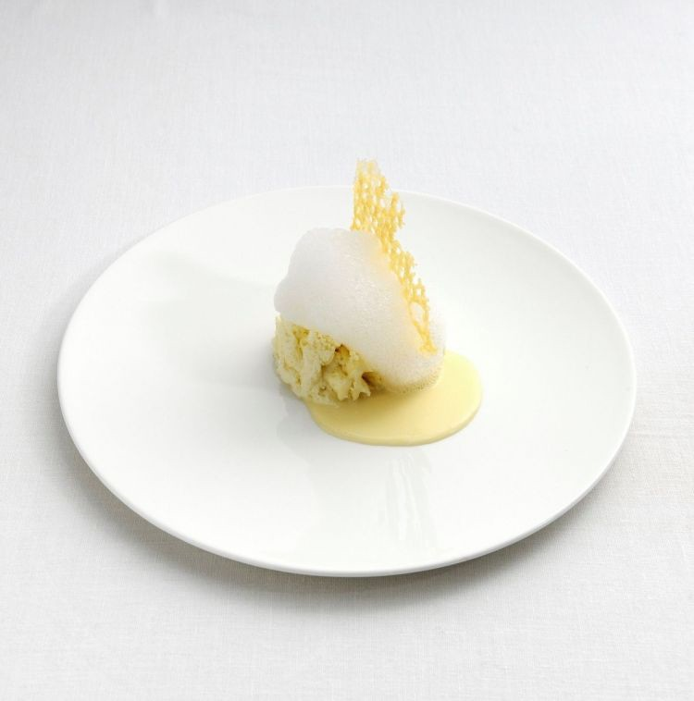
Materials:
Le cinque stagionature del Parmigiano Reggiano in diverse consistenze e temperature di Massimo Bottura at the Museum of Parmigiano Reggiano.
Evaluation strategy: the participants are able to list both negative and positive learnings of the customers after their experience at the agritourism.

Exercise 8: Attract customers you want through effective titles of edutainment activities
Learning outcomes: to increase capacity to integrate humour in providing titles to services and edutainment activities.
Target audience: Agritourism workers. Suggested max. 15 participants.
Requirements: no requirements
Step | Instructions | Duration | Materials
1 | Introduce the participants on the importance to define the target customers of the agritourism. At the same time, your services will attract “customers you want”. Effective titles are a way to attract specific segmented audiences through the technique of audience referencing. Audience referencing means to include the name of the targeted audience within the title of your edutainment activity. | 10 min. | -
2 | Provide an example of how titles may attract different audiences. The description of the target persona is a fundamental process when you aim to create and edutainment activity. In this exercise, you will learn how to teach the identification of the target persona in the area of agritourism through essential questions. Consider that your audience may constituted by workers already having a specific set of customers, or those desiring to open an activity, or even those wanting to attract a specific type of customers.  The edutainment service you create will de facto attract a specific types of customer. “Little pony game” probably will attract families with children, “History of wild herbs in the XIX Century” will probably attract adults with that specific interest towards history. | 10 min. | -
3 | Invite participants to define the title and a description of an edutainment event adopting the technique of the audience referencing. Invite participants to create fun titles of their tours and events concerning agricultural activities. Invite participants to find word games that stimulate the curiosity, the attention and positive emotions of your audience. Inform the participants on the strategy of audience referencing, which means, to address the audience within the titles (“olive oil tasting for experts” qualifies the audience; “sustainable food for people with diabete” indicates the characteristics of the target group and attract them through tailoring”). | 30 min. | -
4 | In case of difficulty, provide additional examples of effective titles. Tract- tour is a word of game mixing the words Tractor and Tour. It is an existing tour in which a tractor is gathering visitors across numerous wineyards of one territory. Unusual elements of using the tractor as a mean of transportation made that tour unique and easy to be memorized. | 30 min. | -
5 | The trainers and participants review titles proposed by all the attendants. | 30 min. | -
Materials: absent
Evaluation strategy: The participants will evaluate the title in terms of the presence of elements concerning sustainability, education and entertainment.

Exercise 9: Customers you have and customers you want
Learning outcomes: to increase capacities to align the agritourism offer with the targeted customers audience
Target audience: Agritourism workers. Suggested max. 15 participants. Being a sensitive topic, when you operate with different agritourism, the participants may fill the table without necessarily sharing all the details that can be marketing-sensitive. It is suggested to operated within the same agritourism.
Requirements: no requirements
Step | Instructions | Duration | Materials
1 | Introduce the topic of customers you want and the general obstacles in the relationships with customers. Hospitality and catering are sectors in which the workload is quite significant and customer-care relationships. For this reason, when you work in the VET training systems for the HoReCa sector in general is not rare to meet workers having had conflicts, stress or frustration in recalling experience for customers. This is due to many reasons: customers individual differences, the position of workers which is essentially always to say yes, to satisfy various requests which sometimes may be overwhelming. This leads to frictions with customers that may also lead to reduce the agritourism reputation. For this reason is  For this reason, when you deal with the task of “defining customers”, you don’t receive always positive descriptions of the customer coming. Your task as a VET trainer of the Agritainment model, is to see things realistically, considering that it’s true, sometimes customers can be “overwhelming” or “difficult”, but your goal is to redirect them, educate them to have a positive experience within your agritourism. | 10 min. | -
2 | Introduce the topic of individual differences of customers and the importance to satisfy the customers despite its variability. Hospitality and catering are sectors in which the workload is quite significant and customer-care relationships. For this reason, when you work in the VET training systems for the HoReCa sector in general is not rare to meet workers having had conflicts, stress or frustration in recalling experience for customers. This is due to many reasons: customers individual differences, the position of workers which is essentially always to say yes, to satisfy various requests which sometimes may be overwhelming. This leads to frictions with customers that may also lead to reduce the agritourism reputation.  For this reason, when you deal with the task of “defining customers”, you don’t receive always positive descriptions of the customer coming. Your task as a VET trainer of the Agritainment model, is to see things realistically, considering that it’s true, sometimes customers can be “overwhelming” or “difficult”, but your goal is to redirect them, educate them to have a positive experience within your agritourism. | 10 min. | -
3 | The exercise “Customers you have” aims to support VET learners and agritourism workers to define the customers they normally have through an agritainment approach. Also, it provides observational skills to define the customers, understand them better and provide to them a better experience.  Here an example of descriptive factors you may consider for the representation of customers you have and their full understanding. You can apply this exercise for single target audiences, or if your customers are truly heterogeneous, you can replicate the exercise in clusters. If you operate with workers of the same company is to allocate the task individually to the same group. This will allow you to understand if the workers have homogeneous or heterogeneous views of the customers in the same agritourism. In that case, open a group discussion on perceptions about customers and how they can influence the workers’ behaviors. Move the attention then from the “customers you have” to the desired goal of “customers you want”. You can apply this exercise in two different modalities:  - you are teaching to agritourism workers with a clear description of their customers and support them in forming a more clear idea of the target persona to be reached  - You are supporting new businesses in forming the target customer persona to target.  In any case, defining the target persona is helpful for both new or structured agritourism. | 30 min. | -
4 | Use the table annexed in the materials as guideline for the attendants to define customers they have and customers you want. | 90 min. | -
5 | Review the produced table by learners, identify focus and insights about customers definition. | 30 min. | -

Materials
Age | Define the most common age ranges
Gender | Describe if you have gender misbalance in your average audience
Co-travellers | Solo/family/couple/Friends/colleagues
Most appreciated services | Define if there is specific most appreciated service
Motivations leading to the travel/experience | Define if you are able to understand the motivation(s) leading customers to select your service
Most common positive comments | Define the customers spontaneous positive comments given in verbal or written form.
Most common negative comments | Define the customers spontaneous negative comments given in verbal or written form.
Knowledge of the technicalities behind your key products | Define per each of your main product/service what they actually technically know and what’s missing.
Environmental awareness and knowledge concerning your key products | Define per each of your main product/service what the customers knows about the environmental preservation
What learning they usually “bring at home” | Define per each of the main product/service what the customer learn that was not known before
Is it common they return for a new experience | Define if they commonly return or not to the agritourism and the motivation for the return or not return.
What them make have positive emotions? | Identify factors that creates positive emotions and what positive emotions in your customers.
Evaluation principles: All participants identified at least some improvements in from the “customers they have” and “customers they want”. The participants identified with critical thinking how to modify their behaviors to support the reach of customers they want.

Exercise 10: Facilitate a group discussion on specific motivations leading to your agritourism
Learning outcomes: to increase capacities to align the agritourism offer with the targeted customers audience
Target audience: Agritourism workers. Suggested max. 15 participants.
Requirements: no requirements. It is suggested to apply the exercise 9 before this
Step | Instructions | Duration | Materials
1 | The table proposed in the exercise 9 can support you in generating a group discussion supporting the group in defining a goal for promoting positive emotions in customers. The initial scheme proposed can support the agritourism workers in identify possible weaknesses in the system. | 10 min. | -
2 | Review the most appreciated services with your attendants. If the group or the single service is proposing that there is one key most appreciated service, support the workers in:  - including comedian style techniques in the existing provision of the service  - Inclusion of educational aspects within the provision of the service product  - Create a set of connected services as “extensions” of the key appreciated service  - Include elements of environmental sustainability within interactions with customers | 30 min. | -
3 | Review the motivations leading to the travel experiences. If the group is not able to determine the motivations much probably leading to the travel experience, you should be able to support them and explore what are the possible motivations behind. If the group provides a general motivation “relaxation”, “fun”, “wellbeing”, support them in finding the more specific motivations behind their decision. Example of questions you may make to the audience or the single trained person are:  - what leads customers to your service than others leading to the same [motivation]  - What are the specific differences that lead customers to your business and not another similar?  - How can you enhance the salience of the [motivations] behind the selection of your businesses  - How can you embed the motivations behind their selection in your storytelling? | 30 min. | -
4 | Review the question “What they make experiment positive emotions”. This is a secondary question that may lead you to understand the motivation of your customer-learner. Positive emotions can be elicited by several factors: relaxation, wellbeing, mental states, even increased knowledge. In this context, it’s helpful to understand also the humor style preferences. Not all people laugh on the same style of comedy or are entertained by the same things. Understanding individual differences in comedy-style can support you in the creation of an edutainment activity. | 30 min. | -
5 | Review the most common positive and negative comments with the following guidelines.  Most common positive comments  If the group is not able to determine the most common positive feedbacks given to the activity, there is probably a major problem within the effectiveness of the agritourism. Support the group in identifying possible strengths and uniqueness elements.  Most common negative comments  In case the group is not able to determine negative comments usually there may be one or more of the following reason:  - the group has limited diagnostic capacity or observational skills;  - the group may fear to represent negative situations with customers in order to not have consequences from the leadership;  - the group denies the presence of possible limits even if aware. The group discussion in this case should be oriented to supporting the group in finding area of improvements.  Try the following strategies:  - use anonymous group discussions, with the provision of possible area of improvements without mentioning who highlight the area of improvement;  - determine positive statements which are the reflex of a possible negative area of improvement, in order to focus the attention of the participants on positive goals to be achieved. | 30 min. | -
Materials: absent
Evaluation methodology: the participants are able to improve the initial strategy performed in the exercise 9 with corrective measures.

Exercise 11: Knowledge of the technicalities behind your key product; Environmental awareness and knowledge concerning your key products
Learning outcomes: to increase travelers engagement in edutainment through the effective selection of technicalities
Target audience: Agritourism workers. Suggested max. 15 participants.
Requirements: no requirements. It is suggested to apply the exercise 9 before this.
Step | Instructions | Duration | Materials
2 | Provide the table used in the annexed materials of the exercises to make the attendants brainstorm about the strategy of edutainment. Use the following criteria: Select then the domain of intervention and the goal of your educational activity in the agricultural site and define the key concepts within the matrix. Teach the agricultural workers to focus especially on unknown and relevant content. Focus on this element and embed content that the participant can “bring at home” as learning. | 50 min. | -
3 | Review and correct the table provided by participants. | 30 min. | -
Materials: Dispose your key concepts in the following matrix
 | Non relevant for the goal for the goal of the activity | Relevant for the goal of the educational activity
Unknown
Known
Evaluation strategy: the participants are following the criteria defined at the step 2.

Exercise 12: Comedy-based speech. Techniques of personifications
Learning outcomes: to increase agritourism workers capacity to use metaphors and techniques of personification and comedy-based language
Target audience: Agritourism workers. Suggested max. 15 participants.
Requirements: no requirements.
Step | Instructions | Duration | Materials
2 | Provide examples of ethopoeia and metaphors through personification. Personification of products is an effective marketing strategies as tends to activate behavioral schemes. If I think that “tomatoes are friends of the heart” I am giving life to that concept, I am starting to build a story. If I say that “lycopene is carotenoid with a protective factor against cardiovascular diseases” I am probably more accurate but I am not using personification, I am not building a story in the mind the audience, I am stating a fact, whose understandability may vary, that may not create a clear image in the mind of the consumer.  The use of “personification” support visualization, imagination and the use of metaphor that animates your speech and engage your audience more than a technical speech. Your goal here is not to give a University lecture, but transmitting key concepts in understandable chunks of information and possibly with fun.  Words trigger a serie of associations in the mind of the learner you may use for educational or humor purposes. What evoke the specific word “friend”? What if I use the word “ally”: the tomatoes are allies of the heart. This evoke a more military based language. So if we have allies, we may have enemies, we may have weapons, etc. What if I say that the white carrot is the mother of all carrots. You can build a speech around persona- based metaphors and the spontaneous association coming from the personal attributions you give to your products. Words, metaphors can open up stories and generate mental associations in the customers, much more than any technical wording, that may be unknown to the general customers. Metaphors can also produce more easily hooks, connections, word games, pseudo-logic associations, comedy-based stories and surprise; all wording that may provoke a humor effect. We aim to this as story-telling, more than technical wording as stories are more easily understood than technicalities. | 10 min. | -
3 | Each participant will find 5 metaphors through personification of 5 different food products. The text of the instructions Define 5 key food products and define 5 metaphors through personification that may represent effectively them . | 30 min. | -
Materials: absent. Optionally you may bring 5 food samples and apply the exercise in a structured way, by adopting only metaphors on 5 typical ingredients of the territory.
Evaluation principles: the participants complete the exercise and find 5 effective metaphors through personification metaphors.

Exercise 13: Comedy-bridges and metaphor-based effective sentences
Learning outcomes: to learn how to use comedy-bridges metaphors in edutainment activities for agritourism
Target audience: Agritourism workers. Suggested max. 15 participants.
Requirements: no requirements. It is suggested to apply the exercise 12 before this.
Step | Instructions | Duration | Materials
2 | Provide an example of comedy-bridge by using tomatoes. The use of personification can support the speaker to have some comedy-based bridge sentences which means that the personification, the metaphor use used to represent the ingredient, the product or its functions within human biology can be used to create comedy-based bridge sentences.  For example, starting the metaphor “tomatoes are friend of the heart” you may continue: “Tomatoes are friends of the heart, and like all best friends…” as they have high quantity of protective substances against cardiovascular diseases.  The use of metaphors and personification allows you to create more easily word games with a humor based finalities. Here an example:  “Tomatoes are friends of the heart, now is the time to know if you want to be friend with tomatoes as to truly know them… You should know at least 1000 varieties. There is a great biodiversity in tomatoes production, and know their differences, use in cuisine and properties is a real challenge. In this lecture you will learn how to…” | 10 min. | -
3 | Explain the mechanism around the functioning of comedy-bridges. This comedy-based wording is based a serie of techniques. For example, it uses the surprise approach:  - tomatoes are friends of the heart create the expectation we may “reciprocate” this feeling.  - The fact that tomatoes biodiversity is an unexpectedly complex topic may question us about if we really want to study them and know them till the end as this may be complex.  - The complexity is solved by the speaker through the introduction of the topic that may be for example: “here we will limit our efforts to study one specific tomato, the prunille, a red tomato from the province of Foggia, known for its properties of [describe your product]” | 10 min. | -
4 | Explain a second example of use of “comedy-bridges” through carrots. Through the metaphor used of before “the white carrot is the mother of all carrots” may continue with a comedy-based bridge sentence. For example, in ethnobotany is described a process of combining and selecting carrots on the basis of our tastes. This can surprise some learners as we all know mostly the orange carrots, which are the most commonly used. We may say that by combining carrots, initially white, we had after many combinations we had the yellow, than the orange and then we made them become black” (ndr, in italian, to make somebody “become black” means “make someone angry”, the comedy hook is here that this process of selecting “must have been exhausted”. Of course, this is a figurative language, but it gives the idea of how long is the process of selecting, crossing vegetable species in order to have the final products we like. This comedy-based bridge may be used for introducing for example a specific carrot, with specific properties, result of a vegetable selection under a controlled environment | 10 min. | -
5 | After having applied the exercise 12, where participants created 5 personification-based metaphors, in this exercise you will ask them to create bridge-sentences and describe the potential use in comedy-based speech through the use of the annexed table in the materials section | 30 min.

Materials
Empty table to be used by learners
Service/product | Metaphors | Sentence | Finality

Table showing a developed example.
Service/product | Metaphors | Sentence | Finality
Tomatoes | Friends of the heart | They are friends for the heart but I don’t know if you truly want to know them as they are 1000 to be known. In this sessions we will focus on one, the prunille from the province of Foggia. | Show the complexity and biodiversity behind tomatoes. Show the positive peculiarities of one specific type of tomatoes.
Optionally you may bring 5 food samples and apply the exercise in a structured way, by adopting only metaphors on 5 typical ingredients of the territory.
Evaluation principles: the participants complete the exercise and find 5 effective metaphors through personification metaphors.

Exercise 14: Build the persona of your product based on sensory based approach
Learning outcomes: to enhance capacity to use sensory-based approach in edutainment activities.
Target audience: Agritourism workers. Suggested max. 15 participants.
Requirements: no requirements.
Step | Instructions | Duration | Materials
1 | Introduce the sensory based approach. How to build the persona of your product?  A strategy may be to start from a sensory based approach  Let’s start with your product and its sensory based elements:  - what is the color, how to color varies across maturation stage,  why that color  - What is the flavor, how the flavor can vary across maturation  stages, why that color in that specific maturation stage, or specific food labels  - What is the smell and the touch, how this gives indications to be  genuine. | 5 min. | -
2 | Provide an example.  Sensorial elements can give you hints on how to define the persona of your product by using words that may makes reference to personality traits.  This is the sweetest tomatoes you will ever try (exaggeration, taste expectation).  “Sweet” is a word we may use for the persona of the product. We may use bitter as well. What positive assumptions we can use for bitter? Serious, mature, for experts, exclusive, not for all palates.  We may use the axis “easy taste”, “difficult taste”.  You may use elements concerning to trust, which is something we adopt for people. You can trust this tomato, this tomato has zero pesticide, zero additives. You may say that the flavor is more seductive (taste expectation, game of word). A flavor may be acid, but also people may be acid.  Miele di Castagno. This has both a sweet and bitter tone, as all of us, also products has their personality. Try the complexity of this flavor. | 10 min. | -
3 | Provide the table annexed in the materials and ask the participants to fill it for at least 1 key product. | 10 min. | -
4 | Each participant explain his idea. | 10 min. | -
5 | The trainer review and correct the inputs provided by the learners | 10 min.

Materials
 | Description | Personality metaphor attribution
Colour
Flavour
Smell
Evaluation principles: the table is filled in all its parts correctly by all learners.

Exercise 15: Use exaggeration and taste expectations as comes-based mechanism
Learning outcomes: to learn the exaggeration techniques to stimulate positive reactions in the audience
Target audience: Agritourism workers. Suggested max. 15 participants.
Requirements: no requirements.
Step | Instructions | Duration | Materials
1 | Explain the importance of adopting techniques when stimulating a positive reaction in the audience. Two mechanism you can adopt to stimulate humor reactions are exaggeration and taste expectation. Specifically taste expectation can stimulate surprise as the taste is not exactly known by the learner visitors. | 5 min. | -
2 | Provide 4 food products which will be used to be the object of the comedy-based language. Provide these indications to the attendants.  - Consider the 4 food products and allocate to each of them a “personality trait”  - Then exaggerate  - Create a taste expectation  - Create a story around the personification of the products, combine it with other humour techniques  Tomato: Fennel: Pepper: Grape: | 30 min. | -
3 | In case of difficulty, provide examples of comedy-based sentences. Example of comedy style techniques  - Use of hypothetical language: Dionisos was the God of Grapes, but what Dionisos didn’t knew is that grapes are…  - Use personification-based technique: “this fennel made a little journey to be here with us” (to make reference to km zero, the term with us use personification)  - Use of the re-labelling technique. For example, borragine herb is also called mountain oyster. Do you know why? Then you can make taste one. This herb has unexpectedly a “sea flavor” and a shape that may vaguely remind oysters. This wording also can produce a comedy-based approach as there is a strong contrast in the use of the word oysters. Oysters can be extremely expensive, borragine is a wild herb and it’s very cheap. | 10 min. | -
4 | Provide keywords related to taste expectation such as sweet, bitter, sour, spicy, bittersweet, etc. And ask to create games of words and comedy- based sentences by using the same explained principles | 30 min. | -
5 | The trainer review and correct the inputs provided by the learners | 10 min.
Materials: absent. Optionally you may use 4 samples of the food targeted.
Evaluation principles: the participants adopt both taste expectations and exaggeration in alignment with the descriptions provided.

Exercise 16: Build your persona. Build your character.
Learning outcomes: support the personal branding of the agritourism worker
Target audience: Agritourism workers. Suggested max. 15 participants.
Requirements: no requirements.
Step | Instructions | Duration | Materials
1 | Introduce the exercise. Stimulate your audience about the importance of showing the personality of the educators in order to create a personal connection with your audience instead of looking “anonymous” or “grey”. The personality of the product is very important as it conveys indirect association with the brand in general, to the target persona of the audience and then the customer. But there are other players in the internal discussion that customers does when selecting your service. Who are you?  When presenting your company/product, you can play with your personality, impersonate roles if they are functional to:  - transmit key information concerning sustainable food  - Convey sustainable attitudes and behaviors concerning food | 10 min. | -
2 | Provide these two techniques concerning “how to build your persona”.  - Use a personal story. This create engagement and familiarity with the customers. The reason why is called self-disclosure. We tend to disclose personal elements for those who release information first  - Use a key personality trait. A classical comedian-style technique is to use exaggeration while describing ourselves in a playful way. Exaggeration also support the memorization of the stories and may be functional to education. | 10 min. | -
3 | Introduce the technique of tragedy-comedy. What is your relation to food or tourism. Maybe you changed your food habits, maybe you changed tourism habits or lifestyle. Embed these elements in your story. Tragedy- comedy is always a good combination in creating effective comedy-based storytelling.  For example, you may have had a past of unhealthy behavior leading to obesity, then you changed approach. Or you may have quite alcohol and substituted with another product, or moved to organic food consumptions. You may have lost 20 kg. You may have been bullied in the past for being too fat, then approaching rural lifestyle changed you for some reasons. Everything can be used as a comedy/tragedy-based hook.  Another tragedy/comedy element may be to urban/rural area. Maybe you were a workaholic, you were in an urban and polluted center and decided to move into a rural area to live a calmer life. | 10 min. | -
4 | Introduce the technique of personality trait, exaggeration techniques and surprise effects in storytelling. Here some examples of sentences that may trigger humor. 1. After that, I become so [personality trait] that I cannot  2. After that, I become so [personality trait] if I eat once something fat then I have to  An exercise, is to support your learners in creating their persona and their story in relation to agrotourism. Examples of characters you may create around your persona and use it in your humor-related speech  - The Defender of the Territory  - The Mythbuster of Greenwashing  - The Intransigent Salutist  - The Machine of Tasting  - The True Friend of Animals  The literal application of metaphors, the use of exaggeration, can support the creation of a memory of the learners-visitor. Edutainment activities can also host other experts in the educational activities, being nutritionists, medical doctors, agronomists. Help them in building a character. | 10 min. | -
5 | Invite the participants to adopt coherence in storytelling, even when adopting clear comedy-based schemes. Creating characters means creating narratives. If you’re doing comedy, there is a portion of narrative, there is some story-telling. Anyhow, always make reference to true basis as differently you may appear non-authentic.  Example: The explanation of ancient Chinese tradition with a strong abruzzese accent may create a discrepancy in the communication. Potentially comic, the combination looks non-authentic. | 10 min. | -
6 | The participants will create 1 example of use of the techniques described and perform a speech. The trainer and the other attendants provide a feedback of alignment of the speech with the techniques adopted. | 60 min. | -
Materials: absent
Evaluation principles: adherence of the speeches to the descriptions of the techniques, operated by the trainer and the other attendants.

Exercise 17: The technique of quotation
Learning outcomes: learn how to use the technique of quotation in comedy based speech
Target audience: Agritourism workers. Suggested max. 15 participants.
Requirements: no requirements.
Step | Instructions | Duration | Materials
1 | Introduce the technique. The technique of quotation allows you to state something without being the author of the sentence. This can be used with a comedian style effect. A quotation is normally used during speeches to give authority to a fact. In order to obtain a comedy-style speech, use quotations combined with unexpected endings, which may produce a surprise effect in the audience. | 10 min. | -
2 | Introduce a variant of the technique. Quotations leading to obvious conclusions  “The University of X demonstrated that fried food can bring this [negative effect]. Mmh, ok, maybe we didn’t needed the University of X to draw this conclusion” | 10 min. | -
3 | Introduce another variant. Quotations using percentages and numbers “The [authority] calculated that [percentage] of [illness] is caused by pesticides. Now, considering that [country] statistics shows that pesticides are used by [percentage] of companies, you can truly understand that… | 10 min. | -
4 | Each participant find 3 actual quotations concerning food and services offered in agritourism and create a sequence of comedy-based sentence based on the explained techniques. | 30 min. | -
5 | All participants read the sentences. Trainer and attendants evaluate if Agritainment principles are embedded and the technique is performed properly. | 10 min. | -
Materials: absent
Evaluation principles: adherence of the speeches to the descriptions of the techniques, operated by the trainer and the other attendants.

Exercise 18: Aprosdoketon and other surprise techniques
Learning outcomes: learn the use of surprise in a comedy-based speech in agritourism
Target audience: Agritourism workers. Suggested max. 15 participants.
Requirements: no requirements.
Step | Instructions | Duration | Materials
1 | Introduce the function of surprise in comedy. Surprise can be also used as a learning mechanism, as per definition it moves the attention of the learner immediately. | 10 min. | -
2 | Explain the technique: the rule of three. The rule of three is a classical comedy-speech related techniques which is based on using sequences of three sentences: two presuppositions and one unexpected ending, which is the one that should create the humorous effect. In our project, we aim to use environmental issues at the core of entertainment activities. The rule of three is used in comedy by creating tension with the first two items and release with the third one. | 10 min. | -
3 | Explain the technique aprosdoketon. In Italian, the word entertain is “divertire” from the latin word “divertere” which means deviate, divert. For this reason, many entertainment techniques are based on moving unexpectedly the attention of the audience in a humoristic way. For example, this is commonly used in many comedian based techniques such as the rule of three, which introduce an unexpected element as a third element of a serie of sentences. The aprosdoketon is instead briefer as it takes one unique sentence or only 2 elements, where the second is unexpected. Examples of Aprosdoketon is “he had a heart of gold, but unfortunately also a liver of iron.” In our project we aim to move the attention to environmental issues, therefore it’s important that the unexpected elements makes reference to environmental elements. | 10 min. | -
4 | Each participant write the demonstration of the technique twice, both for the rule of three and aprosdoketon based on one food product used in their agritourism company. | 60 min. | -
5 | All participants read the sentences. Trainer and attendants evaluate if Agritainment principles are embedded and the technique is performed properly. | 30 min. | -
Materials: absent
Evaluation principles: adherence of the speeches to the descriptions of the techniques, operated by the trainer and the other attendants. The techniques reflects both content related to the environment and education.

Exercise 19: Comedy and pain
Learning outcomes: learn how to use “pain” for edutainment
Target audience: Agritourism workers. Suggested max. 15 participants.
Requirements: no requirements.
Step | Instructions | Duration | Materials
1 | Introduce the function of pain in comedy.  Comedy, pain and reality are often used together. There is a German term to refer to all this called schadenfreude and means (enjoyment of other people's misfortune). Pain in all is forms is also used under the forms of irony or even self-irony. A definition of irony is: saying or doing something that departs from what they or we expect them to say or do”, or again “the expression of one’s meaning by using language that normally signifies the opposite, typically for humorous or emphatic effect.”. There are two criticalities in the use of pain in the speech. The use of pain can offend somebody sensitivity, or can target one’s thinking, or contradict one’s beliefs. Anyhow, if we try to answer to the question if “pain” can be educational, the answer is yes. Our brain is particularly sensitive to pain and try to anticipate much more potentially painful reactions. Think to smoke or alcohol disclaimers used to discourage these kinds of behaviors. They aim to “educate” through pain. In this exercise, I will show you how to use “pain” in a wise way during your comedy related speeches in reference to environment. | 10 min. | -
2 | Comedy related techniques are fundamentally based on contrasts, unexpected sentences, games of words, surprises. Using entertaining techniques on environmental issues can be done by focusing on elements whose majority of the population are unaware. In this exercise, the participants will list 10 elements of their food products / touristic activities which most of the population doesn’t know. Adopt these questions to simulate attedants curiosity about the use of this technique.  What are the possible “pain-related” topics you can introduce when you talk about the ecosystems of food and tourism? What are the types of contrasts you may talk on and educating people in references to the environmental sustainability? | 10 min. | -
3 | Each participant list at least 10 “pain-related” topics related to the alternatives to consumption of healthy and sustainable products adopted in your agritourism. | 10 min. | -
4 | One of the key elements to stimulate cognitive dissonance, pain, or discrepancy is to identify an “enemy”. Of course, not a physical one. The enemy can be conceptual and should be the same enemy of your customers. What are the aims that customers wants from rural tourism and agrotourism?  For food related elements: costs-effectiveness, taste, geographical origin, food safety, environmental values, ethics behind food.  For tourism: environmental factors, wellbeing, relax, cost-effectiveness, experience etc.  These factors can be all used in creating cognitive dissonance that leads to educating customers to sustainable experiences. | 10 min. | -
5 | Each participant creates a comedy-based speech based on the technique comedy and pain. The trainer invites to the adoption of the previously explained techniques: comedy-bridges, aprosdoketon, surprise, pain. | 60 min.
6 | All participants read the sentences. Trainer and attendants evaluate if Agritainment principles are embedded and the technique is performed properly. | 30 min. | -
Materials: absent
Evaluation principles: adherence of the speeches to the descriptions of the techniques, operated by the trainer and the other attendants. The techniques reflects both content related to the environment and education.

Exercise 20: Comedy and cognitive dissonance
Learning outcomes: learn how to use “cognitive dissonance” for edutainment
Target audience: Agritourism workers. Suggested max. 15 participants.
Requirements: no requirements.
Step | Instructions | Duration | Materials
1 | Introduce the concept of cognitive dissonance. As mentioned before, one of the strategies to generate humor is creating unexpected elements in your speech. These unexpected elements can be used in an educative way. The process is called cognitive dissonance. The cognitive dissonance is the presence in our mind of two conflicting elements. Considering that we need to have an internal mental coherence, we try to solve the conflict by giving an explanation to our reality, by solving the dissonance. This process of orienting our perceptions and solving “cognitive dissonance” can be used for learning. This exercise is composed by a set of techniques usable in edutainment in order to produce positive emotions through comedy-based techniques. | 10 min. | -
2 | Find contrasts in the history. One area for the use of irony is based on the contrast old/new. Historical/modern. Effective agro-tourism are the synthesis of traditional and innovative techniques. We rely on traditions but we apply, luckily, modern techniques for preserving food, using technology and so on. You may use historical curiosity about food production, the territory, the technology. Provide examples.  Example: burned grain pasta was used by very poor farmers as discarded elements as not included in the commercial products of pasta. Today, burned grain pasta is sold as a delicacy thanks to it’s smoked flavor.  Moral of the story: you can truly use everything in cuisine sustainably and the frame makes the impact  Contrast past/present: technology and knowledge are the basis for sustainability. Food was “categorizing” people sometimes for their poverty, today is instead considered a delicacy. Another contrast past/ present is the following: the old traditions are often considered very wise in terms of production, in reality, food technology and progress made food more safe. The past generations for example didn’t knew that using the 100% of burned grain was surely unsafe. Today the process is controlled and safe.  Example: pizza is considered one of the main symbols of italian cuisine. Anyhow it evolved on the history and the first version of the pizza was full of defect (very little, difficult to digest, sometimes sold even one week after the preparation, without the use of yeast, and using toppings not considered traditional such as little fishes, lard, only olive oil, only salt). The history of pizza is the history of a dish that travelled and was made famous first by italian living in the US. Only after it became quite famous in all italian regions.  Moral of the story: sometimes tradition is not necessarily wise or respecting our current tastes. Food changes on time and following the technological advancements. Traditional preparation may evolve and sometimes it’s desirable to have a change. Cuisine heritage is local but it migrates as people migrated in the past.  Example of contrasts in history: pineapple pizza is technically a traditional plate being created on the 1960.  Moral of the story: tradition is not always right | 20 min. | -
3 | Find commonalities when you expect differences. Provide an example of the use of the technique. We locate cuisine at a very specific level as we consider food a part of our identity. Pizza or pasta will be felt as italian, anyhow, in our traditions we didn’t had means to standardize very well the preparations and also we lived in conditions of much higher difficulties. Seasonality was not a decision but a forced choice. Haute cuisine was not existing, nobody was criticizing if on that days we didn’t used pecorino romano for the carbonara or another type cheese but essentially we were grateful for whatever cheese as the other option was nothing.  Moral of the story: poverty can teach you something, how to save food, how to adapt your diet and preparation saving costs and increasing the healthiness/sustainability.  Anyhow, besides traditions, the history of food shows that commonalities across different cultures came also with common technological advancements. Food also migrated as people moved across countries, this explains why we can find very similar food preparations in very different countries. For example, the use of sheep intestine rolls is common in the province of Foggia and in Turkiye: the only difference in the preparation is the name, torcinelli in the province of Foggia and kokorec in Turkiye.  Another example of misleading perceptions and food evolving on time is related to the first version of pasta. Cypriot pastitsio has Venetian origins and still includes cinnamon, which was included also in it’s original cuisine. Pasticcio veneto is still cooked today but italians lost the habit to use cinnamon in pasta. Today in Veneto you will most probably not find cinnamon in the pasticcio veneto but you will find it at more than 2000 km distance. If you try to put cinnamon on italian pasta you may find lots of resistance, anyhow, the true tradition is more respected in a distant country  Moral of the story: tradition is a perception. Hobsbawn created the concept of “invention of the tradition”.  Moral of the story: food is evolving and changing, we can innovate traditions, we can find commonalities across different food cultures. | 20 min. | -
4 | Find contrast in the identification of greenwashing and distinguishing it from true environmentally-sustainable actions. On area for the use of contrast is the difference between policies and practices. Laws can regulate minimum requirements for the environmental sustainability. Unmasking the truth can be revealing, educational and also generate a “bitter smile”. For example, a recent action for contrasting plastics, forbidden the use of straws in the touristic activities. Anyhow, this account for a minimum fragment of the overall sustainability of touristic activities, which makes the action non-effective. | 20 min. | -
5 | Find and use contrasts in the motivation of the costs. Cost is one of the key factor affecting customers decisions in any economic activity. This is true also for decisions concerning agriculture and tourism. What’s behind the cost of a product if not always known to customers.  Educational activities can support customers in understanding what’s “behind the scenes” and understanding the costs. Educational activities concerning the costs also allow to enter into contrasts concerning cost- effectiveness of consumption decision making. | 20 min.
6 | Find and use contrasts between thinking and behaviors. We all know that we should eat healthy and sustainable. We all know that we should avoid to drink alcohol, to smoke or to live in polluted areas. None of us wants to eat food with pesticides or other similar experiences. How many people follow the rules, even if cost-effective? A contrast between thoughts and behaviors can give a comedian hook. | 20 min. | -
7 | Find and use contrasts between expensive options and cheap but sustainable. A little electric red minibus could be introduced through the following joke: it’s red like a Ferrari but at least it consume no fuel. | 20 min. | -
8 | Word games with labels. This grape is called baboso negro (in Spanish it means … ) we called it like that because it’s always so difficult to understand his preferences and to grow. That’s why.  This may have a comedy effect in a little wineyards, where every single plant is important and on their production depends the performance of the company. Also in this case we used a personification approach: plants has no human characteristics and they are not reacting on the basis of our behaviors, or behave for personality reasons, but we are using the name of the plant for explaining a concept, and also to pass the effort behind the production of that specific wine. | 20 min. | -
9 | Each participant creates a comedy-based speech based on the technique cognitive dissonance. | 60 min | -
Materials: absent
Evaluation principles: adherence of the speeches to the descriptions of the techniques, operated by the trainer and the other attendants. The techniques reflects both content related to the environment and education.

Exercise 21: The Final Speech
Learning outcomes: refine public speaking capacity in agritourism for the promotion of environmental friendly products and services
Target audience: Agritourism workers. Suggested max. 15 participants.
Requirements: no requirements.
Step | Instructions | Duration | Materials
1 | The participants are invited to perform a final speech adopting all the techniques mentioned in the 20 exercises. Each participant review the entire materials produced and write a 1 page speech to perform. | 60 min. | -
2 | Every participant perform the speech by adopting all the techniques described in the 20 exercises. | 60 min. | -
3 | The participants provide a feedback on a scale from 1 to 10 on the criteria of Agritainment annexed in the materials.  - Positive emotions: the performance is effective in stimulating positive emotions in the audience  - Educational part: the performance is able to stimulate the transfer of knowledge concerning the products and services offered  - Environmental sustainability: the performance is providing effective content motivating customers to environmental sustainability  - Valorization: the performance is valorizing services or products, customers may be motivated by the explanation to the selection of the targeted service or product. | 10 min. | -
4 | The trainer encourage the participants to embed comedy-based principles in the routine activities in the agritourism. | 10 min. | -
Materials:
Evaluation matrix
Evaluation matrix | Rate on a scale from 1 to 10
Positive emotions
Educational component
Environmental sustainability
Valorization of the territory
Evaluation principles: use of the evaluation matrix. The attendant with the highest score is symbolically awarded.

Exercises for creating green-transition inspired group games in educational setting in agritourism and hospitality
General Framework
These Exercises for Green Transition through Agritainment approach aim to support VET trainers, hospitality educators, and agritourism professionals in teaching sustainability principles through interactive group games. Unlike traditional lectures, these exercises use play-based learning and collective experiences to connect environmental responsibility with enjoyment, collaboration, and cultural exchange.
These exercises prepare trainers & professionals to:
- Integrate play-based sustainability education into their programs.
- Teach agritourism workers how to promote sustainable practices through engaging methods.
- Provide replicable game frameworks adaptable to different regions, products, and audiences.
- Ensure participants can translate environmental principles into practice while keeping learners motivated.
Learning Outcomes
After completing the exercises, VET trainers and agritourism workers will be able to:
- Design and deliver green transition-inspired group games.
- Adapt the games to local sustainable products and services.
- Use these games to train learners (hospitality students, farmworkers, etc.) effectively.
Target Groups
Primary:
- VET Trainers in agritourism, hospitality, and sustainable tourism
- Agritourism workers (farmers offering hospitality, eco-lodge managers, sustainable food producers) who act as trainers in their settings
Secondary (indirect beneficiaries):
- VET learners in tourism and hospitality
- Students in agricultural colleges or hospitality schools
- Visitors participating in sustainability workshops or farm tours
Requirements
This section is designed to be operational immediately, with minimal preparation for trainers.
- Venue: Classroom, workshop room, or farm hospitality space with chairs and tables.
- Materials:
  - A4 paper sheets
  - Flipcharts or a whiteboard (if available)
  - Markers and pens
  - Scissors and adhesive tape (optional, for templates)
- Provided Templates: For any activity that requires cards, menus, checklists, or scoring sheets, this manual includes ready-to-print templates. Trainers can photocopy them before the session.
Group Size: Exercises are designed for 8–15 participants but can be adapted.
Time per Exercise: Between 30–90 minutes, depending on complexity.
Template Provision
For each exercise that needs specific materials, the manual includes:
- Printable Cards
- Blank and Example Menus
- Score Sheets / Evaluation Checklists
- Role Cards (for simulations or charades-type games)
This ensures that every trainer, even in resource-limited settings, can run the exercises without purchasing or designing extra materials.
How to Use This Resource
This resource is designed for VET Trainers and Agritourism Workers, but the final beneficiaries of these games will vary. The exercises can be delivered in:
- Classrooms, with VET learners preparing for agritourism or hospitality careers
- Workshops on farms or in hotels, for staff and seasonal workers
- Edutainment activities for visitors/customers, to raise awareness and appreciation for sustainability
- Etc.
Trainer’s Role:
- First, learn and practice the game in a safe environment (with peers).
- Second, reflect on why the game works (attention, positive emotions, eco- learning).
- Third, adapt the exercise for your own learners or customers, using the provided templates and guidance.

Exercise 1: The Eco-Choice Challenge
Learning Outcome: To train VET trainers and agritourism workers in facilitating a decision-making game that helps learners understand the environmental impact of everyday choices in agritourism and hospitality.
Target Group: VET Trainers and Agritourism Workers (8–15 participants)
Requirements
- Classroom or workshop room with chairs/tables
- Printed Eco-Choice Cards (Annex 22)
- Blank score sheets (Annex 21)
- Pens
Step | Instructions | Time | Resources needed
1 | Introduction: Trainer explains the aim of the activity. “We often make small choices in hospitality and agritourism that have big impacts on sustainability. This game helps us identify the greenest choices.” Distribute score sheets. | 10 min | Flipchart/whiteboard (optional), score sheets
2 | Setup: Divide participants into 2–3 teams. Shuffle the Eco-Choice Deck and place it in the center. | 5 min | Printed Eco-Choice Cards
3 | Round 1 – Drawing Choices: Each team draws a card, reads it aloud, and decides together whether it is High Impact (3 pts), Medium Impact (2 pts), or LowImpact (1 pt) for sustainability. The trainer reveals the correct score using the answer key. Teams record results on the score sheet. | 15 min | Eco-Choice Cards, Score Sheet
4 | Round 2 – Justify Your Choice: After each decision, teams give a 30-second justification. Trainer uses prompts: “What resources are affected?” “How would customers perceive this?” | 20 min | Score Sheet, Pens
5 | Round 3 – Scenario Play: Each team draws 3 cards and builds a mini scenario (e.g., breakfast service, eco-tour). They present the most sustainable version. | 20 min | Eco-Choice Cards
6 | Debrief & Reflection: Trainer summarizes key lessons. Ask: “Which choices were hardest? How might you adapt this for your own learners/customers?” Participants note 1 way they will use the game. | 10 min | Flipchart (optional)
Evaluation Methodology
- Knowledge: Teams correctly identify at least 70% of the “greenest choices.”
- Critical Thinking: Justifications link choices to environmental impacts.
- Application: Each trainer writes down one concrete adaptation of the game for their learners/customers.
- Collaboration: Peer feedback on persuasiveness of arguments.
Adaptation Guidance
- For VET Learners: Focus on workplace scenarios (hotel dining service, eco- tour planning).
- For Agritourism Workers: Use local products (farm produce, renewable practices).
- For Customers/Visitors: Simplify and run as an interactive eco-quiz during tours.

Exercise 2: The Green Hospitality Dilemma Game
Learning Outcome: To train VET trainers and agritourism workers in facilitating a role-based decision game where learners debate and choose the most sustainable hospitality solutions in common farm/hotel scenarios.
Target Group: VET Trainers and Agritourism Workers (8–15 participants)
Requirements:
- Printed Dilemma Scenario Cards (Annex 23)
- Role badges (optional, Annex 24)
- Pens and paper for notes
Step | Instructions | Time | Resources needed
1 | Introduction: Trainer explains that hospitality often involves making quick choices that affect sustainability. This game puts participants in roles (e.g., chef, farmer, hotel manager, tourist) to solve dilemmas together. | 10 min | Flipchart/whiteboard (optional)
2 | Setup: Divide participants into small groups (3–5). Distribute one Dilemma Scenario Card per group. Assign each participant a role using badges (e.g., Manager, Chef, Visitor). | 5 min | Printed Scenario Cards, Role Badges
3 | Discussion Round 1: Each group reads its dilemma. Members argue from their role’s perspective to decide on the best course of action. Trainer encourages structured debate. | 20 min | Scenario Cards, Pens
4 | Presentation Round: Each group presents its decision to the plenary. They must explain both their chosen solution and why other options were less sustainable. | 20 min | Flipchart (optional for notes)
5 | Trainer Feedback: After each presentation, trainer highlights the sustainability strengths of the solution and points out any overlooked impacts. | 15 min | None
6 | Reflection & Adaptation: Participants write down how they would adapt this game for their own learners/customers (e.g., different dilemmas, simpler roles). | 10 min | Reflection Sheets (Annex 25)
Evaluation Methodology
- Critical Thinking: Teams justify why their solution is the most sustainable.
- Role Understanding: Each participant contributes from their role’s perspective.
- Sustainability Awareness: Decisions align with green transition principles (local sourcing, waste reduction, energy efficiency).
- Replicability: Participants outline how to adapt at least one dilemma for their own teaching or workplace.
Adaptation Guidance
- For VET Learners: Use dilemmas based on real hospitality school scenarios (menus, housekeeping, catering).
- For Agritourism Workers: Focus dilemmas on daily farm practices (guest meals, waste disposal, local sourcing).
- For Customers/Visitors: Simplify into a “Would You Choose?” game with fewer roles and quick voting.

Exercise 3: The Carbon Footprint Line-Up
Learning Outcome: To train VET trainers and agritourism workers in facilitating a dynamic movement- based game that teaches learners about the environmental impact of different agritourism and hospitality practices.
Target Group: VET Trainers and Agritourism Workers (8–20 participants)
Requirements:
- No printed materials required
- Optional: masking tape or rope to mark a line on the floor
- Pens and paper (only if teams want to take notes)
Step | Instructions | Time | Resources needed
1 | Introduction: Trainer explains the concept of “carbon footprint” in hospitality and agritourism. “Every action we take has an environmental cost. Today we’ll explore which choices are heavier on the planet — and which are lighter.” | 10 min | None
2 | Setup: Mark a long line on the floor (using tape, rope, or simply imagining one). One end represents High Impact (Not Sustainable) and the other represents Low Impact (Very Sustainable). | 5 min | Rope/tape (optional)
3 | Round 1 – Trainer Statements: Trainer reads out a sustainability-related practice (examples below). Participants must position themselves along the line according to how sustainable they think the practice is. | 20 min | None
4 | Group Discussion: Once placed, ask 2–3 participants to explain why they chose their position. Encourage debate and allow people to move if persuaded. | 15 min | None
5 | Round 2 – Participant Proposals: Invite participants to propose their own agritourism/hospitality actions (e.g., “Using solar panels,” “Offering imported wine,” “Running daily tractor rides”). Others then position themselves on the line. | 15 min | None
6 | Debrief & Reflection: Trainer summarizes the biggest insights. Ask: “Which actions surprised you? How can you adapt this game for your own learners/customers?” | 10 min | Flipchart (optional)
Sample Sustainability Practices for Round 1
- Offering bottled water in plastic vs. refillable jugs
- Serving imported tropical fruit vs. local seasonal fruit
- Using disposable cutlery vs. reusable plates
- Providing guided walking tours vs. bus tours
- Composting food waste vs. throwing it away
- Offering vegetarian menu options vs. meat-heavy menus
- Heating a guesthouse with renewable energy vs. fossil fuels
Evaluation Methodology
- Engagement: All participants actively move and take a stance.
- Knowledge: Participants correctly identify which practices are more/less sustainable (confirmed during debrief).
- Critical Thinking: Debates show understanding of environmental trade-offs.
- Replicability: Trainers describe at least one way they could use the game with their learners/customers.
Adaptation Guidance
- For VET Learners: Add more technical scenarios (e.g., energy use in kitchens, packaging choices for catering).
- For Agritourism Workers: Use examples directly from their farm operations.
- For Customers/Visitors: Keep scenarios simple and fun, focusing on visible choices (food, transport, recycling).

Exercise 4: The Sustainability Auction
Learning Outcome: To train VET trainers and agritourism workers in facilitating a simulation game where learners “bid” for the most valuable sustainable practices in hospitality and agritourism, learning to prioritize actions when resources are limited.
Target Group: VET Trainers and Agritourism Workers (8–20 participants)
Requirements:
- No printed materials required (optional auction cards template can be used)
- Scrap paper or sticky notes for “bidding money”
- Pens
Step | Instructions | Time | Resources needed
1 | Introduction: Trainer explains: “In real life, we can’t implement every eco-action at once due to budget, time, or resource limits. Today we’ll run an auction where you ‘buy’ sustainability measures — and see which ones you value most.” | 10 min | Flipchart (optional)
2 | Setup: Divide participants into teams of 3–4. Give each team the same amount of “eco-currency” (10– 15 bidding notes). Explain the rules: teams will bid on sustainable practices as if they were improvements for their farm/hotel. | 5 min | Scrap paper/sticky notes for money
3 | Auction Round 1: Trainer reads the first sustainability practice (see list below). Teams bid to “buy” the practice. Highest bid wins. Trainer records which team purchased which practice. | 20 min | None
4 | Auction Round 2: Continue with more practices. Encourage debate between teams: “Why is this practice worth more to you than others?” | 15 min | None
5 | Presentation Round: Each team presents its “portfolio” of purchased practices, explaining why they prioritized them. Trainer facilitates discussion of trade-offs. | 20 min | Flipchart (optional)
6 | Debrief & Reflection: Trainer summarizes the biggest insights. Ask: “Which actions surprised you? How can you adapt this game for your own learners/customers?” | 10 min | Flipchart (optional)
Sample Sustainability Practices for Auction
- Installing solar panels for the guesthouse
- Composting all kitchen waste
- Replacing plastic bottles with refillable glass pitchers
- Offering daily vegetarian/vegan menu options
- Partnering with local farmers for produce
- Switching to eco-friendly cleaning products
- Reducing portion sizes to cut food waste
- Offering cycling/walking tours instead of car tours
- Using refillable dispensers instead of single-use toiletries
- Training staff to explain sustainability to visitors
Evaluation Methodology
- Engagement: All teams actively bid and explain reasoning.
- Critical Thinking: Teams demonstrate understanding of trade-offs in sustainability.
- Prioritization Skills: Portfolios show awareness of cost vs. impact.
- Replicability: Trainers identify at least one adaptation for their learners/customers.
Adaptation Guidance
- For VET Learners: Add “budget impact” values to each practice so learners must calculate trade-offs.
- For Agritourism Workers: Use real-life examples from their farms (e.g., drip irrigation, local honey partnerships).
- For Customers/Visitors: Run a light version as a “fun auction” during farm tours, letting guests bid on eco-actions they’d like to see.

Exercise 5: The Green Negotiation Table
Learning Outcome: To train VET trainers and agritourism workers in facilitating a role-play game where learners negotiate sustainability solutions among stakeholders with different interests in agritourism and hospitality.
Target Group: VET Trainers and Agritourism Workers (8–15 participants)
Requirements:
- No special materials required
- Optional: printed Role Briefs (Annex 26)
- Flipchart/whiteboard for notes
Step | Instructions | Time | Resources needed
1 | Introduction: Trainer explains: “Sustainability often involves negotiating between different interests — farmers, guests, managers, and local authorities. Today we’ll simulate a negotiation to find the most balanced eco- friendly solution.” | 10 min | Flipchart/whiteboard
2 | Setup: Divide participants into groups of 4–5. Assign each participant a stakeholder role (Manager, Local Farmer, Guest, Sustainability Officer, Local Authority). Hand out role briefs or explain them verbally. | 5 min | Role Briefs (printed or verbal)
3 | Round 1 – Stakeholder Presentations: Each role explains its priorities regarding the sustainability issue (e.g., food sourcing, waste management, energy use). | 15 min | Role Briefs
4 | Round 2 – Negotiation: Groups negotiate to agree on a shared action plan that balances sustainability with economic and customer needs. | 25 min | Flipchart for notes
5 | Round 3 – Agreement Presentation: Each group presents their final agreement to the plenary. Trainer asks clarifying questions: “What compromises were made? What eco-benefits were achieved?” | 20 min | Flipchart
6 | Debrief & Reflection: Trainer leads discussion on the negotiation dynamics. Ask: “Which role was hardest to represent? How can we use this with our learners to show real-world challenges of sustainability?” | 10 min | None
Sample Negotiation Scenarios
- The Eco-Hotel Kitchen: A hotel wants to reduce its carbon footprint. Options include buying local produce, offering vegetarian menus, or investing in composting. Stakeholders must agree on 2 main actions.
- Farm Tourism Expansion: An agritourism farm wants to add a visitor center. Options include eco- materials, renewable energy, or cutting costs with conventional materials.
- Transport for Guests: A guesthouse must decide how to provide transport for farm tours: diesel minivan, bicycles, or an electric shuttle.
Evaluation Methodology
- Engagement: Each participant contributes from their role’s perspective.
- Negotiation Skills: Groups reach a compromise reflecting both sustainability and practicality.
- Awareness: Final plans include at least 2 eco-friendly actions.
- Replicability: Trainers describe how they would adapt scenarios for their own learners/customers.
Adaptation Guidance
- For VET Learners: Assign roles linked to their future careers (chef, event planner, farmer, eco-guide).
- For Agritourism Workers: Use real farm-based issues (e.g., irrigation, waste from tourists, sourcing food).
- For Customers/Visitors: Simplify to a “group decision-making game” where tourists choose the eco-options they’d prefer in a visit.

Exercise 6: The Eco-Story Circle
Learning Outcome: To train VET trainers and agritourism workers in facilitating a storytelling game that helps learners internalize sustainability principles by creating short, engaging narratives.
Target Group: VET Trainers and Agritourism Workers (8–20 participants)
Requirements:
- No printed materials required
- Optional: a few slips of paper with prompts (Annex 27)
- Chairs arranged in a circle
Step | Instructions | Time | Resources needed
1 | Introduction: Trainer explains: “Storytelling is one of the oldest and most powerful tools for teaching. Today, we’ll build short eco-stories that visitors and learners will remember long after the lesson.” | 10 min | None
2 | Setup: Arrange chairs in a circle. Trainer gives the first participant an eco-story prompt (from the list below or improvised). | 5 min | Optional: Prompt slips
3 | Round 1 – Story Building: The first participant begins a story using the prompt (e.g., “On our farm, we discovered a way to…”). Each participant adds 2–3 sentences to continue the story, always linking to a sustainability idea. | 20 min | None
4 | Round 2 – Twist Challenge: Trainer occasionally interrupts with a “twist card” (e.g., “Suddenly, the guests refused the eco-menu!”). Participants must adapt the story creatively while keeping sustainability in focus. | 20 min | Optional: Twist prompts
5 | Presentation Round: After the story circle is complete, the group retells the final story together, reinforcing the eco-messages. | 10 min | None
6 | Debrief & Reflection: Trainer asks: “Which eco- principles came through most strongly? How could you use storytelling in your own teaching or with visitors?” | 10 min | None
Evaluation Methodology
- Creativity: All participants contribute at least once to the eco-story.
- Sustainability Focus: Stories consistently include green transition themes.
- Engagement: Laughter, attention, and collaboration are evident.
- Replicability: Trainers identify how to adapt storytelling (e.g., for school groups, farm tourists, VET learners).
Adaptation Guidance
- For VET Learners: Use prompts linked to professional tasks (designing a menu, welcoming guests, organizing a farm event).
- For Agritourism Workers: Create stories based on real farm/hospitality challenges.
- For Customers/Visitors: Keep prompts simple and fun, focusing on concrete experiences (food, animals, energy, nature).

Exercise 7: The Zero-Waste Relay
Learning Outcome: To train VET trainers and agritourism workers in facilitating an active group game that shows how quick thinking and collaboration can reduce waste in hospitality and agritourism settings.
Target Group: VET Trainers and Agritourism Workers (10–20 participants)
Requirements:
- A few sheets of paper and pens
- Optional: 3–4 everyday objects (plastic bottle, paper bag, fruit peel, etc.)
Step | Instructions | Time | Resources needed
1 | Introduction: Trainer explains: “Waste is a major issue in hospitality. Today, we’ll see how fast and creative you can be in turning waste into new opportunities.” | 10 min | Flipchart
2 | Setup: Split participants into 3–4 teams. Give each team 2–3 “waste objects” (real or written on slips of paper). | 5 min | Waste props or slips
3 | Round 1 – Brainstorm: Each team has 2 minutes to decide a way to reuse or reduce the waste item in an agritourism/hospitality context. | 15 min | Props/slips, pens
4 | Relay Round: Teams take turns presenting their solution in under 1 minute. Next team must not repeat previous ideas. | 20 min | None
5 | Challenge Round: Trainer introduces new waste types mid-game (e.g., “What about food scraps from the kitchen?”). Teams adapt quickly. | 15 min | New slips
6 | Debrief: Trainer highlights the creativity and practicality of ideas. Ask: “Which solutions could you realistically apply in your own work?” | 10 min | Flipchart
Evaluation Methodology
- Teams generate unique waste reduction ideas (no repetitions).
- At least 70% of ideas link clearly to sustainability.
- Trainers note 2–3 methods to adapt for their own learners/customers.
Adaptation Guidance
- For VET Learners: Use common training school waste items (plastic cutlery, packaging).
- For Agritourism Workers: Use real farm/hotel waste examples.
- For Customers/Visitors: Make it playful — “What could YOU do with this banana peel?”

Exercise 8: The Green Menu Puzzle
Learning Outcome: To train VET trainers and agritourism workers in guiding learners to balance sustainability, appeal, and cost when designing hospitality menus.
Target Group: VET Trainers and Agritourism Workers (8–15 participants)
Requirements:
- Flipchart or A4 sheets
- Pens
- Optional: printed Menu Item Slips (Annex 28)
Step | Instructions | Time | Resources needed
1 | Introduction: Trainer explains: “Menus can encourage sustainable choices. Today you’ll build a menu under real-world constraints: customer appeal, budget, and sustainability.” | 10 min | Flipchart
2 | Setup: Divide into small groups. Give each group a blank sheet for their “menu” and a set of Menu Item Slips (optional). | 5 min | Slips/sheets
3 | Round 1 – Menu Creation: Groups design a 3-course menu (starter, main, dessert) featuring at least 2 sustainable choices. | 20 min | Sheets, pens
4 | Round 2 – Constraint Twist: Trainer introduces a constraint (e.g., budget cut, vegetarian group, shortage of imported products). Groups must adapt their menus. | 20 min | Slips/sheets
5 | Menu Presentations: Each group presents their final menu and explains the sustainability benefits. | 15 min | None
6 | Debrief: Trainer highlights the most innovative sustainable adaptations. | 10 min | Flipchart
Evaluation Methodology
- Menus include at least 2 eco-friendly items.
- Teams justify sustainability benefits clearly.
- Adaptations meet new constraints creatively.
Adaptation Guidance
- For VET Learners: Add nutritional and cost dimensions.
- For Agritourism Workers: Focus on their own farm’s produce.
- For Customers/Visitors: Run as a fun menu “vote” for the most eco-friendly dish.

Exercise 9: The Green Challenge Quiz Show
Learning Outcome: To train VET trainers and agritourism workers in facilitating a sustainability quiz game that uses competition and speed to reinforce eco-knowledge.
Target Group: VET Trainers and Agritourism Workers (10–20 participants)
Requirements:
- Whiteboard or flipchart
- Optional: printed question slips (Annex 29)
- Bell or buzzer (optional; can use clapping)
Step | Instructions | Time | Resources needed
1 | Introduction: Trainer explains: “Today we’ll test your green knowledge in a fun, fast-paced quiz. The goal is to recall sustainability facts quickly and correctly.” | 5 min | None
2 | Setup: Divide into 2–3 teams. Decide how to signal answers (bell, clap, raising hand). | 5 min | Bell/clap
3 | Round 1 – Quick Questions: Trainer reads out a series of eco-questions. First team to signal answers. Correct = 1 point; incorrect = -1 point. | 20 min | Question slips
4 | Round 2 – Challenge Questions: Harder questions worth 2 points. Teams may discuss for 30 seconds before answering. | 15 min | Question slips
5 | Final Round – Green Lightning: Each team answers 5 rapid-fire questions. No discussion allowed. | 15 min | Question slips
6 | Debrief & Reflection: Trainer highlights correct answers and explains briefly why. Teams note down 1 fact they didn’t know before. | 10 min | Flipchart
Evaluation Methodology
- Teams actively participate in all rounds.
- At least 70% of answers correct across all teams.
- Participants identify new eco-knowledge they gained.
Adaptation Guidance
- For VET Learners: Add more technical questions (energy, waste systems, EU eco-labels).
- For Agritourism Workers: Use local-specific questions (regional crops, recycling rules).
- For Customers/Visitors: Keep questions light and fun, focusing on visible

Exercise 10: The Sustainable Farm Day Simulation
Learning Outcome: To train VET trainers and agritourism workers in guiding learners through a simulation where they plan and manage a “sustainable day” for visitors on a farm.
Target Group: VET Trainers and Agritourism Workers (10–15 participants)
Requirements:
- Flipchart or whiteboard
- A4 paper and pens
- Printed Scenario Slips and Twist Cards (Annex 30)
Step | Instructions | Time | Resources needed
1 | Introduction: Trainer explains: “Running a day for visitors in agritourism means juggling fun, comfort, and sustainability. Today you’ll simulate planning such a day.” | 10 min | Flipchart
2 | Setup: Divide participants into small groups. Each group receives a Farm Scenario Slip (e.g., vineyard, dairy farm, eco-lodge). | 5 min | Scenario Slips
3 | Round 1 – Planning: Groups design a program of 3–4 visitor activities for one day, including at least 2 eco- friendly elements. | 25 min | Paper, pens
4 | Round 2 – Presentations: Groups present their “Farm Day Program.” | 20 min | Flipchart
5 | Round 3 – Twist Challenge: Trainer gives each group a Twist Card (e.g., sudden rainstorm, food shortage). Groups adapt their plan in 10 minutes. | 15 min | Twist Cards
6 | Debrief & Reflection: Trainer asks: “What compromises were needed? Which sustainability actions were non- negotiable?” | 10 min | Flipchart
Evaluation Methodology
- Plans include at least 2 eco-friendly activities.
- Groups adapt effectively to the twist challenges.
- Each trainer notes 1 adaptation idea for their learners/customers.
Adaptation Guidance
- For VET Learners: Add time constraints or visitor demographics (e.g., school group vs. retirees).
- For Agritourism Workers: Use real data (farm produce, visitor numbers, seasonal constraints).
- For Customers/Visitors: Simplify — let them “vote” on activities for the day.

Exercise 11: The Green Budget Challenge
Learning Outcome: To train VET trainers and agritourism workers in prioritizing sustainability investments when resources are limited.
Target Group: VET Trainers and Agritourism Workers (8–15 participants)
Requirements:
- Printed Budget Sheets (Annex 31)
- Pens
- Optional: “eco-coins” (paper slips or tokens)
Step | Instructions | Time | Resources needed
1 | Introduction: Trainer explains: “We all want to do everything for sustainability — but budgets are limited. Today you’ll invest wisely.” | 10 min | Flipchart
2 | Setup: Divide into teams. Give each team a Budget Sheet and 100 eco-coins. | 5 min | Budget Sheets, eco- coins
3 | Round 1 – Spending: Teams choose eco-actions from the sheet until their budget is used. They must pick at least 3 actions. | 20 min | Budget Sheets
4 | Round 2 – Justification: Teams present their choices and explain why. | 20 min | Flipchart
5 | Round 3 – Budget Cut: Trainer announces a 20% budget cut. Teams must revise their plan. | 15 min | Budget Sheets
6 | Debrief: Trainer highlights most creative/impactful investments. | 10 min | Flipchart
Evaluation Methodology
- Teams balance cost and eco-impact.
- Presentations show clear sustainability reasoning.
- Adapted plans fit within new budget.
Adaptation Guidance
- For VET Learners: Add ROI (return on investment) values for realism.
- For Agritourism Workers: Use actual local farm costs.
- For Customers/Visitors: Run a simplified version as a “Which eco-action would you fund?” poll.

Exercise 12: The Eco-Escape Challenge
Learning Outcome: To train VET trainers and agritourism workers in facilitating a puzzle-based challenge that reinforces sustainability knowledge.
Target Group: VET Trainers and Agritourism Workers (10–20 participants)
Requirements:
- Printed Clue Sheets (Annex 32)
- Pens
Step | Instructions | Time | Resources needed
1 | Introduction: Trainer explains: “You’re locked in a challenge. Only solving eco-puzzles will get you out — and teach you how sustainability saves the day.” | 10 min | None
2 | Setup: Split participants into teams. Give each team Clue 1. Correct answer unlocks Clue 2, and so on. | 5 min | Clue Sheets
3 | Puzzle Round 1 – Matching: Match eco-practices with their benefits. | 15 min | Clue Sheet 1
4 | Puzzle Round 2 – Unscramble: Unscramble eco-words. | 15 min | Clue Sheet 2
5 | Final Puzzle – Riddle: Solve a sustainability riddle to “escape.” | 10 min | Clue Sheet 3
6 | Debrief: Trainer discusses answers and links them to real-world practices. | 10 min | Flipchart
Evaluation Methodology
- Teams solve all puzzles within time.
- Correct answers demonstrate understanding of sustainability.
- Trainers adapt at least 1 puzzle for their own learners/customers.
Adaptation Guidance
- For VET Learners: Add more technical clues (energy units, EU eco-labels).
- For Agritourism Workers: Use puzzles based on local farm or hospitality practices.
- For Customers/Visitors: Simplify clues into riddles and fun questions.

Exercise 13: The Eco-Pitch Challenge
Learning Outcome: To train VET trainers and agritourism workers in guiding learners to create and deliver short, persuasive pitches promoting sustainable hospitality or agritourism practices.
Target Group: VET Trainers and Agritourism Workers (8–15 participants)
Requirements:
- Flipchart or A4 sheets
- Pens
- Printable Pitch Prompt Cards (Annex 33)
Step | Instructions | Time | Resources needed
1 | Introduction: Trainer explains: “To promote sustainability, we must sell the idea — not just the product. Today, you’ll practice eco-pitches to persuade an audience.” | 10 min | Flipchart
2 | Setup: Divide into teams of 2–3. Give each team a Pitch Prompt Card (e.g., eco-menu, zero-waste policy). | 5 min | Prompt Cards
3 | Round 1 – Preparation: Teams have 15 minutes to prepare a 1-minute pitch. They must explain what it is, why it’s sustainable, and why customers should care. | 15 min | Paper, pens
4 | Round 2 – Pitches: Each team delivers its pitch. Trainer times and records. | 20 min | None
5 | Round 3 – Feedback & Voting: Audience votes on the most persuasive eco-pitch. Trainer provides constructive feedback. | 20 min | Flipchart
6 | Debrief & Reflection: Trainer asks: “What strategies made the pitches convincing? How could you adapt this with learners or visitors?” | 10 min | None
Evaluation Methodology
- Pitches include at least 2 sustainability benefits.
- Teams stay within time limit.
- Audience feedback identifies persuasiveness.
Adaptation Guidance
- For VET Learners: Add scoring for structure, clarity, and eco-impact.
- For Agritourism Workers: Use real farm/hotel practices.
- For Customers/Visitors: Simplify into a fun “elevator pitch” activity with applause voting.

Exercise 14: The Green Service Roleplay
Learning Outcome: To train VET trainers and agritourism workers in facilitating roleplays that teach learners how to communicate sustainability directly to guests/customers.
Target Group: VET Trainers and Agritourism Workers (10–20 participants)
Requirements:
- Chairs arranged in pairs or small groups
- Printable Role Cards and Guest Questions Cards (Annex 34)
Step | Instructions | Time | Resources needed
1 | Introduction: Trainer explains: “Hospitality workers often need to explain eco-practices to guests in simple, engaging ways. Today we’ll roleplay those situations.” | 10 min | Flipchart
2 | Setup: Pair participants. One acts as staff (farmer, waiter, guide), the other as guest. Give each pair a Role Card for staff and a Question Card for the guest. | 5 min | Role & Question Cards
3 | Round 1 – Roleplay: Guests ask their questions. Staff must answer clearly and persuasively, linking to sustainability. | 20 min | Cards
4 | Round 2 – Switch Roles: Swap roles and replay with new cards. | 20 min | Cards
5 | Feedback Session: Trainer leads a group reflection: “Which answers sounded convincing? Which could be improved?” | 15 min | Flipchart
6 | Debrief: Trainer summarizes effective communication techniques (clarity, positivity, emotional appeal). | 10 min | None
Evaluation Methodology
- Staff answers include clear sustainability benefits.
- Guests understand the eco-message.
- Trainers note at least 1 communication strategy for replication.
Adaptation Guidance
- For VET Learners: Add formal grading for body language and persuasion.
- For Agritourism Workers: Use real guest FAQs.
- For Customers/Visitors: Run a light version where kids/visitors ask fun eco- questions.

Exercise 15: The Sustainability Jigsaw
Learning Outcome: To train VET trainers and agritourism workers in facilitating a collaborative game where learners build a “jigsaw” of sustainability principles, reinforcing how different actions connect.
Target Group: VET Trainers and Agritourism Workers (8–15 participants)
Requirements:
- Printed Jigsaw Pieces (Annex 35)
- Scissors and tape (for assembly)
Step | Instructions | Time | Resources needed
1 | Introduction: Trainer explains: “Sustainability is like a puzzle — every piece matters. Today, you’ll build a jigsaw to see how eco-actions connect.” | 10 min | Flipchart
2 | Setup: Distribute shuffled Jigsaw Pieces to participants. Each piece has a sustainability action or benefit written on it. | 5 min | Jigsaw Pieces
3 | Round 1 – Assembly: Teams work together to connect pieces by matching actions with benefits (e.g., “Bike Rentals → Lower Carbon Emissions”). | 20 min | Pieces
4 | Round 2 – Missing Pieces: Trainer withholds 3–4 key pieces. Teams must guess the missing links (e.g., “Solar panels → ?”). | 15 min | Pieces
5 | Round 3 – Group Discussion: Completed jigsaw is displayed. Trainer highlights how each piece contributes to the sustainability whole. | 15 min | Flipchart
6 | Debrief & Reflection: Participants reflect: “Which link surprised you most? How can you adapt this activity for your learners/customers?” | 10 min | None
Evaluation Methodology
- Teams correctly match most actions with benefits.
- Missing links are logically filled.
- Trainers describe at least 1 adaptation for their context.
Adaptation Guidance
- For VET Learners: Use complex eco-actions (carbon offsets, EU eco-labels).
- For Agritourism Workers: Focus on local farm practices.
- For Customers/Visitors: Use simplified pairs with images for visual appeal.

Exercise 16: The Eco-Scavenger Hunt
Learning Outcome: To train VET trainers and agritourism workers in facilitating a scavenger hunt that teaches learners to identify sustainable practices, materials, or symbols in their environment.
Target Group: VET Trainers and Agritourism Workers (10–20 participants)
Requirements:
- Outdoor or large indoor area
- Printed Scavenger Hunt Clue Cards (Annex 36)
- Pens and score sheets
Step | Instructions | Time | Resources needed
1 | Introduction: Trainer explains: “You’ll work in teams to find eco-items and practices around you. The goal is to see sustainability where others may miss it.” | 10 min | Flipchart
2 | Setup: Divide participants into 3–4 teams. Give each a set of Scavenger Hunt Clue Cards and a Score Sheet. | 5 min | Clue Cards, Score Sheets
3 | Round 1 – Hunt: Teams search the venue/farm area for items or practices matching their clue cards. | 20 min | Clue Cards
4 | Round 2 – Reporting: Teams report back with their findings and show evidence (photos, descriptions, or verbal proof). | 20 min | Score Sheets
5 | Bonus Challenge: Trainer announces a final “hidden eco-challenge” (e.g., “Name one change that would make this place more sustainable”). | 10 min | None
6 | Debrief & Reflection: Trainer highlights discoveries and links them to real hospitality practices. | 10 min | Flipchart
Evaluation Methodology
- Teams find at least 70% of items.
- Bonus challenge produces creative ideas.
- Trainers note how they’d adapt hunts for their context.
Adaptation Guidance
- For VET Learners: Use clues tied to technical hospitality items (energy meters, recycling bins).
- For Agritourism Workers: Use farm-based clues (compost, irrigation systems, local food storage).
- For Customers/Visitors: Simplify clues into family-friendly categories (find something green, find a recycling sign).

Exercise 17: The Green Crisis Team Challenge
Learning Outcome: To train VET trainers and agritourism workers in facilitating a cooperative problem- solving game where learners handle simulated eco-crises in hospitality/agritourism.
Target Group: VET Trainers and Agritourism Workers (8–15 participants)
Requirements:
- Printed Crisis Scenario Cards (Annex 37)
- Flipchart or A4 sheets for group notes
Step | Instructions | Time | Resources needed
1 | Introduction: Trainer explains: “Sustainability sometimes means handling sudden challenges. You’ll work as a crisis team to solve eco-problems quickly.” | 10 min | Flipchart
2 | Setup: Divide into small groups. Each group receives a Crisis Scenario Card. | 5 min | Scenario Cards
3 | Round 1 – Crisis Response: Groups have 15 minutes to come up with an action plan. | 15 min | Paper, pens
4 | Round 2 – Presentation: Each group presents its crisis plan. | 20 min | Flipchart
5 | Round 3 – Peer Review: Other groups ask questions and challenge decisions. | 15 min | None
6 | Debrief & Reflection: Trainer discusses which strategies were most effective. | 10 min | Flipchart
Evaluation Methodology
- Plans include at least 2 clear eco-actions.
- Teams respond creatively under time pressure.
- Trainers identify how to replicate scenario training in their context.
Adaptation Guidance
- For VET Learners: Include realistic business crises (supply shortages, energy price spikes).
- For Agritourism Workers: Focus on farm-specific issues (crop failure, water scarcity).
- For Customers/Visitors: Simplify into a “What Would You Do?” discussion.

Exercise 18: The Eco-Chain Reaction
Learning Outcome: To train VET trainers and agritourism workers in showing learners how small sustainable actions link together to create larger environmental impact.
Target Group: VET Trainers and Agritourism Workers (8–20 participants)
Requirements:
- Printed Eco-Action Cards (Annex 38)
- String or tape (optional, for linking cards on the wall/floor)
Step | Instructions | Time | Resources needed
1 | Introduction: Trainer explains: “Every eco-action creates a ripple effect. Today you’ll build a chain reaction showing how our choices connect.” | 10 min | Flipchart
2 | Setup: Distribute Eco-Action Cards randomly among participants. | 5 min | Eco-Action Cards
3 | Round 1 – Building the Chain: First participant places their card and explains its eco-impact. Next person links their card logically (e.g., “Composting → Less landfill waste → Fertile soil”). | 20 min | Cards
4 | Round 2 – Gaps: Trainer introduces “Gap Cards” where participants must invent a missing link (e.g., “?  → Less CO₂ emissions”). | 15 min | Gap Cards
5 | Final Round: Display the full chain. Trainer reviews how small actions connect. | 15 min | String/tape
6 | Debrief & Reflection: Ask: “Which links surprised you? How could this be adapted for your learners/customers?” | 10 min | None
Evaluation Methodology
- Full chain shows logical sustainability links.
- Gap Cards are filled with creative, accurate answers.
- Trainers note 1 way to adapt this activity.
Adaptation Guidance
- For VET Learners: Use advanced eco-actions (carbon credits, renewable certificates).
- For Agritourism Workers: Focus on local farm-to-guest links.
- For Customers/Visitors: Use images/icons instead of text for easy understanding.

Exercise 19: The Sustainability Hot Seat
Learning Outcome: To train VET trainers and agritourism workers in facilitating a fast-paced Q&A game that reinforces eco-knowledge and develops confidence in responding to questions about sustainability.
Target Group: VET Trainers and Agritourism Workers (8–15 participants)
Requirements:
- None (optional: a chair designated as the “Hot Seat”)
Step | Instructions | Time | Resources needed
1 | Introduction: Trainer explains: “Hospitality workers often face unexpected eco-questions from guests. This game will prepare you to answer quickly and confidently.” | 10 min | None
2 | Setup: Place a chair as the “Hot Seat.” One participant volunteers or is chosen to sit in it. Others prepare sustainability-related questions. | 5 min | None
3 | Round 1 – Quick Fire: For 5 minutes, group members fire short sustainability questions (e.g., “Why should we eat local food?”). The person in the Hot Seat answers as fast as possible. | 15 min | None
4 | Round 2 – Challenge Round: The trainer or peers ask trickier questions (e.g., “Is organic always better?”). Hot Seat answers must be clear and persuasive. | 20 min | None
5 | Role Rotation: Another participant takes the Hot Seat until everyone has had a turn. | 15 min | None
6 | Debrief & Reflection: Trainer highlights effective answering strategies (clarity, honesty, positive framing). | 10 min | None
Evaluation Methodology
- Participants answer at least 3 questions in the Hot Seat.
- Answers include accurate eco-principles and persuasive reasoning.
- Trainers identify strategies learners can use in real guest interactions.
Adaptation Guidance
- For VET Learners: Add grading (clarity, correctness, confidence).
- For Agritourism Workers: Focus on FAQs from real guests.
- For Customers/Visitors: Run a lighter version as a fun “Ask the Farmer” session.

Exercise 20: The Green Commitment Circle
Learning Outcome: To train VET trainers and agritourism workers in facilitating a reflective, collaborative activity where learners commit to real sustainable actions.
Target Group: VET Trainers and Agritourism Workers (8–20 participants)
Requirements:
- None
Step | Instructions | Time | Resources needed
1 | Introduction: Trainer explains: “Sustainability becomes real when we commit to action. In this circle, you’ll make your personal green promise.” | 10 min | None
2 | Setup: Arrange participants in a circle. Trainer explains the rules: each person will share one sustainability action they commit to in their training or workplace. | 5 min | None
3 | Round 1 – Sharing Commitments: Each participant takes a turn: “I commit to…”. Trainer notes themes on a flipchart if available. | 20 min | None
4 | Round 2 – Pair Exchange: Participants pair up and briefly discuss how they’ll achieve their commitments. | 15 min | None
5 | Round 3 – Group Reflection: Volunteers share inspiring commitments from their partners. | 15 min | None
6 | Closing: Trainer invites a group applause for all commitments and reminds participants: “Every small action is part of the bigger transition.” | 10 min | None
Evaluation Methodology
- All participants share a commitment.
- Commitments are specific, realistic, and sustainability-focused.
- Trainers reflect on how to follow up with learners in their own settings.
Adaptation Guidance
- For VET Learners: Ask for commitments related to their future careers (e.g., designing eco-friendly menus).
- For Agritourism Workers: Encourage commitments tied to their farms (e.g., reducing single-use plastics).
- For Customers/Visitors: Use as a closing circle in eco-tours, letting guests pledge one action at home.

Exercises for teaching how to create agritainment activities for people with disabilities; with a dedicated activities for mental and physical disabilities
This collection of VET training practices is designed to support trainers in preparing agritourism workers to deliver inclusive agritainment activities for people with disabilities, with dedicated approaches for both mental and physical disabilities. The exercises provide ready-to-use resources, step-by-step guidance, and adaptable methods to ensure accessibility, safety, and engagement for all visitors.
Each activity is built to help trainers pass on the skills needed to create meaningful, enjoyable, and educational experiences that promote positive emotions, environmental and cultural sustainability, and valorization of the visitor experience. The focus is on practical, low-complexity setups with materials prepared in advance, minimizing the need for additional sourcing.
The exercises cover a wide variety of interactive formats—sensory exploration, adaptive crafts, accessible cooking, inclusive games, and nature-based experiences—ensuring that agritourism sites can offer equitable participation opportunities while celebrating local heritage, biodiversity, and sustainable farming practices. Trainers are encouraged to adapt the activities to their local context while maintaining the core principles of inclusion, safety, and sustainability.

Exercise 1: Nature in Senses – Guided Sensory Garden Tour for Cognitive Wellness
Learning outcome: To train VET learners to design and lead an accessible sensory garden tour for individuals with mental disabilities, using multi-sensory engagement to promote relaxation, stimulate memory, and strengthen the connection with nature.
Requirements:
- Annex 39- Sensory cue cards (smell, touch, see, hear) – laminated, large-print, with clear symbols
Step | Instructions | Time | Resources needed
1 | Present the concept of sensory gardens and their benefits for people with mental disabilities. Explain how sensory activities can reduce anxiety, improve mood, and support cognitive engagement. | 10 min | Flipchart
2 | Demonstrate the Smell Zone method by guiding learners through how to introduce scented herbs (lavender, mint, rosemary) and prompt associations. Observe demonstration, note exam | 15 min | Raised bed/props, cards
3 | Demonstrate the Touch Station method using plants and materials with different textures. Model how to encourage descriptive words and positive emotional responses. | 15 min | Touch-friendly plants, cards
4 | Demonstrate the Sight Safari method, inviting learners to notice colors, shapes, and patterns in plants. Show how to engage visitors in choosing favorites and making visual comparisons. | 15 min | Flowers, cards
5 | Demonstrate the Sound Walk by introducing sound elements such as wind chimes or water features, and modeling how to encourage visitors to listen carefully and share what they hear. | 15 min | Chimes, sound sources, cards
6 | Show how to end the activity with a Reflection & Relaxation session, including quiet time, journaling, or simple art. |  | Mats, coloring/journaling materials
Evaluation methodology
Each VET learner reflects on how the sensory garden activity can:
- Create enjoyment and relaxation (positive emotions)
- Support nature-based learning for people with mental disabilities (education)
- Use accessible and local materials (sustainability)
- Improve the value and inclusivity of agritourism services (valorization)

Exercise 2: Farm Friends Connection: Guided Animal Interaction for Mental Wellness
Learning outcome: To train VET learners to design and facilitate safe, structured, and sensory-rich interactions between farm animals and individuals with mental disabilities, focusing on emotional well-being, communication, and confidence-building.
Requirements:
- Annex 40- Visual communication cards (emotions, yes/no, activity steps)
- Toy animal or puppet for demonstration
- Soft grooming brushes with large handles
Step | Instructions | Time | Resources needed
1 | VET trainer introduces the concept of guided animal interaction for people with mental disabilities. Discuss benefits such as emotional well-being, sensory stimulation, and social connection. | 10 min | Flipchart
2 | VET trainer shows how to prepare animals, arrange feeding/grooming stations, and display rules with visual cards. Model a short “welcome talk” to visitors, demonstrating how to make the introduction engaging and inclusive. | 15 min | Puppet/toy animal, visual cards
3 | VET trainer demonstrates the Touch Station method using animals and materials with different textures. Model how to encourage descriptive words, positive emotional responses, and safe handling. | 15 min | Brushes, treat bowls, animals/props
4 | VET trainer demonstrates how to guide participants through feeding, grooming, and gentle touch in one smooth sequence while giving clear prompts, positive reinforcement, and ensuring participant safety. | 15 min | Emotion cards, wipes
Evaluation methodology
Each VET learner reflects on how the session format:
- Encourages positive emotions
- Teaches respectful animal care
- Uses local, sustainable resources
- Enriches the agritourism experience for visitors with mental disabilities

Exercise 3: Growing for All – Inclusive Container Gardening
Learning outcome: To train VET learners to plan and facilitate adaptive container gardening activities for individuals with physical, cognitive, or sensory disabilities, fostering independence, environmental awareness, and enjoyment.
Requirements:
- Printable Annex 41: Inclusive Container Gardening Planning Sheet
Step | Instructions | Time | Resources needed
1 | VET trainer introduces the concept of inclusive container gardening, explaining benefits for people with disabilities and how it can be applied at agritourism sites. | 10 min | Flipchart
2 | VET trainer demonstrates how to set up accessible containers and shows how to position tools and materials for easy reach. | 15 min | Puppet/toy animal, visual cards
3 | VET trainer models the planting process: choosing seeds, filling with soil, planting, labeling, and watering, explaining adaptations for different needs. | 15 min | Soil, seeds, labels, watering can
4 | VET trainer demonstrates how to add simple personalization (naming the plant, decorating the container) and explains how to guide participants in ongoing care. | 15 min | Plant label, decoration example
5 | VET trainer leads a closing reflection with learners, showing how to encourage participants to share their experience and commit to plant care. | 5 min | Flipchart or discussion prompts
Evaluation methodology: Each VET learner reflects on how the activity promotes enjoyment and self-expression (positive emotions), teaches basic plant care (education), uses accessible and sustainable materials (sustainability), and enhances the value of the agritourism offer for visitors with disabilities (valorization). They complete Annex 41 as their plan for implementing inclusive gardening at their site.

Exercise 4: Creative Roots – Agricultural Craft Station for Inclusive Agritainment
Learning outcome: To train VET learners to design and lead simple, farm-themed craft activities adapted for individuals with disabilities, ensuring accessibility, creativity, and a meaningful connection to agriculture.
Requirements:
- Annex 42
Step | Instructions | Time | Resources needed
1 | VET trainer introduces the concept of agricultural crafts as a way to connect visitors with nature and farm life. Explain benefits for visitors with disabilities (creativity, sensory engagement, inclusion). | 10 min | Flipchart
2 | VET trainer demonstrates how to set up an accessible craft station, including table height, clear workspace, labeled materials, and adaptive tools. | 15 min | Table, materials, adaptive tool
3 | VET trainer models a demonstration activity (e.g., Veggie Stamp Art) from start to finish, showing how to simplify steps and make the activity sensory-rich. | 15 min | Vegetables, paints, paper
4 | Agritourism workers practice delivering the activity in pairs, alternating roles of facilitator and visitor with disabilities, then switch. | 15 min | Craft materials
5 | VET trainer leads a group discussion on how to adapt the craft for different needs and integrate it into agritourism experiences | 5 min | Flipchart
Evaluation methodology
Each agritourism worker reflects on how the activity:
- Creates enjoyment and encourages creativity (positive emotions)
- Teaches about natural and local materials (education)
- Uses sustainable and recycled resources (sustainability)
- Adds value to the visitor experience (valorization)

Exercise 5: Inclusive Harvesting Experience for People with Disabilities
Learning outcome: To equip VET trainers with the skills, structure, and ready-to-use resources to teach agritourism workers how to design and lead inclusive harvesting activities that enable visitors with disabilities to participate safely, confidently, and enjoyably.
Requirements:
- Annex 43: Reflection sheets
Step | Instructions | Time | Resources needed
1 | VET trainer introduces the purpose of inclusive harvesting in agritourism, its benefits for visitors with disabilities, and its role in enhancing sustainability and visitor satisfaction. | 10 min | Flipchart
2 | VET trainer demonstrates to trainees how to prepare the environment: accessible crop rows or containers, placement of tools, and visibility of rule cards. | 15 min | Adaptive tools, visual cards
3 | VET trainer models how to guide visitors step-by-step in harvesting, including giving simple, clear instructions, using demonstration techniques, and ensuring safe tool handling. | 15 min | Sample produce, adaptive tools
4 | VET trainer shows how to run the weighing and collecting stage, encouraging visitors to participate in measuring produce and learning about quantities. | 15 min | Weighing scale, basket
5 | VET trainer demonstrates how to conclude with celebration and reflection, using verbal sharing or visual/written reflection sheets, and explains how this helps visitors retain positive memories. | 5 min | Reflection sheets
Evaluation methodology
At the end of the session, each trainee (agritourism worker) completes Annex 43 as their implementation plan. They reflect on how the activity:
- Creates enjoyment and inclusion (positive emotions)
- Teaches practical harvesting skills (education)
- Uses accessible and sustainable practices (sustainability)
- Improves the visitor experience (valorization)

Exercise 6: From Soil to Song – Inclusive Farm-to-Table Storytime & Music Workshop
Learning outcome: To equip VET trainers with the skills and ready-to-use resources to teach agritourism workers how to run an inclusive, sensory-rich storytelling and music session that connects visitors with disabilities to farm life, local food, and cultural heritage.
Requirements:
- Farm-themed storybook (large-print or braille), visual aids, and props
- Sensory items (e.g., herbs, wool, vegetables)
- Simple instruments (shakers, tambourines, drums) and song sheets
- Feedback cards, pens, and optional farm snack
Step | Instructions | Time | Resources needed
1 | VET trainer models how to greet each participant by name and begin with a calm song or simple rhythm (e.g., hand drumming). Explain to trainees how this sets a friendly, inclusive tone. | 10 min | Props for greeting, simple percussion
2 | VET trainer demonstrates reading a farm-themed book (e.g., “Farm to Table” by Darcy Pattison, “Before We Eat” by Pat Brisson) while using props, images, and sound effects. Show how to encourage interaction by asking yes/no or choice questions and passing around items. | 15 min | Large-print/braille book, props, sound effect tools
3 | VET trainer leads a farm-themed song (e.g., “Old MacDonald”, “The Garden Song”) with instruments. Demonstrate how to incorporate call-and-response or movement (e.g., waving scarves) to engage different abilities. | 15 min | Instrument, song sheets, scarves
4 | VET trainer models how to recap the story theme, ask for participant feedback (“What did you like most?”), and optionally share a healthy farm snack. Highlight to trainees how this reinforces learning and builds positive emotions. | 10 min | Feedback cards
Evaluation Methodology: Each trainee reflects on how their designed workshop engages visitors emotionally (positive emotions), teaches about farm life and traditions (education), uses local and reusable materials (sustainability), and enhances the overall visitor experience (valorization). The trainer reviews and provides feedback on feasibility and inclusivity.

Exercise 7: Build-a-Bug Hotel – Pollinator Paradise
Learning outcome: To equip VET learners with the knowledge and ready-to-use resources to implement a bug hotel activity in their agritourism site, attracting pollinators and engaging visitors in sustainability learning.
Requirements
- Pre-built bug hotel or large printed photo/foam board display
- Annex 44: Bug Hotel Planning Sheet
Step | Instructions | Time | Resources needed
1 | The trainer welcomes trainees and introduces the concept of a bug hotel. The trainer explains its role in supporting pollinators, controlling pests naturally, and providing an educational attraction. The trainer uses the pre-built bug hotel or large photo as a visual aid, linking the concept to environmental sustainability and visitor experience improvement. | 10 min | Pre-built bug hotel/photo
2 | The trainer shows the laminated “Bug Hotel Steps” poster or slide. The trainer goes through each stage in detail:  1. Choose a safe location – sheltered from wind, near plants.  2. Select a structure – wooden frame/crate.  3. Fill with varied habitats – bamboo for bees, pinecones for ladybirds, straw for beetles, clay for solitary wasps.  4. Secure materials – ensure no loose parts.  5. Add signage – explain purpose to visitors.  The trainer explains why each step matters and includes any cultural/historical links (e.g., use of local wood, traditional straw stuffing). | 15 min | Steps poster, handout
3 | The trainer presents strategies for making the bug hotel a tourist attraction:  • Guided mini-tours (“Meet the Guests of the Bug Hotel”).  • Seasonal workshops for guests (adding new materials in spring).  • Naming contests or photo spots.  • Linking to local biodiversity trails or garden tours. The trainer shows the laminated sign template and explains how workers can personalise it with their farm’s branding. | 15 min | Visitor sign template, photossheets, scarves
4 | The trainer instructs trainees to use Annex 6 to design their own bug hotel concept for their site. | 10 min | Annex 44
Evaluation Methodology: The trainer instructs each trainee to complete Annex 6 as an action plan describing how they will implement a bug hotel activity at their site. Trainees are guided to reflect on how the activity will create positive emotions for visitors by fostering fun and curiosity, provide educational value about biodiversity, use sustainable and locally sourced materials, and add valorization to the overall visitor experience.

Exercise 8: Growing Joy – Daily Agritainment Experience for All Abilities
Learning outcome: To equip VET trainers with a structured approach for teaching agritourism workers how to deliver daily, sensory-rich farm activities for visitors with physical, cognitive, or developmental disabilities, ensuring inclusivity, safety, and engagement.
Requirements
- Annex 45: Laminated visual schedule cards
- Annex 8: Daily Agritainment Planning Sheet
Step | Instructions | Time | Resources needed
1 | The trainer introduces the concept of a structured, inclusive agritainment day for people with disabilities. The trainer explains benefits for participants (skills, sensory development, social inclusion) and benefits for the farm (community engagement, inclusivity reputation). | 10 min | Flipchart, photos
2 | The trainer presents each daily block (Plant & Play, Animal Interaction, Creative Corner, Storytime/Sensory Walk, Reflection) using the laminated visual schedule. For each block, the trainer describes the purpose, key adaptations, and safety notes. | 15 min | Visual schedule cards, adaptive tool samples
3 | The trainer shows trainees examples of adaptive tools, visual instruction cards, and alternative participation methods (e.g., observation-only options for animal time). | 15 min | Adaptive tools, communication aids
4 | The trainer guides trainees through completing Annex 46, identifying which activities fit their space, what adaptations are needed, and how to sequence the day. | 10 min | Annex 46
Evaluation Methodology: The trainer instructs each trainee to complete Annex 46 as an action plan for implementing an inclusive agritainment day at their site. Trainees reflect on how each activity will create positive emotions, teach skills, promote sustainability through use of farm resources, and enhance visitor experience.

Exercise 9: Farm-to-Table Inclusive Cooking Class
Learning outcome: To equip VET trainers with the knowledge and structured guidance to train agritourism workers on planning, preparing, and delivering a fully inclusive cooking experience for visitors of all abilities, ensuring accessibility, engagement, and sustainability in real-time agritourism settings.
Requirements (ready-to-use for the VET trainer)
- Requirements (ready-to-use for the VET trainer)
- Laminated picture-based recipe cards (large print, step-by-step images)
- Pre-selected easy recipes (allergy-friendly, dietary adaptable)
- Adaptive cooking tools (easy-grip knives, peelers, measuring cups with raised markings, non-slip mats)
- Sensory engagement kit (pre-bagged herbs, spices, vegetables for touch/smell)
- Accessible workspace setup photos or diagrams
Step | Instructions | Time | Resources needed
1 | The trainer explains the concept of inclusive cooking in agritourism and its benefits for visitors and the farm. The trainer shows sample recipes, adaptive tools, and visual recipe cards. | 10 min | Recipes, adaptive tools, visual cards
2 | The trainer walks trainees through setting up an inclusive kitchen space, demonstrating counter layout, adaptive tool placement, and safe zones. | 15 min | Photos of layouts, adaptive tools
3 | The trainer explains how to involve participants’ senses through touch, smell, and taste. Demonstrates how to present each sensory element. | 15 min | Sensory engagement kit
4 | The trainer explains how to adapt each recipe for different needs (e.g., blending vs. chopping, seated cooking, alternative ingredients). | 10 min | Recipe cards, adaptive tools
5 | The trainer facilitates a discussion where trainees identify which recipes and adaptations would work at their site and how to present them to visitors. | 20 min | Flipchart, markers
Evaluation methodology: Each trainer demonstrates their ability to guide agritourism workers in planning and delivering an inclusive cooking session. Trainers must clearly explain how the activity can generate positive emotions for visitors, support environmental sustainability through the use of local and seasonal products, provide educational value about food and culture, and ensure valorization of the visitor experience.

Exercise 10: Hands of Nature – Eco-Crafting for All
Learning outcome: To equip VET trainers with the skills and guidance to train agritourism workers in delivering eco-crafting sessions using natural and recycled farm materials, ensuring accessibility for participants of all abilities and promoting Requirements
- Annex 47: Eco-Crafting Safety & Setup Guide (printed, one per trainee)
Step | Instructions | Time | Resources needed
1 | The trainer welcomes trainees, introduces the eco-crafting activity, and explains its tourism, sustainability, and inclusivity value. Uses sensory warm-up by passing around textured leaves, pinecones, or herbs. | 10 min | Example craft, sensory materials
2 | The trainer teaches how to prepare materials in advance for visitors, explaining safe collection of natural items and storage. Discuss options for using recycled materials. | 10 min | Collection baskets/bags, labelled samples
3 | The trainer demonstrates how to guide visitors in choosing a craft idea using visual aids. Trainees practice explaining layout and decoration ideas. | 10 min | Sketch sheets, visual guides
4 | The trainer models techniques for assisting visitors during crafting, including seating adaptations, simplified tools, and communication strategies. | 20 min | Craft materials, adaptive tools
5 | The trainer shows ways to encourage visitors to share their creations and create a temporary display area. Brief discussion on linking the activity to cultural storytelling or seasonal events. | 10 min | Display space, stands
Evaluation Methodology: Each trainer demonstrates their ability to teach agritourism workers how to run an eco‑crafting activity that delivers positive emotions (enjoyment, creativity), promotes environmental sustainability (use of local and recycled materials), provides education (learning about nature and culture through crafting), and ensures valorization (enhancing the visitor experience and farm reputation). Trainers present a clear action plan showing how they would guide workers to achieve these four outcomes in real agritourism settings.

Exercise 11: Voices of the Farm – Inclusive Agritourism Media Training
Learning outcome: To equip VET trainers with the skills to train agritourism workers in guiding visitors—especially those with disabilities—in creating accessible, engaging media content that promotes farm life, cultural heritage, and sustainable tourism.
Requirements
- Annex 48: Storyboard Template – "My Agritourism Story"
Step | Instructions | Time | Resources needed
1 | VET trainer explains to trainees the value of visitor-generated content in agritourism marketing. Discuss how this empowers guests and promotes inclusivity. | 10 min | Flipchart
2 | The trainer teaches trainees how to guide visitors in identifying a story theme (e.g., “A Day at the Farm”). Explain framing, sequencing, and emotional connection in media. | 10 min | Annex 10
3 | The trainer demonstrates trainees how to assist visitors in taking photos/videos using adaptive equipment and simple framing techniques. Stress pairing visitors for support. | 15 min | Tablets, tripods, adaptive mounts
4 | The trainer trains trainees on helping visitors use simple editing apps and narration tools. Cover accessibility adaptations (voice-to-text, captions, large fonts). | 15 min | Editing apps, headphones
5 | VET trainer demonstrates how to organise a group viewing of media projects, encourage positive feedback, and discuss how farms can use visitor content for promotion. | 10 min | Projector or screen
Accessibility Adaptations
- Use adaptive camera mounts for wheelchair users.
- Provide large-print and Braille instructions.
- Ensure audio instructions are clear and avoid background noise.
- Encourage teamwork to reduce physical and cognitive load on visitors.
Evaluation Methodology: Each trainer demonstrates their ability to teach agritourism workers how to run an inclusive media creation activity that achieves positive emotions (visitor enjoyment, pride in creation), environmental sustainability (highlighting sustainable farm practices in content), education (telling stories that inform about culture, history, and farming), and valorization (using media to enhance the farm’s image and visitor engagement)
Appendix
Free & Accessible Photo/Video Editing Tools
- CapCut
  - Platform: Android, iOS, Desktop
  - Features: Easy drag-and-drop interface, subtitles, voice-over
  - Link: https://www.capcut.com
- Canva
  - Platform: Web, iOS, Android
  - Features: Templates for social posts, easy photo editing, accessible UI
  - Link: https://www.canva.com
- InShot
  - Platform: iOS, Android
  - Features: Simple video editing, filters, captions
  - Link: https://inshot.com
- Microsoft Clipchamp
  - Platform: Web
  - Features: Beginner-friendly, text-to-speech, transitions
  - Link: https://clipchamp.com
Voice-to-Text & Narration Tools
- Google Recorder (Android)
  - Real-time transcription and voice recording.
  - Link: https://recorder.google.com
- Otter.ai
  - Platform: Web, iOS, Android
  - Features: AI-powered transcription, shareable notes
  - Link: https://otter.ai
- Microsoft Dictate
  - Built-in tool in Microsoft Word & Office
  - Link: https://dictate.microsoft.com
Free Stock & Farm Image Repositories (For Practice)
- Unsplash Agriculture Collection
  - Link: https://unsplash.com/s/photos/agriculture
- Pixabay Farm Images
  - Link: https://pixabay.com/images/search/farm/

Exercise 12: Farm Tales on Stage – Agricultural-Themed Performance Workshop
Learning outcome: To train VET trainers to teach agritourism workers how to guide visitors—especially those with disabilities—through a short, inclusive farm-themed performance that builds confidence, communicates agricultural heritage, and fosters visitor engagement.
Requirements
- Annex 49: Sample Script
Step | Instructions | Time | Resources needed
1 | The trainer explains to trainees how a short, themed performance can enhance the tourist experience, strengthen community storytelling, and be adapted for inclusivity. | 10 min | Flipchart
2 | The trainer walks through the sample script and shows how to adapt it for different abilities using Annex 49. | 10 min | Annex 49
3 | The trainer demonstrates how to help visitors choose roles, adapt movement or speaking parts, and use props creatively. | 15 min | Costumes, props
4 | The trainer models how to run a short rehearsal that is engaging but manageable, keeping pacing comfortable and inclusive. | 15 min | Audio system, scripts
5 | The trainer teaches how to lead a reflection circle, using emotion cards to encourage visitor feedback on enjoyment, learning, and comfort. | 10 min | Emotion cards
Accessibility Adaptations
- Adaptive microphones and headsets for those with limited mobility.
- Use of sign language, AAC devices, or visual storyboards for narration.
- Tactile props and sound cues for participants with visual impairments.
- Flexible staging so all roles can be performed seated if needed.
Evaluation Methodology: Each trainer demonstrates their ability to teach agritourism workers how to deliver an inclusive performance that creates positive emotions (fun, pride, confidence), promotes environmental and cultural sustainability (sharing farm heritage and rural traditions), provides education (farming seasons, teamwork, animal care), and ensures valorization (strengthening the farm’s reputation and tourist satisfaction).

Exercise 13: Feathered Friends – Crafting and Hanging Bird Feeders for All Abilities
Learning outcome: To equip VET trainers with the skills to train agritourism workers in delivering an inclusive bird feeder crafting activity that promotes environmental stewardship, visitor creativity, and interaction with local wildlife.
Requirements
- Annex 50: Visual Step Cards – Bird Feeder Craft
- Pre-prepared feeder bases: toilet paper rolls, pine cones, plastic bottles (cut and cleaned)
- Hanging options: shepherd’s hooks, low branches, or fences
Step | Instructions | Time | Resources needed
1 | The trainer explains to trainees the purpose of the activity, linking it to sustainability, wildlife support, and visitor engagement. Show a completed example. | 10 min | Flipchart
2 | The trainer demonstrates how to pre-prepare materials so visitors can focus on crafting, not cutting or complex assembly. | 10 min | Prepped bases, tools
3 | The trainer models how to guide visitors step-by-step using visual cards—choosing a base, applying spread, adding seeds, tying string. | 15 min | Annex 50
4 | The trainer teaches safe hanging methods and how to involve visitors in choosing spots that are bird-friendly and accessible. | 15 min | Hanging equipment
5 | The trainer demonstrates how to encourage visitors to share what they made, name their feeders, or talk about the birds they hope to see. | 15 min | Emotion/reflection cards
Accessibility Adaptations
- Provide adaptive tools for visitors with limited grip.
- Offer seated crafting options.
- Use large-print or pictorial step cards.
- Choose hanging locations that are reachable without ladders.
Evaluation Methodology: Each trainer demonstrates their ability to teach agritourism workers how to run the bird feeder activity so it generates positive emotions (fun, pride, connection to nature), supports environmental sustainability (feeding local birds with natural/recycled materials), provides education (understanding bird feeding and habitats), and ensures valorization (enhancing the farm’s eco-friendly image).

Exercise 14: Hay Bale Adventure – Inclusive Obstacle Fun on the Farm
Learning outcome: To train VET trainers to teach agritourism workers how to set up and facilitate an inclusive hay bale obstacle course that is safe, accessible, and engaging for visitors of all abilities, while promoting physical activity, teamwork, and a connection to rural life.
Requirements
- Annex 51: Sample Course Layout Diagram (printed for reference)
- Annex 52: Visual Instruction Cards (laminated for outdoor use)
Step | Instructions | Time | Resources needed
1 | The trainer explains to trainees how inclusive obstacle courses promote health, teamwork, and tourism engagement. Use Annex 51 to illustrate possible layouts. | 10 min | Flipchart, Annex 51
2 | The trainer demonstrates trainees how to set up hay bales, ramps, and sensory stations. Explain positioning for safety and accessibility. | 10 min | Hay bales, ramps, flags
3 | The trainer demonstrates how to use Annex’s 52 visual cards to guide visitors. Explain adapting instructions for different needs. | 10 min | Annex 52
4 | The trainer teaches trainees how to manage visitor flow, provide encouragement, adapt tasks, and keep sessions safe. Include ideas like “farm missions” for fun. | 20 min | Cones, props
5 | The trainer demonstrates trainees how to guide a group cool-down, use emotion cards for feedback, and record visitor reactions for improvement. | 10 min | Emotion cards
Accessibility Adaptations
- Wheelchair-friendly loops and ramps
- Tactile and high-contrast markers for visually impaired visitors
- Support staff at each obstacle for assistance
- Alternative routes for those unable to complete certain challenges
Evaluation Methodology: Each trainer demonstrates their ability to teach agritourism workers to set up and run the hay bale obstacle activity in a way that creates positive emotions (fun, excitement), promotes environmental sustainability (safe reuse of farm materials), provides education (awareness of rural life and farming tasks), and ensures valorization (improving visitor satisfaction and farm image).

Exercise 15: Dough-Making Delight – Organic Baking for All Abilities
Learning outcome: To train VET trainers to teach agritourism workers how to facilitate an inclusive, sensory-rich dough-making experience using organic ingredients, adapted for participants with different physical, sensory, and cognitive needs.
Requirements
- Annex 53: Visual Recipe Card – "Make Your Own Organic Dough" (one per participant)
- Annex 54: Ingredient Label Cards (A5 size, high-contrast with optional Braille)
- Annex 55: Adaptive mixing tools (easy-grip spoons, non-slip mats, two-handled bowls)
Step | Instructions | Time | Resources needed
1 | Trainer explains to trainees the purpose of the activity—linking it to sensory engagement, tourism appeal, and inclusion. Demonstrates accessible handwashing techniques. | 10 min | Annex 53
2 | Trainer models how to let visitors smell, touch, and identify ingredients using labelled jars and description cards. | 10 min | Annex 54
3 | Trainer shows how to guide visitors step-by-step through adding and mixing ingredients using adaptive tools if needed. | 10 min | Annex 55
4 | Trainer demonstrates kneading techniques and safe adaptations, then shaping dough into simple forms. | 20 min | Dough scrapers, rolling pins
Accessibility Adaptations
- Adaptive utensils and workstations for varied mobility
- Large-print and Braille recipe cards
- Support for hand-over-hand guidance if needed
- Alternative methods for those unable to knead (dough press, shaping molds)
Evaluation Methodology: Each trainer demonstrates their ability to teach agritourism workers how to run the dough-making activity in a way that generates positive emotions (creativity, enjoyment), supports environmental sustainability (organic and locally sourced ingredients), provides education (traditional food-making skills), and ensures valorization (enhancing the farm’s hospitality and visitor appeal).

Exercise 16: Labeling & Packaging Organic Baked Goods
Learning outcome: To train VET trainers to teach agritourism workers how to label and package organic bakery products using eco‑friendly materials, ensuring tasks are accessible, efficient, and meet organic presentation standards.
Requirements
- Annex 56: Sample Organic Labels (printed and laminated)
- Annex 57: Step-by-Step Visual Instructions (laminated for reuse)
Step | Instructions | Time | Resources needed
1 | Trainer explains to trainees the role of labeling and packaging in marketing and sustainability. Show examples from Annex 56. | 10 min | Annex 56
2 | Trainer demonstrates how to help visitors match bakery products to correct labels using visual and tactile cues. | 10 min | Samples, label cards
3 | Trainer shows how to guide visitors in peeling and placing labels using Annex 19 as a reference. Emphasize accuracy and visibility. | 10 min | Labels, applicators
4 | Trainer demonstrates safe placement of bread into eco-friendly packaging, tying/sealing, and avoiding damage to products. | 15 min | Bags, boxes, string
5 | Trainer shows how to arrange packaged goods for a market display, then role-play customer interactions. | 15 min | Table, packaged goods
Accessibility Adaptations
- Use tactile guides and large-print labels for low vision.
- Provide adaptive grips for label applicators.
- Allow seated participation.
- Offer pre-cut string or tape for easy closure.
Evaluation Methodology: Each trainer demonstrates their ability to teach agritourism workers how to run the bakery packaging activity so it delivers positive emotions (pride, satisfaction), promotes environmental sustainability (eco-friendly materials), provides education (product identification and presentation skills), and ensures valorization (improved market appeal).

Exercise 17: Music & Movement – Bread Dance!
Learning outcome: To train VET trainers to teach agritourism workers how to lead an inclusive, music-and-movement activity that uses bread-making motions as a fun and educational way to engage visitors, encourage physical activity, and celebrate local food heritage.
Requirements
- Annex 58: Bread Dance Movement Cards
- Annex 59: Sample Playlist
Step | Instructions | Time | Resources needed
1 | Trainer explains to trainees how themed movement activities add value to visitor experiences. Demonstrate a short warm-up to calming music, showing seated and standing adaptations. | 10 min | Annex 59
2 | Trainer shows trainees the Bread Dance Movement Cards (Annex 20) and explain how each movement links to a bread-making stage. | 10 min | Annex 58
3 | Trainer guides trainees on breaking down each dance move (mixing, kneading, shaping, baking). Emphasize using clear prompts, visual cues, and encouraging energy. | 10 min | Props, flashcards
4 | Trainer demonstrates how to combine all movements with an upbeat playlist, ensuring accessibility for all visitors. | 15 min | Annex 59
5 | Trainer teaches trainees how to finish with gentle stretches, encourage visitors to share their favorite dance step, and connect the activity to local bread-making traditions. | 10 min | Calming music
Accessibility Adaptations
- Offer seated options for all steps
- Use tactile props for visually impaired visitors
- Provide large-print and illustrated movement cards
- Encourage flexible pacing so all can participate comfortably
Evaluation Methodology: Each trainer demonstrates their ability to teach agritourism workers how to lead the Bread Dance so it generates positive emotions (fun, connection), promotes environmental and cultural sustainability (celebrating local bread traditions), provides education (bread-making process), and ensures valorization (memorable visitor experience).

Exercise 18: Inclusive Exploration in the Cornfield
Learning outcome: To train VET trainers to teach agritourism workers how to facilitate an inclusive maze or cornfield exploration for visitors with disabilities, ensuring accessibility, safety, and engaging sensory experiences that build confidence and promote environmental appreciation.
Requirements
- Annex 60: Printable Accessible Maze Map (visual & tactile versions)
- Annex 61: Sensory Station Cards (laminated for outdoor use)
Step | Instructions | Time | Resources needed
1 | Trainer explains to trainees how an inclusive maze experience can promote sensory exploration, mobility skills, and fun in agritourism. Show examples from Annex 60. | 10 min | Annex 60
2 | Trainer demonstrates how to position visual, tactile, and auditory cues for accessibility. Show how to place staff for safety and engagement. | 10 min | Flags, ropes, beacons
3 | Trainer teaches how to lead visitors through orientation, explaining cues, rules, and safety using clear language and visual aids. | 10 min | Annex 61
4 | Trainer models adding interactive challenges (symbol hunt, texture match, riddles) at stations, ensuring inclusivity for all ability levels. | 15 min | Sensory station props
Accessibility Adaptations
- Tactile ground markings for visually impaired visitors
- Sound cues for orientation
- Rest areas along the route
- Wide, flat paths for mobility aids
- Staff trained in guiding and disability etiquette
Evaluation Methodology: Each trainer demonstrates their ability to teach agritourism workers how to deliver the maze experience so it generates positive emotions (adventure, confidence), supports environmental sustainability (low-impact design using reusable materials), provides education (understanding farm landscapes and sensory navigation), and ensures valorization (unique, inclusive tourist offering).

Exercise 19: A Bingo & Memory Game Adventure
Learning outcome: To train VET trainers to teach agritourism workers how to run inclusive bingo and memory card games that use farm visuals and sounds to engage visitors, improve recognition skills, and create a fun, social learning environment.
Requirements
- Annex 62: Printable Bingo Cards (visual-based with large text)
- Annex 63: Memory Game Card Set (laminated, 12 pairs)
Step | Instructions | Time | Resources needed
1 | Trainer explains to trainees the purpose of combining visual and sound-based games for visitor engagement. Demonstrate with 3 sample sounds/images. | 10 min | Annex 62
2 | Trainer shows how to hand out bingo cards and tokens. Demonstrate calling an item by showing its picture and/or playing its sound. Model how workers assist participants when needed. | 15 min | Bingo cards, calling cards
3 | Trainer demonstrates setting up memory cards face-down or up (depending on needs). Model guiding participants to take turns, find matches, and name items. | 15 min | Annex 63
4 | Trainer explains how to run both games in one session, with a short break in between, to maintain energy and engagement. | 10 min | Game materials
Accessibility Adaptations
- Large-print, high-contrast visuals
- Braille or tactile labels on cards
- Audio cues for low vision visitors
- Velcro or magnetic boards for easier handling
- Flexible rules to encourage participation over competition
Evaluation Methodology: Each trainer demonstrates their ability to teach agritourism workers to run the games so they generate positive emotions (fun, laughter, social interaction), support environmental sustainability (reusable laminated materials), provide education (recognition of farm visuals and sounds), and ensure valorization (enhanced visitor satisfaction).

Exercise 20: Buzz and Beyond – Exploring the World of Bees
Learning outcome: To train VET trainers to prepare agritourism workers to deliver an inclusive, sensory-friendly beekeeping learning experience for adult visitors with disabilities, using safe observation methods and multi-sensory engagement.
Requirements
- Annex 64: Bee Facts Visual Guide (laminated, large print, with tactile elements)
- Annex 65: Communication Board (PECS-style with bee-related symbols)
- Annex 66: Tactile bee and hive models (non-toxic, easy to clean)
Step | Instructions | Time | Resources needed
1 | Trainer explains to trainees how to introduce bee activities to visitors, including allergy checks, safety guidelines, and setting expectations for sensory comfort. | 10 min | Annex 64
2 | Trainer demonstrates how to deliver a bee education talk using tactile models, visual boards, and inclusive questioning techniques. | 15 min | Annex 64 & 66
3 | Trainer models how to lead visitors to the observation hive, describe bee roles, and use magnifiers/digital screens for accessibility. | 15 min | Observation hive, magnifiers
4 | Trainer shows how to run a pollination role-play or bee craft using recycled materials. Emphasize adapting tasks to visitor abilities. | 10 min | Craft supplies, props
5 | Trainer teaches trainees to guide visitors in sharing what they learned, using communication boards or feedback tools. | 10 min | Annex 65
Accessibility Adaptations
- PECS cards and tactile props for non-verbal communication
- Large-print and Braille guides
- Seated options and shaded areas for outdoor viewing
- Sensory regulation tools (headphones, fidgets)
- Flexible participation options (crafts, puzzles, or quiet viewing)
Evaluation Methodology: Each trainer demonstrates their ability to teach agritourism workers how to run the bee experience so it generates positive emotions (curiosity, enjoyment), supports environmental sustainability (education on pollination), provides education (bee roles, hive structure, pollination process), and ensures valorization (unique farm attraction).

Exercises for performing education about green hospitality through the use of edutainment
The Green Agritainment project aims to support VET trainer and agritourism owners to promote the sustainability of their products through edutainment activities.
The distinctive element of this module is:
- Exercises for performing education about green hospitality using edutainment.
The following sequence of exercise are developed within the frame of the Erasmus+ KA220-VET project "Green Agritainment: VET Strategies for Edutainment in European Agritourism". The objective of the project is to equip VET learners and practitioners of the agritourism and agri-food sectors with the needed competencies and tools to incorporate sustainability and educational entertainment— "agritainment"—in their business.
The tasks that fall within this category—" Exercises for performing education about green hospitality through the use of edutainment."—all contribute to the overall aim of the project of raising green competence acquisition through innovative, experiential, and interactive learning. The 20 exercises (see table 5.1) target VET learners and trainers via the provision of concrete, flexible methodologies to increase awareness, environmental stewardship, and climate- responsible behaviour among young visitors to agritourism destinations.
Supporting WP2's deliverables (Handbook of Agritainment) and WP3's (Digital Course), these best practices are suggested to be evaluated, optimized, and disseminated as inspirational examples throughout the European Union. The measures can be adaptable in different learning and farm environments and are aligned with the EU Green Deal objectives and the SDGs, offering scalability for a more sustainable, nature-conscious Europe.
Learning Outcomes
This module is designed to equip VET Trainer and agritourism workers with the necessary skills need to communicate the benefits of sustainable hospitality practices to their customers, thereby improving the overall awareness of the importance of sustainable practices relating to accommodation, food, waste management, renewable energy, design and bio-diversity. At the end of the module the participants will be able to:
- Identify and explain key principles of green hospitality by engaging in interactive edutainment activities, such as role-playing, simulations, or gamified scenarios.
- Design and present a creative edutainment-based campaign or activity that promotes sustainable practices within the hospitality industry.
Target groups
The target groups are VET trainers and agritourism workers.
Requirements
All exercises can be implemented without technical requirements other than a laptop. All other resources and materials are supplied for use within the various practices detailed within the module.
Step-by-step instructions
This module is designed to be delivered in classroom settings. It is suggested that trainers alternate between playing the recorded power point presentation at the start of each practice, followed by using the interactive exercises designed ensure learners have fun while learning about sustainability. Depending on the topic being covered and the number of learners you have in the classroom, VET trainers may focus on the following principles:
- Each practice is designed to last one hour, with the optimum number of learners being 20.
- Select the practice from the 20 practices listed under this module, that best suits the target audience represented amongst the learners.
- Follow the teaching plan as detailed for each practice ensuring that the learners are given opportunities to engage with the topic in question in a spirit of fun and engaging way.
Evaluation principles
The evaluation process for assessing performing education about green hospitality using edutainment may differ depending on the target audience, VET trainers, or customers who visit agritourism businesses. A suite of different interactive and fun assessments has been designed and are accessible to both the VET trainers to assess their own learning, as well as, to assess the learners from whatever target audience is in the classroom.

Exercise 1: Introduction to Green Hospitality in Agritourism
Learning outcome: Learners will be able to explain the principles of green hospitality and evaluate sustainable practices in Agritourism settings.
Target audience: Agritourism business owners, managers, and staff new to green hospitality concepts.
Materials:
- Recorded Power Point
- Annex 67- Green Hospitality Action Plan - Group Activity Worksheet (1 per person)
- Self-adhesive flipchart sheets (1 sheet per group)
Step | Instructions | Time | Resources needed
1. | Welcome and Introductions | 10 min | Blank labels for name tags
2. | Contextualising Green Hospitality (Presentation) | 10 min | Laptop/Monitor
3. | Groups of 3-5 participants (develop an action plan for a chosen business within the group) | 20 min | Flip chart paper and markers  Green Hospitality Action Plan - Group Activity Worksheet
4. | Presentation of action plans | 20 min | Wall space to display flip chart sheets

Exercise 2: Sustainable Resource Management
Learning outcome: Learners will be able to identify key resources for sustainable management.
Target audience: agritourism facility managers, maintenance staff, and sustainability coordinators.
Materials:
- Recorded Power Point
- Green Hospitality C Agritourism Quiz and answer key (Annex 68)
Step | Instructions | Time | Resources needed
1. | Welcome and Introductions | 10 min | Blank labels for name tags
2. | Sustainable Resource Management (Video) | 10 min | Laptop/Projector/Monitor
3. | Group Activity (examples of best practice in agritourism) | 15 min | Blank paper and pens
4. | Resource Management Plan (Individual activity) | 15 min | Blank Management plan templates & pens
5. | Green Hospitality & Agritourism Quiz (In pairs) | 10 min | Printed copies of the quiz and one quiz answer key for the trainer

Exercise 3: Echo-friendly Accommodation Practices
Learning outcome: Learners will be able to identify and evaluate at least three eco-friendly accommodation practices and propose actionable strategies to implement them within a hospitality or agritourism setting.
Target audience: Hospitality and agritourism professionals, including accommodation managers, sustainability officers, and frontline staff, who are seeking to enhance their knowledge and implementation of environmentally responsible practices within their lodging operations.
Materials:
- Recorded Power Point
- Annex 69- Reducing Carbon Footprint Quiz and answer key
Step | Activity | Time | Resources Needed
1. | Welcome and Introductions | 10 min | Blank labels for name tags
2. | Echo-Accommodation (Video) | 10 min | Laptop/Projector/Monitor
3. | Individual Activity (examples of best practice in design) | 15 min | Blank paper and pens
4. | Digital Mood Board (Group activity) | 15 min | Participants Own Laptops
5. | Reducing Carbon Footprint Quiz (In pairs) | 10 min | Printed copies of the quiz. One between two learners.

Exercise 4: Green Marketing Strategies
Learning outcome: Learners will be able to Identify and describe basic green marketing strategies used by businesses to support environmental goals.
Target audience: Marketing teams, social media managers, and business owners.
Materials:
- Recorded Power Point
- Green Marketing Plan Templates C Facilitator Notes
- Annex 70- Green Marketing Quiz and answer key
Step |  | Activity | Time | Resources Needed
1. | Welcome and Introductions |  | 10 min | Blank labels for name tags
2. | Green Marketing (Video) |  | 10 min | Laptop/Projector/Monitor
3. | Roleplay in pairs (how to communicate green practices to customers) |  | 15 min | Roleplay Instructions Sheet
4. | Develop a green marketing plan for your business |  | 15 min | Green Marketing plan templates  Facilitator Notes
5. | Green Marketing Kahoot Quiz (In pairs) |  | 10 min | Green Marketing Quiz sheets & Answer Key

Exercise 5: Sustainable Food Practices
Learning outcome: Learners will be able to identify and implement sustainable food practices in their workplace to reduce environmental impact and promote responsible consumption.
Target audience: Employees and trainees in the food service industry, including restaurants, catering, and hospitality sectors.
Materials:
- Recorded Power Point
- Annex 71- Sustainable Food Practices Quiz and answer key
Step | Activity | Time | Resources Needed
1. | Welcome and Introductions | 10 min | Blank labels for name tags
2. | Sustainable Food (Video) | 10 min | Laptop/Projector/Monitor
3. | - Form small groups of 3-5 participants.  - Discuss the sustainable food practices currently observed in your business.  - Consider areas such as sourcing, packaging, waste management, and menu planning.  - Each group should identify at least  three practices and share them with the class.  5. Reflect on how these practices benefit the environment and the business. | 15 min | Blank paper and pens
4. | Individual Activity:  Instructions:  - List five ways your business can reduce food waste.  - For each method, describe how it can be implemented and who is responsible.  - Share your ideas with a partner and discuss potential challenges and solutions.  Example:  - Method: Track food waste daily  - Implementation: Use a logbook to record discarded items  - Responsible: Kitchen staff | 15 min | Blank paper and pens
5. | Food waste Quiz (In pairs) | 10 min | Food waste Quiz Sheets C Answer Key

Exercise 6: Renewable Energy Solutions
Learning outcome: Learners will be able to identify and evaluate renewable energy solutions and propose practical strategies to implement them in a business context.
Target audience: Employees, trainees, or students interested in sustainability, energy efficiency, and environmental responsibility within business operations.
Materials:
- Recorded Power Point
- Annex 72- Renewable Energy Quiz and answer key
Step | Activity | Time | Resources Needed
1. | Welcome and Introductions | 10 min | Blank labels for name tags
2. | Renewable Energy (Video) | 10 min | Laptop/Projector/Monitor
3. | Topic: What renewable energy practices are in use in your business?  Instructions:  - Form small groups of 3 to 5 participants.  - Discuss the types of renewable energy sources your business uses (e.g., solar panels, wind turbines, geothermal systems).  - Share how these practices are implemented and their impact on operations.  - Identify any challenges or opportunities for improvement.  - Prepare a summary to present to the larger group. | 15 min | Blank paper and pens
4. | Individual Activity:  Instructions:  - List current energy-consuming practices in your business.  - Identify areas where energy is being wasted.  - Brainstorm at least 3 strategies to reduce energy consumption (e.g., LED lighting, smart thermostats, energy audits).  - Estimate potential cost savings for each strategy.  - Share your findings with the group | 15 min | Blank paper and pens
5. | Renewable Energy Quiz | 10 min | Renewable Energy Quiz Sheets & Answer Key

Exercise 7: Eco-friendly Transportation
Learning outcome: Learners will understand the importance of eco-friendly transportation in tourism and identify practical ways to reduce carbon emissions through sustainable travel choices for both visitors and supply chains.
Target audience: Transportation coordinators, guest service managers, and sustainability teams.
Materials:
  - Recorded Power Point
  - Annex 73- Eco-friendly Transportation Quiz and answer key
Step | Activity | Time | Resources Needed
1. | Welcome and Introductions | 10 min | Blank labels for name tags
2. | Echo-Friendly Transportation (Video) | 10 min | Laptop/Projector/Monitor
3. | Group discussion:  In your group, discuss the following: - How do visitors currently travel to your business? - How are supplies delivered to your business? – What are the environmental impacts of these transport methods? – What changes could be made to reduce emissions? | 15 min | Blank paper and pens
4. | Individual Activity:  Reducing Transport Needs: List three ways your business could reduce the need for transport or introduce eco-friendly alternatives:  - Bonus: Identify one local supplier or service that could help reduce  transport emissions: | 15 min | Blank paper and pens
5. | Echo-friendly transport Quiz (In pairs) | 10 min | Eco-friendly Transportation Quiz  Sheets & Answer Key

Exercise 8: Community Engagement and Education
Learning outcome: Learners will understand the importance of community engagement and education in Agritourism and explore ways their business can positively contribute to the local community.
Target audience: Community outreach coordinators, guest service managers, and business owners.
Materials:
  - Recorded Power Point
  - Annex 74- Eco-friendly Transportation Quiz and answer key
Step | Activity | Time | Resources Needed
1. | Welcome and Introductions | 10 min | Blank labels for name tags
2. | Community Engagement in Agritourism (Video) | 10 min | Laptop/Projector/Monitor
3. | Group discussion:  In small groups, discuss the following question: How can we educate visitors about green hospitality in agritourism in a way that is engaging and effective? Consider: - What methods can be used (e.g., signage, tours, digital media)? - How can staff be involved in the education process? - What roles do local stories and traditions play in sustainability education? | 15 min | Blank paper and pens
4. | Individual Activity:  Activity: Identify 3 ways your business could engage positively with the local community.  - Think about: - Supporting local events or charities - Collaborating with local artisans or farmers - Offering educational experiences for visitors. | 15 min | Blank paper and pens
5. | Community Engagement Quiz (In pairs) | 10 min | Community Engagement &  Education Quiz Sheet & Answer Key

Exercise 9: Green Event Planning
Learning outcome: Learners will understand the principles of green event planning and be able to identify sustainable practices that minimize environmental impact while engaging the local community through events.
Target audience: Event planners, guest service managers, and sustainability coordinators.
Materials:
  - Recorded Power Point
  - Annex 75- Green Event Planning Quiz and answer key
Step | Activity | Time | Resources Needed
1. | Welcome and Introductions | 10 min | Blank labels for name tags
2. | Geen Event Planning (Video) | 10 min | Laptop/Projector/Monitor
3. | Activity: Identify 3 Ways to Incorporate Events into Your Business Think about how your business can use events to engage the community and promote sustainability. List three ideas below:  1.  2.  3. | 15 min | Blank paper and pens
4. | Group discussion:  In small groups, discuss how to promote green events in your local community while minimizing environmental impact. Consider the following: - What types of events are most suitable for green practices? - How can you educate attendees about sustainability during the event? - What partnerships or resources can help support green event planning? | 15 min | Blank paper and pens
5. | Green Events Quiz (In pairs) | 10 min | Green Event Planning Quiz &  Answer Key

Exercise 10: Water Conservation Techniques
Learning outcome: Learners will apply water conservation strategies in agritourism and business settings.
Target audience: Facility managers, maintenance staff, and sustainability coordinators.
Materials:
  - Recorded Power Point
  - Annex 76- Water Conservation Quiz and Answer Key
Step | Activity | Time | Resources Needed
1. | Welcome and Introductions | 10 min | Blank labels for name tags
2. | Water Conservation (Video) | 10 min | Laptop/Projector/Monitor
3. | Group discussion:  Discuss the following:  - What are the main demands for water use in agritourism?  - What challenges exist in conserving water in this agritourism?  - Share examples of successful water conservation practices from your own businesses. | 15 min | Blank paper and pens
4. | Individual Activity:  Instructions: - Think about your business operations and identify three initiatives that could help save water. - For each initiative, describe:  - What it is  - How it works  - The expected benefits | 15 min | Blank paper and pens
5. | Water Conservation Quiz (In pairs) | 10 min | Water conservation quiz & answer key

Exercise 11: Waste Management Strategies
Learning outcome: Learners will understand key waste management strategies, identify methods to reduce waste in agritourism, and implement practical initiatives to minimize environmental impact in their business operations.
Target audience: Facility managers, housekeeping staff, and sustainability coordinators.
Materials:
  - Recorded Power Point
  - Annex 77- Waste Management Quiz and Answer Key
Step | Activity | Time | Resources Needed
1. | Welcome and Introductions | 10 min | Blank labels for name tags
2. | Waste Management (Video) | 10 min | Laptop/Projector/Monitor
3. | Group discussion:  Instructions: - Form small groups and discuss practical ways to reduce waste in agritourism settings. - Consider how to educate visitors about waste reduction through signage, workshops, and interactive a- Share examples from your own experiences or research. | 15 min | Blank paper and pens
4. | Individual Activity:  Instructions: Think about your business operations and identify three initiatives you could implement to reduce waste.  1.  2.  3. | 15 min | Blank paper and pens
5. | Waste Management Quiz (In pairs) | 10 min | Waste Management Quiz & Answer Key

Exercise 12: Bio-diversity Conservation
Learning outcome: Learners will understand the importance of biodiversity conservation and be able to identify how agritourism business practices can impact local ecosystems.
Target audience: Agritourism business owners, groundskeepers, landscapers, and sustainability coordinators.
Materials:
  - Recorded Power Point
  - Annex 78- Bio-diversity Conservation Quiz and Answer Key
Step | Activity | Time | Resources Needed
1. | Welcome and Introductions | 10 min | Blank labels for name tags
2. | Bio-diversity Conservation (Video) | 10 min | Laptop/Projector/Monitor
3. | Group discussion: Topic: How does your business impact the flora and fauna in your locality?  - Discuss the types of flora and fauna present in your local area.  - Identify how your business operations may affect these species.  - Share ideas on how to minimize negative impacts and promote biodiversity. | 15 min | Blank paper and pens
4. | Activity Sheet: Task: Identify 3 steps you could take to include biodiversity in your business model.  Instructions: - Reflect on your current business practices. - Think about how you can support local ecosystems. - Write down three actionable steps that promote biodiversity.  1.  2.  3. | 15 min | Blank paper and pens
5. | Bio-diversity Quiz (In pairs) | 10 min | Bio-diversity Quiz & Answer Key

Exercise 13: Green Building Design
Learning outcome: Learners will be able to understand the principles of green building design and identify practical steps to enhance the environmental performance of buildings within their business operations.
Target audience: Agritourism business owners, architects, interior designers, and facility managers.
Materials:
  - Recorded Power Point
  - Annex 79- Green Building Design Quiz and Answer Key
Step | Activity | Time | Resources Needed
1. | Welcome and Introductions | 10 min | Blank labels for name tags
2. | Green Building Design (Video) | 10 min | Laptop/Projector/Monitor
3. | Group discussion:  Topic: How 'Green' are the buildings you operate in your businesses?  Instructions: - Form small groups of 3-5 participants. - Discuss the current environmental performance of your business premises. - Identify areas where improvements can be made. - Share examples of green features already implemented. | 15 min | Blank paper and pens
4. | Individual Activity:  Instructions: - Reflect on your current building design and operations. - List three actionable steps you can implement to improve sustainability. - Consider aspects such as energy efficiency, water conservation, and material use.  1.  2.  3. | 15 min | Blank paper and pens
5. | Green Building Design Quiz (In pairs) | 10 min | Green Building Design Quiz & Answer Key

Exercise 14: Sustainable Landscaping
Learning outcome: Learners will be able to understand the principles of sustainable landscaping and identify practical ways to implement eco-friendly landscaping practices in agritourism businesses.
Target audience: Agritourism business owners, landscapers, groundskeepers, and sustainability coordinators.
Materials:
  - Recorded Power Point
  - Annex 80- Sustainable Landscaping Quiz and Answer Key
Step | Activity | Time | Resources Needed
1. | Welcome and Introductions | 10 min | Blank labels for name tags
2. | Sustainable Landscaping (Video) | 10 min | Laptop/Projector/Monitor
3. | Group discussion:  Topic: How can agritourism businesses incorporate sustainable landscaping? Instructions:  In small groups, discuss practical ways agritourism businesses can implement sustainable landscaping. Consider plant selection, water use, soil health, and visitor education. Share examples from your local area or business. | 15 min | Blank paper and pens
4. | Individual Activity:  Activity Sheet: Identify 3 ways in which you could incorporate sustainable landscaping into your business:  1.  2.  3. | 15 min | Blank paper and pens
5. | Sustainable Landscaping Quiz (In pairs) | 10 min | Sustainable Landscaping Quiz & Answer Key

Exercise 15: Green Hospitality Certification
Learning outcome: Learners will be able to explain the key benefits and requirements of Green Hospitality Certification and identify practical changes needed within a hospitality business to meet certification standards.
Target audience: Agritourism business owners, managers, and sustainability coordinators.
Materials:
  - Recorded Power Point
  - Annex 81-Green Hospitality Certification Quiz and Answer Key
Step | Activity | Time | Resources Needed
1. | Welcome and Introductions | 10 min | Blank labels for name tags
2. | Geen Certification (Video) | 10 min | Laptop/Projector/Monitor
3. | Group discussion:  Topic 1:  Discuss how Green Certification could benefit your business in terms of:  - Cost savings  - Marketing and branding  - Customer loyalty  - Staff engagement  Topic 2:  In the same groups, discuss why visitors might care about Green Certification.  - Consider:  - Environmental awareness  - Ethical travel choices  - Influence of online reviews and sustainability ratings | 20 min | Blank paper and pens
4. | Indi Activity Sheet: Planning for Green Certification  Instructions:  Think about your current hospitality business or a hypothetical one.  Identify three changes you might need to make to apply for Green Certification.  1.  2.  3. | 10 min | Blank paper and pens
5. | Green Hospitality Certification Quiz (In pairs) | 10 min | Green Hospitality Certification Quiz & Answer Key

Exercise 16: Sustainable Tourism Practices
Learning outcome: Learners will be able to describe the principles of sustainable tourism and explain how the UNWTO’s Sustainable Development Goals (SDGs) guide responsible tourism practices.
Target audience: Agritourism business owners, tourism managers, guest service managers, and marketing teams.
Materials:
  - Recorded Power Point
  - Annex 82- Green Hospitality Certification Quiz and Answer Key
Step | Activity | Time | Resources Needed
1. | Welcome and Introductions | 10 min | Blank labels for name tags
2. | Sustainable Tourism (Video) | 10 min | Laptop/Projector/Monitor
3. | Group discussion:  Discuss the meaning of sustainable tourism in your own words.  Explore how the UN’s Sustainable  Development Goals (SDGs) relate to tourism.  Consider examples of how tourism businesses can align with SDGs such as: SDG 12: Responsible Consumption and  Production; SDG 13: Climate Action; SDG  8: Decent Work and Economic Growth | 15 min | Blank paper and pens
4. | Individual Activity:  Think about your current tourism or hospitality business (or a hypothetical one).  Complete the table below by identifying:  3 SDGs you are currently supporting.  1.  2.  3.  3 SDGs you could begin supporting by making changes to your business model.  1.  2. | 15 min | Blank paper and pens

Exercise 17: Green Hospitality Technology
Learning outcome: Learners will be able to identify and evaluate the role of technology in promoting environmentally sustainable practices within the hospitality industry and propose practical solutions for greener operations.
Target audience: Agritourism business owners, IT managers, facility managers, and sustainability coordinators.
Materials:
  - Recorded Power Point
  - Annex 83- Green Hospitality Certification Quiz and Answer Key
Step | Activity | Time | Resources Needed
1. | Welcome and Introductions | 10 min | Blank labels for name tags
2. | Green Hospitality Technology (Video) | 10 min | Laptop/Projector/Monitor
3. | Group discussion:  Discuss the types of technology currently used in your business or workplace.  Reflect on how these technologies impact sustainability, efficiency, and customer experience.  Each group should appoint a spokesperson to summarize and share key points with the larger group. | 15 min | Blank paper and pens
4. | Individual Activity:  Individually, brainstorm three specific ways technology could help your business reduce its environmental footprint.  Consider areas such as:  Energy and water usage Waste reduction  Guest engagement and education Supply chain and procurement.  Write down your ideas and explain how each one contributes to sustainability. | 15 min | Blank paper and pens
5. | Green Technology Quiz (In pairs) | 10 min | Green Technology Quiz & Answer Key

Exercise 18: Guest Engagement in Green Practices
Learning outcome: Learners will be able to identify and apply strategies to actively engage guests in sustainable and environmentally responsible practices within tourism and hospitality settings.
Target audience: Agritourism business owners, guest service managers, marketing teams, and sustainability coordinators.
Materials:
  - Recorded Power Point
  - Annex 84- Green Hospitality Certification Quiz and Answer Key
Step | Activity | Time | Resources Needed
1. | Welcome and Introductions | 10 min | Blank labels for name tags
2. | Guest Engagement in Green Practices (Video) | 10 min | Laptop/Projector/Monitor
3. | Group discussion:  Topic: How can agritourism businesses get guests to engage in green practices?  Instructions:  Form small groups of 3–5 participants. Discuss the following prompts:  What green practices are most relevant in an agritourism setting?  How can these practices be communicated to guests in a friendly and engaging way?  What role can storytelling, demonstrations, or firsthand activities play?  Each group should prepare a summary of their ideas to share with the class. | 15 min | Blank paper and pens
4. | Individual Activity:  Task: Identify 3 strategies that you could adopt to encourage guests to engage with your business in sustainable practices.  Instructions:  Reflect on your own business or a tourism business with which you are familiar.  Write down three specific strategies that could be implemented to promote guest participation in sustainability.  For each strategy, briefly explain: What the strategy  involves, why it would be effective, how it could be communicated to guests | 15 min | Blank paper and pens
5. | Guest Engagement in Green Practices Quiz (In pairs) | 10 min | Guest Engagement in Green Practices Quiz & Answer Key

Exercise 19: Financial Benefits of Green Hospitality
Learning outcome: Learners will be able to identify and explain how implementing green hospitality practices can lead to long-term financial savings and improved operational efficiency.
Target audience: Agritourism business owners, financial managers, and sustainability coordinators.
Materials:
  - Recorded Power Point
  - Annex 85- Financial Benefits of Green Hospitality Quiz and Answer Key
Step | Activity | Time | Resources Needed
1. | Welcome and Introductions | 10 min | Blank labels for name tags
2. | Financial Benefits of Green Hospitality  (Video) | 10 min | Laptop/Projector/Monitor
3. | Group discussion:  Topic: How can adopting green hospitality practices save you money?  Instructions:  - In small groups of 3–5 participants.  - Discuss real or potential examples from your workplace or industry.  - Consider areas such as energy, water, waste, and procurement.  - Reflect on both short-term and long- term financial impacts.  - Appoint a spokesperson to summarize your group’s key points. | 15 min | Blank paper and pens
4. | Individual Activity:  Instructions:  - Individually or in pairs, brainstorm three green initiatives that could be implemented in your business.  - For each initiative, briefly explain:  - What it involves  - How it contributes to sustainability  - How it would save money overtime  - Write your ideas on a worksheet or flipchart.  - Share your top idea with the group. | 15 min | Blank paper and pens
5. | Financial Benefits Quiz (In pairs) | 10 min | Financial Benefits Quiz & Answer Key

Exercise 20: Continuous Improvement in Green Hospitality
Learning outcome: Learners will be able to identify opportunities for continuous improvement in green hospitality practices and develop strategies to enhance sustainability efforts within their operations.
Target audience: Agritourism business owners, managers, and sustainability coordinators.
Materials:
    - Recorded Power Point
    - Annex 86- Continuous Improvement in Green Hospitality Quiz and Answer Key
Step | Activity | Time | Resources Needed
1. | Welcome and Introductions | 10 min | Blank labels for name tags
2. | Continuous improvement in Green Hospitality (Video) | 10 min | Laptop/Projector/Monitor
3. | Group discussion:  Topic: How do you keep up to date on developments in green practices?  Instructions:  - Form small groups.  - Share how you currently stay informed about green hospitality trends and innovations.  - Discuss the sources you use (e.g., industry publications, training, conferences).  - Identify one new method each group member could try to stay updated. | 15 min | Blank paper and pens
4. | Individual Activity:  Instructions:  - Reflect on your current business operations.  - Identify three specific areas where you believe improvements can be made in terms of green practices and sustainability.  - For each area, describe the current practice, the proposed improvement, and the expected sustainability benefit.  - Share your findings with the group or post them on a shared board. | 15 min | Blank paper and pens
5. | Continuous Improvement in Green Hospitality Quiz | 10 min | Continuous Improvement in Green Hospitality Quiz & Answer Key

Exercises for performing edutainment activities in agritourism sectors concerning environmental and cultural sustainability also referring to historical elements of places
This chapter presents a collection of 20 guided training exercises for VET trainers to use in building the capacity of agritourism employees to design and deliver edutainment activities. The focus is on helping trainers prepare learners—current or future agritourism workers—to create engaging, memorable experiences for adult visitors that combine entertainment with education.
All exercises are designed to be implemented in agritourism settings with a strong emphasis on environmental and cultural sustainability, while also highlighting the historical elements of places. By linking local heritage, traditional practices, and sustainable resource use, the activities encourage visitors to develop a deeper appreciation for rural life and the cultural identity of the region.
The collection covers a variety of formats—from sensory games and storytelling experiences to eco-cultural routes, zero-waste gastronomy, heritage crafts, and seasonal event planning—ensuring there is a wide range of tools that can be adapted to different contexts. Each exercise is presented with step-by-step instructions, ready-to-use templates, and minimal, easy-to-source materials, allowing VET trainers to deliver them without complex preparation.
The chapter aligns with the GreenComp framework for sustainability competencies, fostering key skills such as systems thinking, valuing sustainability, collective action, and adaptability. By working through these activities, VET trainers will equip agritourism workers to:
- Provide visitors with authentic, place-based experiences that blend entertainment with cultural and historical knowledge.
- Promote sustainable tourism practices that protect the environment and respect local traditions.
- Strengthen the social and economic resilience of rural communities.
- Enhance the cultural and environmental value of agritourism offers year-round.
The ultimate goal is to enable agritourism professionals to act as ambassadors of their local environment, culture, and history—offering experiences that not only entertain but also educate and inspire.

Exercise 1: Mapping Local Identity through Cultural and Historical Symbols
Learning outcome: To support the ability to identify, connect, and present local cultural and historical assets in a way that creates engaging, sustainable agritourism experiences for adult visitors.
Requirements:
- Digital map of Bulgaria or relevant region (online via tablet/laptop or shared screen)
- Printable icon pack: 20 cut-out symbols (crafts, culinary items, heritage sites, festivals) – Annex 87
- Printable Agritourism Route Planning Sheet – Annex 88
- Pre-written sample agritourism route with historical storytelling
Step | Instructions | Time | Resources needed
1 | The VET trainer introduces the role of cultural and historical storytelling in enhancing agritourism for adult audiences. Presents one inspirational example such as: “Harvest storytelling and jam-making workshops linked to ancient food rituals.” | 10 min | Flipchart or slides
2 | Participants work in small groups. Each group receives a set of cultural/historical icons (Annex 1). They use the digital map to virtually place the icons in areas known for those traditions. They discuss and justify their placement. | 20 min | Annex 87, digital map
3 | Groups complete the Agritourism Route Planning Sheet (Annex 2) by choosing 3–4 culturally significant stops and describing how each stop offers an experience with both sensory and heritage elements (e.g., taste + story, craft + legend). | 25 min | Annex 88
Evaluation methodology: All participants reflect on how the activity involves the senses and pleases (positive feelings), teaches about local heritage, customs, and history narration (learning), employs local symbols and community knowledge to foster sustainability (sustainability), and enriches the quality of the tourist experience through dense cultural immersion (valorization). They conclude a feasible action plan to implement a heritage-led experience or trail at their agritourism farm or site.

Exercise 2: Heritage in Focus: Designing Agritourism Photo Story Stations
Learning outcome: To build the capacity to design engaging storytelling photo stations with historical land use, neighborhood lore, and heritage traditional tools or crafts to promote agritourism through visual heritage interpretation.
Requirements:
- Printable photo frame templates themed on heritage
- Flipchart or digital projector with examples of rural legends and old crafts
- Phones/tablets for viewing sample photo setups
Step | Instructions | Time | Resources needed
1 | VET trainer introduces the idea of Photo Story Stations – dedicated areas where tourists can take pictures while learning about a local story, tradition, or tool. Trainer presents examples featuring local legends, ancient farming tools, or folk crafts. | 10 min | Flipchart/digital display with images
2 | Participants brainstorm regional heritage elements they want to highlight (e.g., “The Old Cheese Cave”, “Harvest Dance Spot”, “Grandfather’s Tool Wall”). Trainer shares inspiration prompts (Annex 3) and sample captions. | 20 min | Heritage prompt cards, caption templates
3 | Participants select a concept and creates a mock-up design of a photo station using templates. They define: 1) location, 2) story, 3) traditional element (e.g. craft or tool), and 4) visitor interaction (e.g., pose with tool, stand under sign, etc.). | 25 min | Templates, signs, props, markers
4 | Participants present their idea and explain how it highlights cultural identity, sensory experience, and authenticity. Peer feedback focuses on realism and storytelling clarity. | 10 min | Oral presentation or flipchart
Evaluation Methodology: All the participants consider how the activity engages the senses and creates joy (positive emotions), teaches seasonality and food literacy (education), utilizes local materials to enhance sustainability (sustainability), and enhances the quality of the visitor experience (valorization). They complete an action plan that is realistic for implementing the corner on their farm.

Exercise 3: Crafting Heritage – Integrating Traditional Crafts into Sustainable Agritourism
Learning outcome: To build the capacity of agritourism workers to design hands-on craft-based activities that preserve local tradition, engage adult visitors, and support environmental and cultural sustainability.
Requirements
- Workshop Design Template (Annex 89) for sketching layout, duration, materials, and visitor engagement
- Sample photos of traditional tools and craft products
Step | Instructions | Time | Resources needed
1 | The VET trainer introduces the idea of using local crafts (e.g., pottery, weaving, wood carving) as a tool for adult visitor engagement. The focus is on authentic storytelling, sustainability, and hands-on interaction. Examples are shown of successful craft-tourism integration. | 10 min | Flipchart, real samples or images of local crafts
2 | Participants choose one traditional craft and brainstorm how it can be turned into a short, engaging workshop or visitor activity. They consider adult learning preferences and cultural storytelling. | 20 min | Worksheets
3 | Groups use the Workshop Design Template to create a visitor experience around their chosen craft. They define: craft name, materials (preferably local), interaction (try-it-yourself, co-create, storytelling), duration, and location on the farm. | 25 min | Annex 89
4 | Each participant shares their design and how it supports cultural heritage and local economy. Peers offer suggestions on feasibility and appeal. | 10 min | Verbal presentations
Evaluation Methodology: Each participant reflects on how the activity engages the senses and creates joy (positive emotions), teaches seasonality and food literacy (education), utilizes local materials to enhance sustainability (sustainability), and enhances the quality of the visitor experience (valorization). They complete an action plan that is realistic for implementing the corner on their farm.

Exercise 4: Zero-Waste Heritage Cooking in Agritourism
Learning outcome: To develop the ability to design and deliver an authentic, zero-waste cooking activity that combines traditional culinary practices with environmental and cultural sustainability.
Requirements:
- Printed recipe sheets with traditional zero-waste dishes
- Ingredient planning worksheet (Annex 90)
Step | Instructions | Time | Resources needed
1 | The VET trainer introduces the concept of zero-waste cooking through traditional gastronomy: root-to-leaf and nose-to-tail use. Examples from European cultures are shared, such as dishes made from off-cuts or food that was preserved creatively to reduce waste. | 10 min | Flipchart
2 | The trainer demonstrates simple recipes using often-discarded food parts (e.g., carrot tops pesto, stale bread dumplings, bone broth, citrus peel cleaner). Cultural background is shared for each recipe. | 20 min | Pre-prepared samples, printed recipes
3 | Participants work in small groups to design their own heritage-inspired zero-waste dish using a provided basket of sample ingredients and scraps. They fill out the Ingredient Utilisation Planning Sheet (Annex 4). | 25 min | Annex 90
4 | Each participant presents their recipe, cultural inspiration, and waste minimisation technique. Trainer and peers give feedback. | 10 min | Verbal presentations
Evaluation Methodology: Each participant reflects on how the activity involves creativity and discovery of taste (positive emotion), teaches about sustainable cooking methods on the basis of tradition (learning), recycles materials with low carbon footprint and waste (sustainability), and constructs engaging story-based experiences for visitors (valorization). They determine a feasible action plan tailored for their agritourism environment.

Exercise 5: Footsteps of Heritage – Designing an Eco‑Cultural Walking Route
Learning outcome: To develop the ability to design a visitor-ready eco-cultural walking route that integrates sensory interaction with nature and heritage to create a meaningful agritourism experience for adults.
Requirements:
- Digital or printed map of the local area
- Eco-Cultural Trail Design Template
Step | Instructions | Time | Resources needed
1 | The trainer introduces the idea of an eco-cultural trail that combines physical movement with storytelling. Participants explore how trails can help visitors connect with the landscape through history, senses, and personal meaning. | 10 min | Flipchart
2 | Participants receive icon cards and a map. In groups, they identify 4–6 thematic stops for a visitor trail. Each stop should invite sensory action (smell, touch, listen, look) and feature a story or tradition. | 20 min | Maps, icon cards, sensory prompt list
3 | Each group uses the Eco-Cultural Trail Template to sketch the route, place icons, write mini-narratives, and suggest visitor actions (e.g., “Smell this herb,” “Listen to the wind,” “Read this tale of the chapel”). | 25 min | Annex 91
4 | Groups briefly present their routes. Trainer encourages discussion on clarity, visitor flow, and how the route balances nature and culture. | 10 min | Verbal presentations
Evaluation Methodology: Each participant reflects on how their trail design appeals to the senses and evokes emotional connection (positive emotions), educates visitors about natural and cultural environments (education), encourages environmentally sustainable visitor behavior and resource stewardship (sustainability), and enhances the uniqueness and memorability of the experience (valorization).

Exercise 6: Green Branding – Designing a Sustainable Identity for Agritourism
Learning outcome: To build the capacity of agritourism workers to create sustainable, story-driven branding that promotes environmental awareness, cultural heritage, and regional authenticity.
Requirements:
- Brand Template (Annex 92)
- Samples of eco-tourism and agritourism logos, slogans, product packaging
- Color pencils or markers
- Case study handout of a sustainable agritourism brand (optional)
Step | Instructions | Time | Resources needed
1 | The trainer introduces the concept of “green branding” — logos, visuals, and messages that reflect sustainability and cultural depth. Key principles include storytelling, authenticity, ecological awareness, and cultural relevance. | 10 min | Flipchart
2 | Groups examine real branding samples (eco-labels, sustainable farms, tourism logos) and discuss what makes them effective for visitors. The trainer guides them in evaluating environmental cues, cultural messages, and emotional tone. | 20 min | Branding samples
3 | Each group uses the Brand Template to create a brand identity for an imaginary or real agritourism site. They define core values (e.g., “seasonal kitchen”, “ancient forest tours”), design a logo/sketch, write a tagline, and describe how the brand connects visitors to place and purpose. | 25 min | Annex 92
4 | Groups present their brand to others and receive feedback. Discussion focuses on the emotional and sensory resonance of the brand and how well it reflects sustainability and local character. | 10 min | Branding poster
Evaluation Methodology: Each participant reflects on how their green branding creates interest and emotional attachment (positive attitudes), educates on local environment and heritage (education), sustains in materials and themes (sustainability), and constructs visitor identification and commitment (valorization). They present a short plan to implement or expand their green branding at their place.

Exercise 7: The Taste of the Village – Local Food, People, and Stories
Learning outcome: To develop the ability of agritourism workers to design and deliver sustainable tasting events that highlight local food heritage, cultural storytelling, and community engagement.
Requirements:
- Event Planning Sheet (Annex 93)
Step | Instructions | Time | Resources needed
1 | The trainer introduces the idea of a tasting event that promotes local culture, community storytelling, and sustainable food use. Participants explore examples of regional food fairs, slow food pop-ups, and agritourism tastings. | 10 min | Flipchart
2 | Working in groups, learners use the Event Planning Sheet to brainstorm the concept of their tasting event: title, location, seasonality, guest profile, and key sustainability elements (zero-waste, reusable materials, local-only sourcing). | 30 min | Annex 93
3 | Participants present their event concept and get peer and trainer feedback on feasibility, creativity, sustainability, and cultural depth. | 10 min | Flipchart or table display
Evaluation Methodology: Each participant reflects on how the tasting experience induces local pride and emotional attachment (positive feelings), informs regarding regional food culture and gastronomy (education), promotes local and seasonal products with less wastage (sustainability), and enhances the quality of visitor experience through narratives and authenticity (valorization).

Exercise 8: Memories from Nature – Creating Sustainable Souvenirs
Learning outcome: To equip agritourism workers with the ability to design eco-friendly, culturally rooted souvenirs using natural or recycled materials, enriching visitor experiences through storytelling and sustainability.
Requirements:
- Story Starter Cards (Annex 94)
- Crafting supplies
Step | Instructions | Time | Resources needed
1 | Trainer presents examples of eco-friendly souvenirs made from local materials (vs mass-produced items). Participants discuss why visitors value handmade items that tell a story. | 10 min | Flipchart or photos
2 | Trainer introduces crafting materials and explains how each represents local nature or traditions (e.g., “pinecones from the forest trail”, “linen scraps from traditional weaving”). Participants explore materials and draw quick sketches of souvenir ideas. | 15 min | Craft materials table, sketch paper
3 | Participants select materials and a Cultural Story Starter card. Each group creates a unique souvenir that represents a place, tradition, or memory, and prepares a name and story to accompany it. | 35 min | Story Starter Cards, crafting supplies
Evaluation Methodology: Each participant reflects on how the products of souvenir-making engage the senses and feelings (emotional bonding, positive feelings), are a learning experience about culture heritage and nature, are made from recycled or local materials (sustainability), and contribute to agritourism product authenticity (valorization). They complete a short plan to incorporate souvenir-making activity on their farm or tourist destination.

Exercise 9: Modular Herb Garden & Ethnobotany Showcase – “A Place of Aroma, Memory & Meaning”
Learning outcome: To train agritourism workers to design a portable herb garden exhibit that educates visitors on the cultural, historical, and sensory significance of local herbs while demonstrating sustainable growing techniques.
Requirements:
- Annex 95: Modular Herb Plan Sketch Sheet
- Sample herbs or images (e.g., thyme, sage, chamomile, oregano, lavender)
Step | Instructions | Time | Resources needed
1 | The trainer introduces the cultural and historical value of herbs in the local region (folk medicine, traditions, rituals). Samples or photos are passed around. | 10 min | Herb samples or cards
2 | Learners select 2–3 local herbs and complete Ethnobotanical Cards that include historical use, culinary significance, and a related myth or memory. | 20 min | Printed cards, example templates
3 | Using the Modular Plan Sketch Sheet, groups design a portable herb corner (for school visits, guesthouse patios, market stalls). They decide layout, signage, and container types. Optional use of recycled or mobile materials. | 25 min | Annex 95, pens, sample materials
Evaluation Methodology: Each participant reflects on how the experience of modular herbs evoked curiosity and sensorial engagement (positive emotions), expressed local ecological and cultural plant wisdom (learning), promoted sustainable, low-impact cultivation (sustainability), and inserted local tradition into tourist spaces such as fairs or guesthouses (valorization). A short action plan is completed on how they will implement a similar exhibit at their site.

Exercise 10: Local Legend Storyteller – “The Voice of Tradition”
Learning outcome: To enable agritourism workers to interpret and deliver regional legends, folktales, and myths in an emotionally engaging and culturally respectful way that enhances the adult visitor experience.
Requirements:
- Annex 97: Storytelling Practice Sheet
- Selected short folktales, legends, or regional myths (digitally or printed)
- Annex 96- Printable Emotion and Gesture Cue Cards
Step | Instructions | Time | Resources needed
1 | The trainer introduces the role of storytelling in preserving cultural heritage and enhancing visitor immersion. A short legend is read aloud as an example. | 10 min | Flipchart
2 | Participants practice using their voice, body, and facial expression through guided warm-up exercises using Emotion and Gesture Cue Cards. | 20 min | Annex 96: Cue cards
3 | In pairs, learners receive a short regional folktale or legend and complete the Storytelling Practice Sheet to prepare tone, emotion, pacing, and gestures. | 25 min | Annex 97
4 | Each learner tells their story to the group using gestures, props, and expressive language. Group feedback is guided by three questions: Did it connect emotionally? Was the message clear? Did it reflect the local culture? | 10 min | Open space, optional props
Evaluation Methodology: Each participant reflects on how the storytelling exercise generated feelings and cultural pride (positive feelings), transferred local identity and heritage (education), used oral tradition as a low-resource, enduring form of engagement (sustainability), and improved visitor interpretation through living culture (valorization).

Exercise 11: Designing the Sustainable Guest Room – “A Room Full of Stories”
Learning outcome: To enable agritourism workers to design a guest room that educates visitors through its features—merging environmental sustainability with regional cultural and historical storytelling.
Requirements:
- Printable Design Planning Sheet (Annex 98)
- Photos of sustainable building materials (wood, clay, wool, etc.)
- Pencils, sketch paper, or digital drawing tools (optional)
Step | Instructions | Time | Resources needed
1 | The VET trainer presents inspiring examples of sustainable guest rooms from rural areas—where energy efficiency and local culture come together. They explain that rooms can be storytelling tools. | 10 min | Slideshow or poster with case examples
2 | In small groups, participants receive illustrated cards featuring: cultural elements (e.g., woven motifs, local legends), sustainable solutions (e.g., rainwater systems), and historic references (e.g., reused beams from old barns). | 20 min | Card set, Annex 98 planning sheet
3 | Groups draft a design for a guest room combining these elements. They mark where each feature will go (e.g., a photo wall of village history, recycled wooden bed, QR code linking to a local folktale audio). | 25 min | Sketch sheets or digital tools
4 | Each group presents their "Room Full of Stories," explaining how it reflects both environmental values and cultural heritage. The trainer gives feedback on feasibility and educational potential. | 10 min | Presentations
Evaluation Methodology: Each participant reflects on how their design tells visitors through its materials, stories, and sustainability. They assess the emotional appeal (positive feelings), seasonality and inclusion of place-based knowledge (education), use of eco-materials (sustainability), and host-guest interaction in general (valorization).

Exercise 12: Photo Story – “A Day in the Village Through the Tourist’s Eyes”
Learning outcome: To develop the capacity to observe and analyze the cultural and environmental value of rural settings through the lens of a tourist, using visual storytelling to enhance sustainable and authentic visitor experiences.
Requirements:
- Smartphones or tablets with cameras (can be shared)
- Printable photo commentary templates (Annex 99)
- Sample photo stories from other villages (provided by the trainer)
Step | Instructions | Time | Resources needed
1 | The VET trainer introduces the activity by showing an example of a simple photo story taken by a tourist visiting a local village. The trainer explains how photographs can highlight culture, emotions, and sustainability elements through a guest’s lens. | 10 min | Sample photo stories
2 | Participants form pairs or small groups and are given the task: “Walk around the village or agritourism site and take 5–7 photos that tell the story of a day in the village from the perspective of a tourist. Focus on cultural elements, sensory moments, emotional impressions, and signs of sustainability (or lack thereof).” | 20 min | Smartphones or tablets
3 | Back in the training space, participants select their photos and use the Photo Commentary Template (Annex 13) to write short descriptions for each one. The focus should be on: What do tourists notice? What feels meaningful? What might be confusing or missing? | 25 min | Printed templates, pens
Evaluation Methodology: Each participant reflects on how the activity involves the senses and pleases (positive feelings), helps in the identification of visual storytelling as a learning device (learning), decides on sustainable or non-sustainable practices observed (sustainability), and illuminates the improvement of visitor experience and interpretation (valorization).

Exercise 13: Cultural Farmer’s Basket – “Taste & Tales of Our Heritage”
Learning outcome: To equip agritourism workers with the ability to curate an interactive, sensory-rich local basket that connects traditional foods and crafts with heritage stories, turning it into a marketable edutainment experience for adult visitors.
Requirements:
- Easy-to-source traditional products (e.g., local jam, cheese, herbs, olive oil, honey, handmade soaps, textiles)
- Reusable or compostable baskets or eco-bags
- Sample traditional fabric (or printouts with traditional motifs)
- Storytelling prompt cards (Annex 100)
Step | Instructions | Time | Resources needed
1 | The trainer introduces the concept of the “Cultural Farmer’s Basket” as a sustainable tourism product that combines storytelling, local food, and crafts. Participants explore examples from the region or other countries (e.g., folk-inspired packaging, QR codes with stories, folklore recipes). | 10 min | Photos, samples, or video examples
2 | In small teams, participants brainstorm 3–4 typical items (food or craft) they could place in a basket for their own region. They discuss seasonality, accessibility, and sustainability. They then select their items and write micro-stories using prompt cards. | 20 min | Product samples, story starter cards (Annex 100)
3 | Teams wrap the products using traditional textile-inspired materials or natural packaging and label each with a printed tag and short cultural description (legend, proverb, or historical note). | 25 min | Wrapping paper, scissors, labels, traditional print samples
Evaluation Methodology: Each participant reflects on how the activity involves the senses and delights (positive emotions), informs about local traditions and foodways (education), promotes low-waste and local sourcing practices (sustainability), and enhances the quality of the visitor experience (valorization).

Exercise 14: Farming Time Capsule – “Voices from the Land”
Learning outcome: To co-create a participatory edutainment exhibit in the form of a “time capsule” that narrates past, present, and future perspectives on farming traditions, sustainability, and rural culture through storytelling and symbolic objects.
Requirements:
- Time Capsule Planning Sheet (Annex 101)
- Ready-to-print labels for PAST / PRESENT / FUTURE tags
- Selection of symbolic materials (local tools, seed packets, fabric scraps, photos, herbs, recycled items)
Step | Instructions | Time | Resources needed
1 | The VET trainer introduces the concept of a “Farming Time Capsule” — a creative, symbolic exhibit or basket that showcases three categories of items: PAST (e.g., tools, customs, objects from earlier farming life), PRESENT (current local materials or routines), and FUTURE (visions of sustainable farming). The capsule invites tourists to reflect on the evolution of rural life and sustainability. | 10 min | Flipchart, printed examples, photos
2 | Small groups of participants brainstorm and gather symbolic items or visuals (real or printed) that represent PAST, PRESENT, and FUTURE in the context of their local farm culture. They discuss why each item is meaningful and fill out a draft plan. | 20 min | Printed tags (PAST/PRESENT/FUTURE), Time Capsule Planning Sheet (Annex 101), sample objects, recycled materials, image bank
3 | Groups develop mini exhibit displays using their selected items. For each object, they write a short caption or micro-story explaining its cultural or environmental value. These can include quotes from elders, old photos, or local sayings. | 25 min | Tags, markers, boxes or crates, printed quotes
4 | Groups present their “capsules” in a gallery walk format. The trainer encourages storytelling from the participants, and visitors (other learners) can ask questions or give feedback on the emotional and educational impact. | 10 min | Display space
Evaluation Methodology: Each participant reflects on how the activity engages the visitor emotionally with rural identity (positive emotions), discovers sustainable and historic practice (education), uses found or recycled materials (sustainability), and adds value to the tourist experience (valorization).

Exercise 15: Edible Time Machine – A Historical Farm Tasting Journey
Learning outcome: To enable VET learners to design food-based edutainment activities that combine historical, cultural, and sustainability narratives for adult visitors.
Requirements:
- Timeline template (Annex 102) showing evolution of 2–3 ingredients or dishes.
- Food tasting samples (real or symbolic) – e.g., spiced bread, fermented dairy, herb tea.
Step | Instructions | Time | Resources needed
1 | Trainer introduces the concept: food as a lens into local history and sustainability. Explains how recipes and ingredients reflect farming practices, trade, and climate. | 10 min | Flipchart, example story
2 | Small groups select 1 local dish (e.g., cheese pie, herbal tea) and research its historical roots, cultural meaning, and any sustainable practices involved. | 20 min | Recipe cards, internet or trainer-prepared notes
3 | Groups fill in a timeline sheet showing how the dish evolved over time—adding notes on farming changes, ingredient swaps, or preparation techniques. | 25 min | Timeline templates (Annex 102)
Evaluation Methodology: Each participant reflects on how the tasting experience involves the senses and elicits emotional connection through taste (enjoyment), teaches about the evolution of local food culture and sustainability (learning), draws attention to the use of regional and seasonal products (sustainability), and transforms the visitor experience into a lived, storytelling-based experience (valorization).

Exercise 16: Outdoor Cooking with Local Products – “Taste of the Region”
Learning outcome: To train VET learners in planning and delivering an outdoor cooking activity that promotes local culture, sustainable sourcing, and engaging storytelling.
Requirements:
- Annex 103: Outdoor Cooking Activity Plan Sheet.
- Example seasonal local ingredients (small sample portions, not full cooking quantities).
Step | Instructions | Time | Resources needed
1 | The VET trainer explains the purpose of an outdoor cooking activity in agritourism: to entertain adult visitors, share local food heritage, and promote sustainability through seasonal sourcing. The trainer presents examples (photos, short video) from real agritourism events. | 10 min | Flipchart, photos
2 | Trainer shows a simplified cooking setup and walks learners through the activity flow they would use with tourists: welcoming guests, introducing the dish, involving visitors in 1–2 simple steps, telling the product’s story, and serving small portions. | 20 min | Demo cooking setup, sample ingredients
3 | Learners work in small groups to fill in Annex 17: Activity Plan Sheet, choosing a dish from their own region, noting seasonal ingredients, possible suppliers, and the short story they would tell. | 25 min | Annex 103 sheet, pens
4 | Each group presents their planned activity to the rest of the class. Trainer provides feedback on feasibility, cultural depth, and sustainability measures. | 10 min | Flipchart
Evaluation Methodology: Each participant reflects on how the training had educated them to use cooking as an edutainment practice (positive feelings), impart cultural and historical food knowledge (education), promote sustainable sourcing (sustainability), and make the experience of visitors easier through interaction (valorization). They complete Annex 103 as their personal action plan in how to run the activity in their firm.

Exercise 17: Tourist Info Center Simulation – “Welcoming Guests as Regional Ambassadors”
Learning outcome: To train VET learners to confidently present their region’s cultural, historical, and environmental attractions to adult visitors, using engaging communication and problem-solving skills that enhance the visitor experience.
Requirements:
- Printable Annex 104: Tourist Info Simulation Role Sheet
- Digital or printed regional map (highlighting key attractions, heritage sites, agritourism businesses, hiking routes, cultural events)
- Example brochures, postcards, or QR codes to local information pages
- Case scenario cards with common tourist questions or challenges
Step | Instructions | Time | Resources needed
1 | Trainer explains the purpose of a tourist information center in agritourism, focusing on cultural storytelling, environmental sustainability, and promoting local businesses. Trainer shows examples of good practice. | 10 min | Flipchart, example photos or brochures
2 | Trainer arranges a simple table and chairs to simulate an info desk. Materials (maps, brochures, sample products) are displayed. Roles are assigned: receptionist, route advisor, local product seller, cultural guide. | 20 min | Table, chairs, maps, brochures, sample products
3 | “Visitor” learners approach the desk with case scenario cards (e.g., looking for a hiking route, wanting a traditional food tasting, asking for eco-friendly accommodation). Role-players answer using the materials and their knowledge of the region. | 25 min | Case scenario cards, role sheets
4 | Trainer facilitates a group discussion: What made the interaction engaging? How were cultural and sustainability values included? How can this be applied in their agritourism business? | 10 min | Flipchart
Evaluation Methodology: Each participant reflects on how the simulation fostered active visitor interactions (positive sentiment), delivered joint environmental and cultural knowledge (education), promoted sustainable tourism decision-making (sustainability), and enhanced perceived visitor value (valorization). They complete Annex 104 as an intention to pilot a similar visitor welcome experience in their own context.

Exercise 18: Wild Forest Fruits and Social Enterprise – “From Foraging to Sustainable Business”
Learning outcome: To train VET learners in combining sustainable foraging practices with the creation of social enterprise concepts, transforming local natural resources into culturally and environmentally responsible tourism products.
Requirements:
- Annex 105: Social Enterprise Planning Sheet
- Photos or short video clips of sustainable foraging in the Rhodopes (for indoor training simulation)
- Simple jam-making demonstration materials (optional, can be simulated)
Step | Instructions | Time | Resources needed
1 | Trainer explains the value of wild forest fruits in local culture and economy, and the importance of sustainable harvesting. Share examples from the Rhodopes region. | 10 min | Flipchart, example photos
2 | Trainer uses berry cards or props to explain sustainable harvesting methods (e.g., using a berry comb correctly, leaving enough fruit for wildlife, avoiding uprooting plants). | 10 min | Berry cards, props
3 | Trainer demonstrates or describes making a traditional product (e.g., blueberry jam), explaining why value-added products fetch higher prices in tourism markets. | 10 min | Sample jars, recipe card
4 | Learners form small groups, choose a forest product (berries, herbs, mushrooms), and use Annex 105 to develop a simple business concept that benefits the community (e.g., cooperative, guided trail, product line). | 20 min | Annex 105 sheet, pens
Evaluation Methodology: Each participant reflects on how the activity connects nature-based resources with pride and enjoyment in heritage (positive feelings), teaches sustainable harvesting and value-adding (learning), safeguards ecosystem integrity (sustainability), and creates memorable, marketable experiences for tourists (valorization). They complete Annex 105 as their action plan.

Exercise 19: Cultural Calendar & Seasonal Events – “A Year in Our Village”
Learning outcome: To train VET learners to design a yearly calendar of seasonal activities and events that blend local traditions, agricultural cycles, and sustainable practices into attractive, visitor-friendly experiences.
Requirements:
- Annex 106: Cultural & Seasonal Events Planning Sheet
- Example local or regional events list (e.g., harvest festivals, planting days, craft fairs)
Step | Instructions | Time | Resources needed
1 | Trainer explains the purpose of a cultural calendar: to guide agritourism operators in offering events that highlight seasonal agriculture, traditions, and sustainability. Share examples from similar rural areas. | 10 min | Photos, calendar example
2 | Learners brainstorm traditional activities and events for each season (e.g., spring herb gathering, summer cultural festivals, autumn harvest, winter storytelling evenings). | 10 min | Flipchart, event list
3 | In small groups, learners use the Annex 106 sheet to fill in key events for each month, including cultural or historical background, sustainable elements, and visitor engagement ideas. | 20 min | Annex 106 sheet, markers
4 | Groups present their calendars, explaining one seasonal highlight and how it blends heritage with sustainability. | 20 min | Flipchart
Evaluation Methodology: Each participant reflects on how the calendar layout helps to generate nice memories (positive emotions), educates tourists about local traditions and agriculture (education), allows for seasonal, low-impact tourism (sustainability), and preserves agritourism products' added value throughout the year (valorization). They use Annex 106 as their business planning tool.

Exercise 20 – Pop-Up Heritage Game Corner: “Guess, Touch, Taste”
Learning outcome: To train VET learners to design and run a compact, interactive heritage game corner that entertains adult visitors while teaching them about local culture, history, and sustainable practices.
Requirements:
- Annex 107: Heritage Game Corner Planning Sheet
Step | Instructions | Time | Resources needed
1 | Trainer explains to learners how a game corner can be used at markets, fairs, or agritourism sites to attract visitors, keep them engaged, and make learning fun. | 10 min | Flipchart
2 | Trainer sets up a small “Guess, Touch, Taste” station: visitors smell herbs and guess their name, touch a mystery item in a cloth bag, or taste a sample and identify its main ingredient. Each guess earns points or a small token. | 10 min | Table, props
3 | Learners choose their own theme (e.g., “Village Kitchen in the Past,” “Tools of the Field,” “Flavours of the Forest”) and list 3–5 objects for their game. They fill in Annex 21 with clues, cultural/historical links, and sustainable aspects. | 20 min | Annex 107, pens
Evaluation Methodology: Each participant reflects on how the game format creates amusement (positive emotions), delivers cultural and historical knowledge (education), utilizes local and recycled materials (sustainability), and makes the outing more interactive and memorable (valorization). They complete Annex 107 as their action plan.

Annexes

Annex 1
Participant Name: | ______________________________________________
Date: | ____________________
Step 1: Identify Seasonal Products
List at least three seasonal or local farm products you will include in your discovery corner:
Product 1 | ______________________________________
Product 2 | ______________________________________
Product 3 | ______________________________________
Step 2: Design Your Setup
Describe how your discovery corner will be physically arranged (e.g., on a table, under a tree, using baskets, signs, etc.):

Step 3: Explain the Educational Value
How will this activity engage children and promote sustainability values?

Annex 2
Farm-to-Table Game Planning Worksheet
- Participant Information: Name, farm name, and date
- Ingredient & Product Matching Table: A fill-in table for 4–6 local ingredient → product pairs (e.g., “wheat → bread”, “grapes → juice”)
- Game Instructions for Children: Space to write 2–3 simple steps for explaining the game
- Materials List: For visuals, printed cards, props, markers, etc.
Card templates
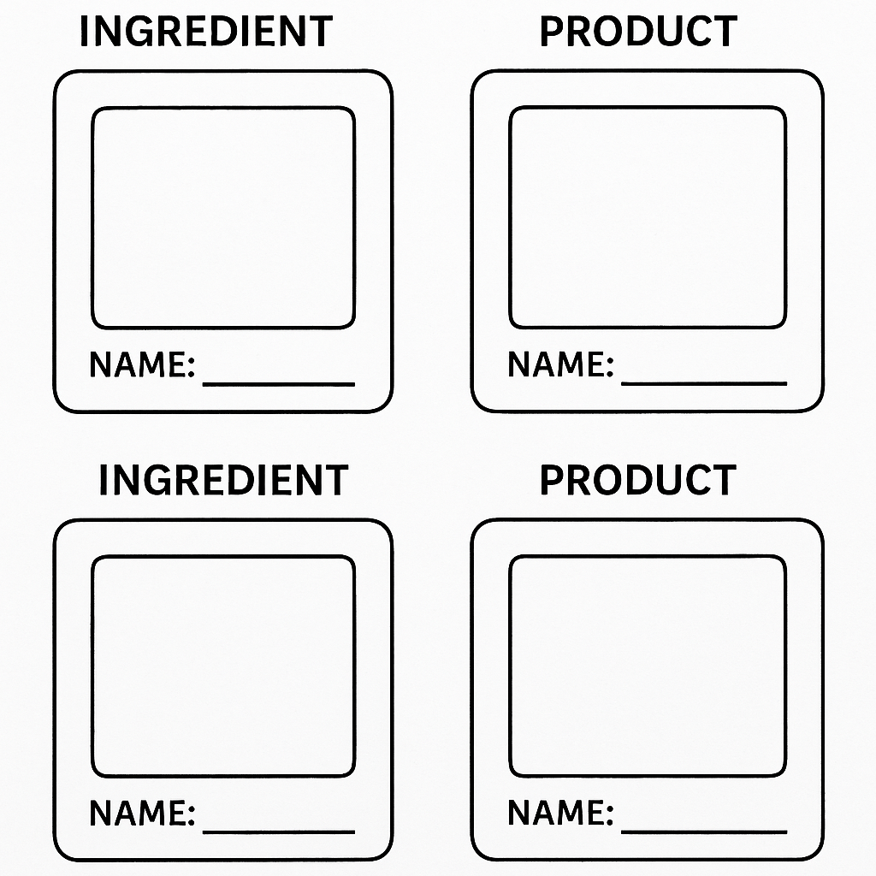

Annex 3
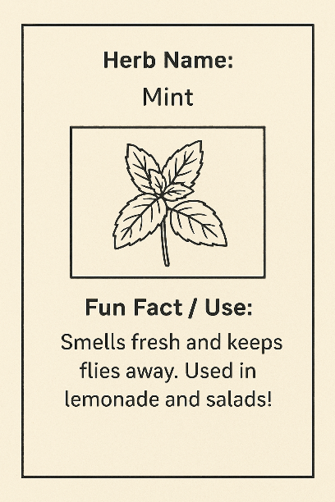

Annex 4
This annex provides printable tools and planning templates to help agritourism workers set up a 'Little Agripreneurs' mini-market simulation. The activity allows children to role-play as farm product sellers, learning basic entrepreneurial skills in a fun, tourism-related setting.
1. Sample Product Cards (Print and Cut)
Use these sample cards or create your own with farm-specific products. Print on thick paper or laminate for reuse.
Product Name Price
Mini Jar of Honey €2.00
Herbal Soap €1.50
Bread Roll €1.00
Lavender Sachet €1.20
Fresh Egg €0.50
Olive Oil Bottle (100ml) €2.50
2. Blank Branding Card Template
Children can create a logo or design label for their farm stand. Encourage creativity and local inspiration.
3. Price Tag Template
Use these price tag templates to attach to each item. Write the product and price clearly.
[ Product: __________ ] [ Price: _____ ]
[ Product: __________ ] [ Price: _____ ]
[ Product: __________ ] [ Price: _____ ]
4. Sample Play Money / Tokens
Cut these tokens for children to use during the simulation.
1 Token 2 Tokens 5 Tokens 10 Tokens
5. Implementation Planning Sheet
Use the following questions to help plan your farm stand activity:
- Which products will you simulate selling?
- Where will you set up the mini-market? (e.g., picnic area, garden corner)
- How will you explain prices and sustainability to children?
- What roles will children play (e.g., buyer, seller, helper)?
- What local story or theme could make it more immersive?

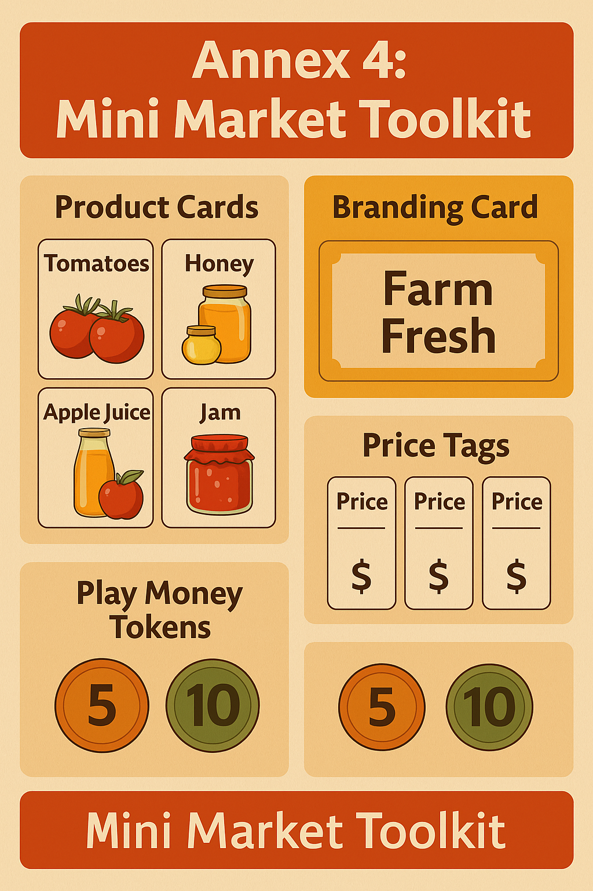

Annex 5
This annex supports the 'Agritourism Detective – The Farm Sorting Challenge' activity. It includes zone sorting labels, sample item ideas, and a planning sheet to customize the experience for your own farm site.
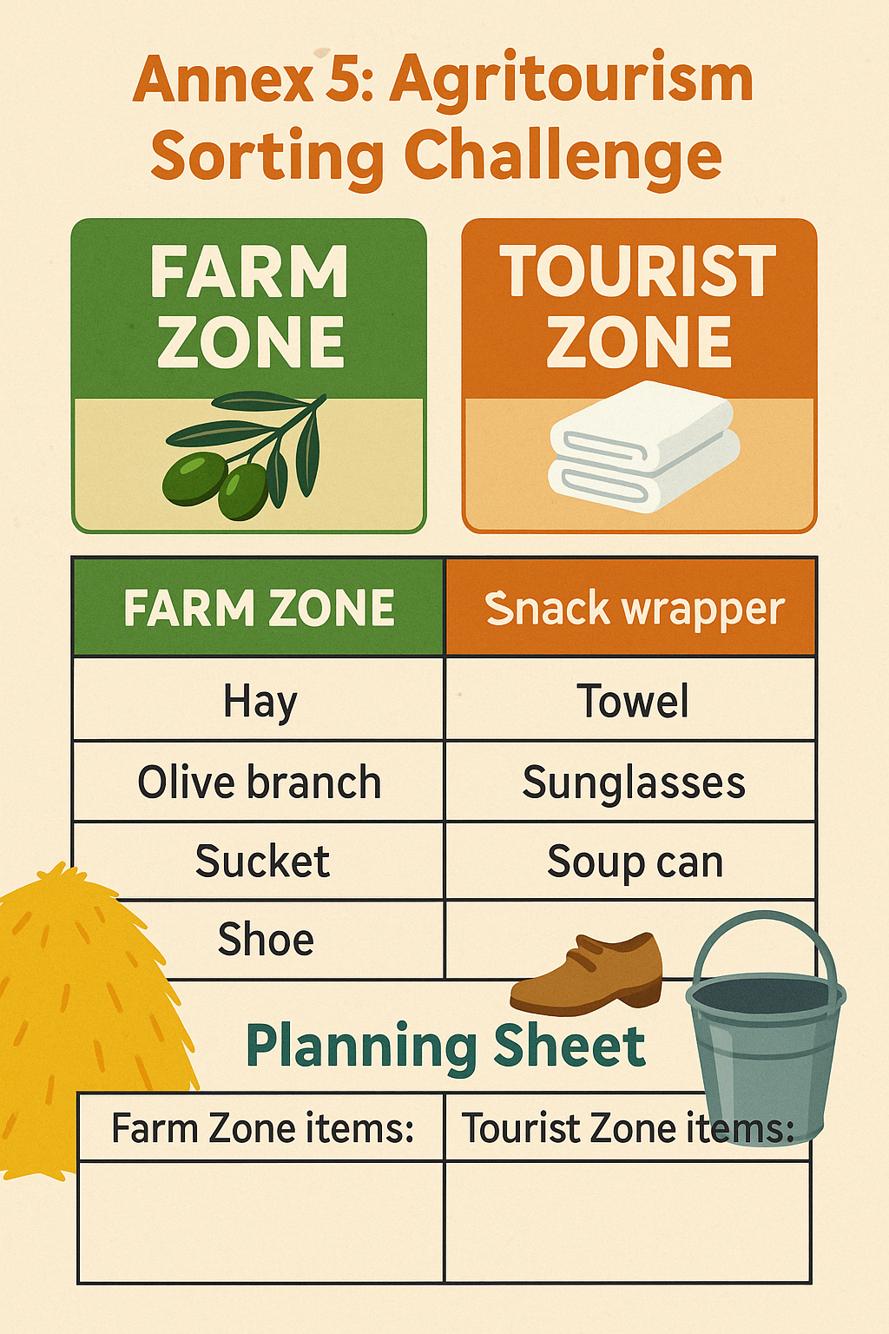

3. Planning Sheet
Use this section to plan how you'll adapt the sorting challenge to your farm’s agritourism setting.
- Which items will you include for sorting? (List 3–4 for each zone)
- Where will the activity take place? (e.g., near picnic area, barn, garden path)
- What story or role-play element will you include? (e.g., detective hats, scenario cards)
- How will you explain the purpose of sorting to children?
- What sustainability message do you want them to remember?

Annex 6
1. Printable Energy Role Cards
Each of these cards represents a stage in the energy flow from the sun through natural and human systems. You can print and cut them, and optionally laminate for reuse.
Role | Description
Sun | Starts the energy cycle. Shines light and provides warmth.
Plant | Uses sunlight to grow. Converts solar energy into food.
Animal | Eats plants. Transfers energy up the food chain.
Human | Uses energy to grow food, work, and live.
Solar Panel | Captures sunlight to create clean electricity.
Compost (optional) | Decomposes organic matter and returns nutrients to the soil.

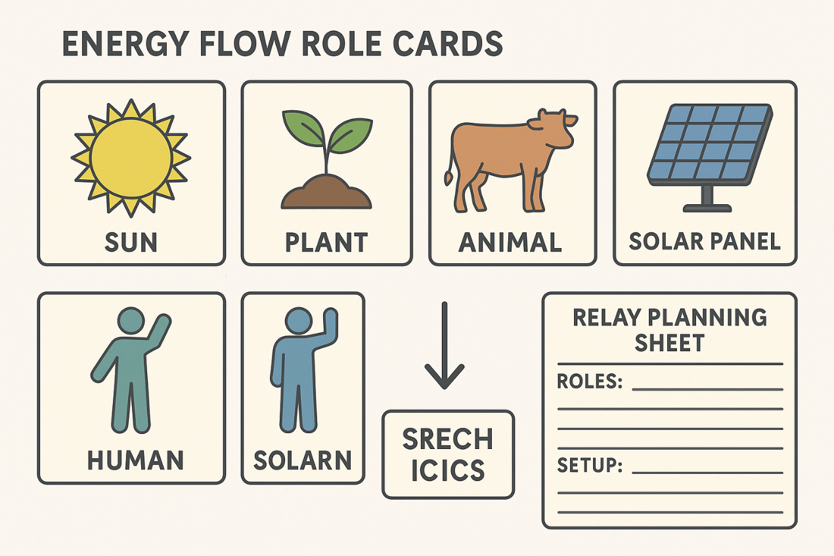
2. Agritourism Worker Planning Sheet
Use this sheet to plan how you’ll deliver the “Sun Power Relay” game on your farm. Tailor the experience to your specific environment and the age group of visiting children.
A. Which roles will you include in your version of the game? (Tick or circle your choices)
Sun
Plant
Animal
Human
Solar Panel
Compost
B. Where will you set up the game on your farm? (e.g., orchard path, courtyard, grassy area)

C. What instructions will you give to children at the beginning of the game? (Example: “We will act like the sun and plants to learn how energy moves through nature.”)

3. Child Reflection Prompts
After completing the game, ask children 1–2 of the following questions to help them think about what they learned:
What would happen if the sun didn’t shine?
Why do plants need the sun?
Can humans grow food without the help of the sun?
What happens when we use too much energy?
How do solar panels help us use energy more sustainably?
What role do animals or compost play in nature’s energy cycle?

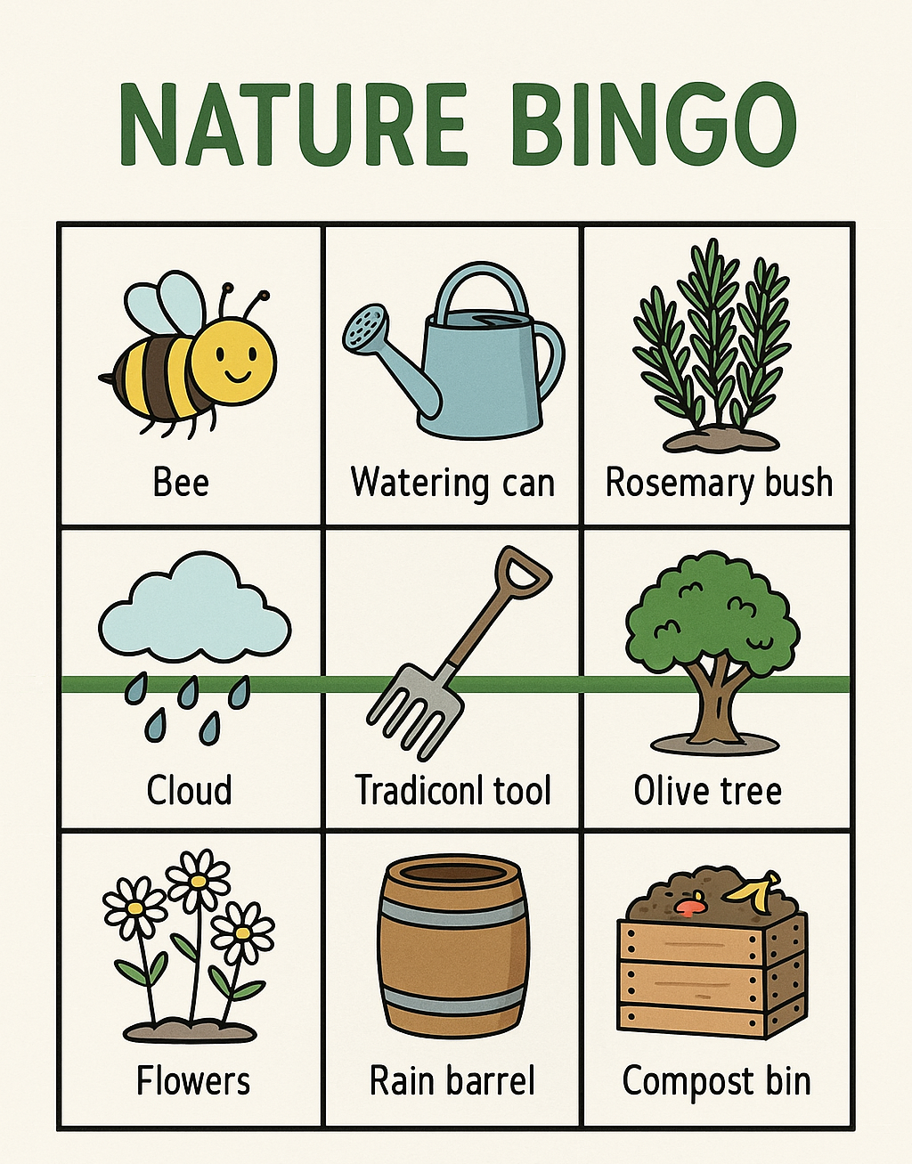
Annex 7

Annex 8
1. What are Eco-Instruments?
Eco-instruments are simple musical instruments made from natural or reused materials found on farms or in rural settings. They offer a fun and creative way for children to explore sound, sustainability, and the value of recycling.
2. How to Make Simple Eco-Instruments
1. Seed Shaker
Materials: Small plastic bottle or container, dried seeds or beans, tape or glue.
Instructions: Fill the container with seeds. Seal tightly. Children can decorate the bottle with paper or fabric.
What it teaches: Reuse, sound, natural materials.
2. Tin Can Drum
Materials: Clean empty can (no sharp edges), balloon or fabric, rubber band or tape.
Instructions: Stretch the balloon over the open end of the can. Secure with a rubber band. Tap gently to create drum sounds.
What it teaches: Repurposing, rhythm, coordination.
3. Stick Chimes
Materials: Small sticks, string, a hanger or branch.
Instructions: Tie the sticks with string and hang them from a branch or hanger. Let them clink together in the wind.
What it teaches: Nature’s sounds, balance, wind energy.
4. Bottle Cap Tambourine
Materials: Bottle caps, strong cardboard or wood ring, wire or string.
Instructions: Punch holes in the bottle caps. Attach them to the ring using wire or string so they jingle when shaken.
What it teaches: Recycling metal, rhythm, crafting.
3. Safety Tips for Working with Children
- Always check for sharp edges or breakable materials.
- Supervise use of scissors, wire, or tape.
- Keep small items (e.g., seeds, caps) away from very young children.
- Offer pre-cut or prepared versions of some materials for safety.

Annex 9
This annex supports the VET training of agritourism workers in designing a child-led educational walk focused on water-saving practices across tourist areas of the farm. The materials include sample walk cards for use with children and a planning worksheet to help workers implement the activity during family visits or school group tours.
1. Guidance for Agritourism Workers
As part of your agritourism offer, you can organize a fun 'Water Watchers' walk where children act as Eco-Guides and introduce guests to sustainable water practices used around the farm. Use the cards below to guide their observations and create a playful tour route through your accommodation area, kitchen garden, or picnic zones.
2. Printable Guest Water Walk Cards
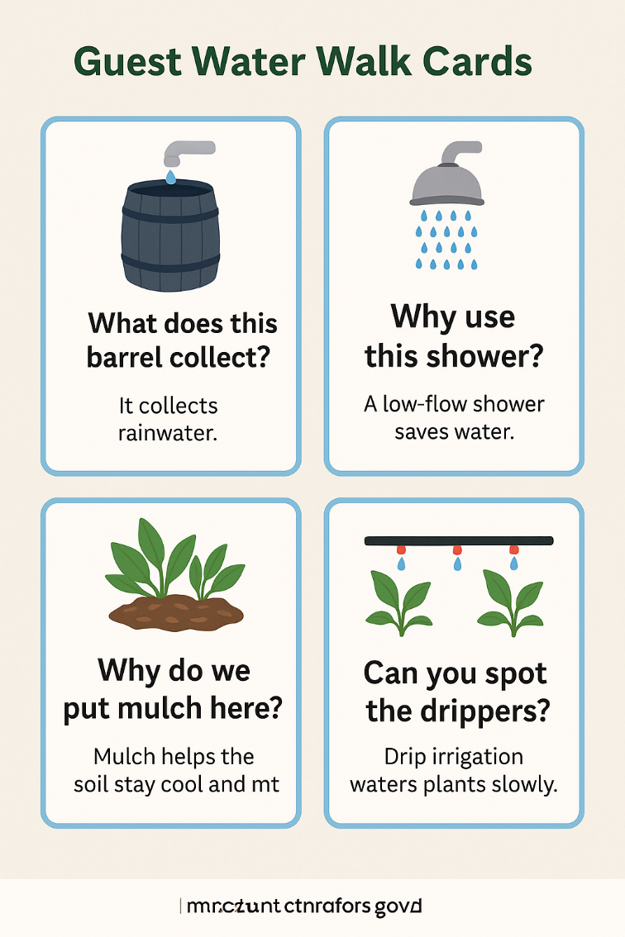

3. Tour Planning Sheet
Use this worksheet to design your own guest-area water walk for children.
- What 2–3 tourist locations on your farm will children explore (e.g., eco-room, kitchen garden, refill station)?
- What water-saving features will they see and explain?
- What guiding questions or short explanations will children use during the walk?
- Where will the tour start and end? Will there be signs or props along the route?
- How will you introduce this activity to families or school groups?

Annex 10
This annex supports the VET training activity 'Compost Champions – Farm Café Edition'. It includes printable sorting cards and a planning sheet to help agritourism workers design a fun composting simulation for children visiting farm cafés or picnic areas.
1. Printable Compost Sorting Cards
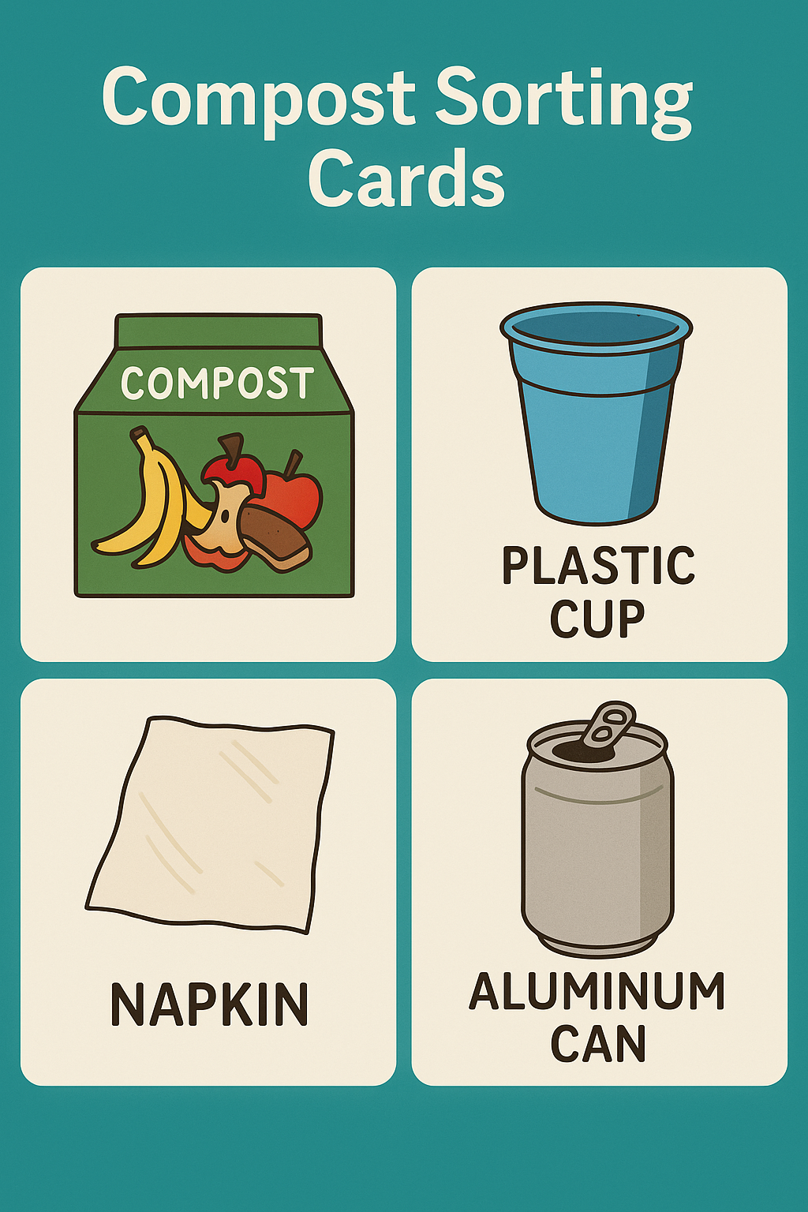
Cut out and laminate the cards below. Children can sort them into compost, plastic, or general waste bins during the activity.

2. Compost Game Planning Sheet
Agritourism workers can use this sheet to plan a compost sorting activity in tourist-facing food areas.
- What food items are typically served or consumed by tourists at your farm café or picnic area?
- Which of these items are compostable, recyclable, or general waste?
- Where will you host the composting simulation (e.g., picnic table, outdoor kitchen corner)?
- How will children interact with the materials (e.g., tray cleanup, scavenger game, sorting race)?
- What story or imaginative element can you add (e.g., Compost Heroes, Zero Waste Wizards)?

Annex 11
1. Example: Tomato Snack Journey
Seed – A tomato seed is planted in the soil.
Growth – The plant grows with sunlight and water.
Harvest – Ripe tomatoes are picked from the plant.
Wash & Prepare – Tomatoes are cleaned and prepared.
Snack – Served as part of a salad or snack plate.
2. Your Own Seed-to-Snack Journey
Use this space to plan a food journey based on something grown or prepared at your agritourism site.
Product (e.g., apple, wheat, olive): _________________________
Step 1 (Seed/Start): ________________________________________
Step 2 (Growth): __________________________________________
Step 3 (Harvest): __________________________________________
Step 4 (Prepare/Process): ___________________________________
Step 5 (Final Snack): _______________________________________
Optional Activity with Children (e.g., tasting, story, drawing): __________________

Annex 12
1. Sample Trail Icons / Legend
Use these visual icons or labels for marking key stops along your discovery trail.
- Guesthouse / Farm Stay
- Goat or Animal Barn
- Herb or Vegetable Garden
- Olive Tree Grove
- Campfire or Picnic Spot
- Rainwater Collection Area
- Compost or Eco Station
- Workshop or Craft Area
- Trail Start / Explorer’s Station
2. Discovery Trail Prompts for Children
Post these questions or riddles at each stop. Children can check them off on a map or collect stamps after answering.
- What smells like pizza but grows in the garden? (Basil)
- Which tree gives us oil for cooking and soap? (Olive)
- What animal gives us milk for cheese here? (Goat)
- What lives in the compost bin and eats leftovers? (Worm)
- Can you find something made by hand in this area?
- Where do we collect water from the sky? (Rain barrel)
3. Trail Planning Sheet
Use this sheet to plan your own discovery trail with child-focused activities and educational content.
- What are 4–6 safe and interesting places children can visit on your farm?
- What question, riddle, or task will you place at each stop?
- How will children track their progress (e.g., checklist, stamp card, photo)?
- What materials will you need to set up signs and waypoints?
- How will you introduce the trail to families or school groups?

Annex 13
This annex supports the VET training activity 'Taste Trek – From Farm to Tourist Table'. It provides printable tasting cards for children and a planning sheet to help agritourism workers create engaging tasting experiences using local farm products.
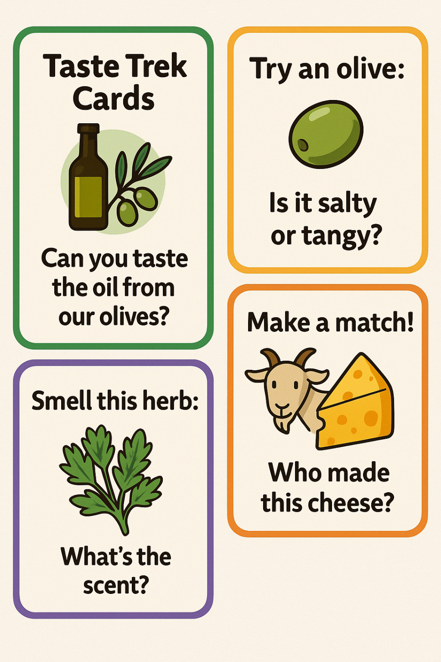
1. Taste Trek Cards for Children

2. Tasting Station Setup Planning Sheet
Agritourism workers can use this sheet to design their child-friendly tasting activity.
- What 3–5 local farm products will you include in your tasting station?
- What short story or fact will you tell about each product?
- Will children taste, smell, or guess? How will they interact with the product?
- Where will the tasting take place (e.g., outdoor kitchen, picnic table, farm shop)?
- Will you offer a reward (e.g., taste passport stamp) or collect feedback from children?

Annex 14
1. Room Designer Cards (Printable)
Cut out and use these cards to spark ideas during the activity. Children can pick or be assigned a card to include in their design.
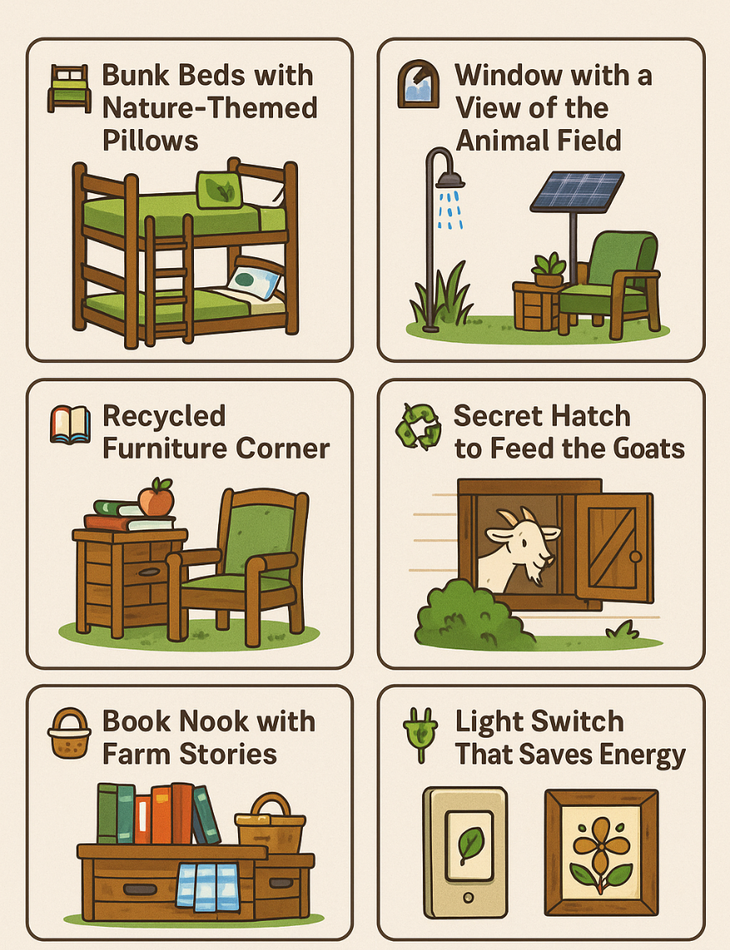

2. Activity Setup Planning Sheet
Use the following prompts to plan your children's room design activity.
- What materials will children use (drawing tools, recycled craft items, building blocks)?
- How will you introduce the activity and give kids their 'design mission'?
- Will they design alone, in pairs, or groups?
- What kind of features will you encourage (eco-elements, animal links, fun ideas)?
- How will children present or display their room (mini-presentation, story, exhibition)?

Annex 15
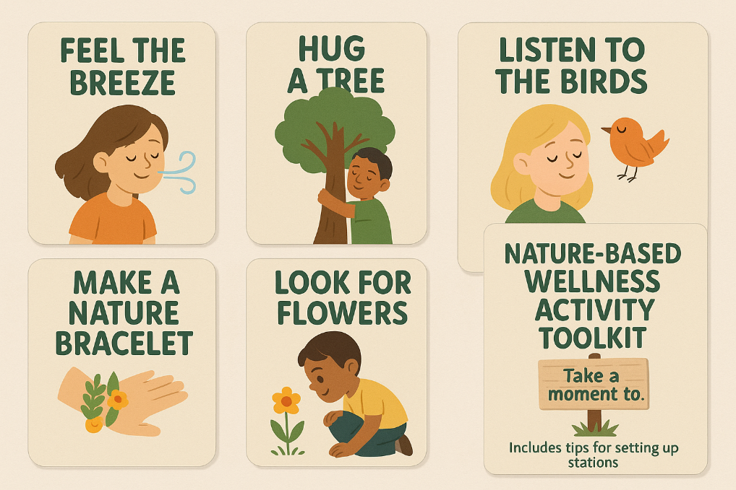

Annex 16
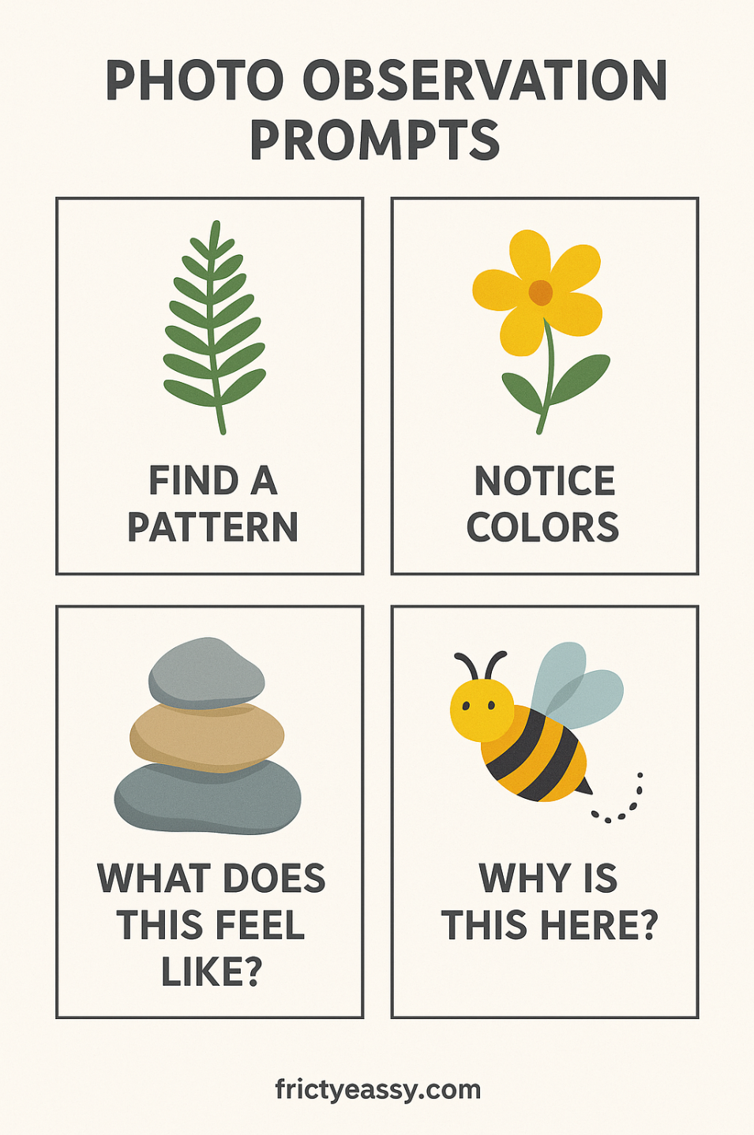

Annex 17
1. Local Food Map Template
Use the blank farm or village map outline to guide children in placing local food items where they might grow or be found. This can include fields, orchards, gardens, kitchens, or markets.
Encourage questions such as:
- Where do tomatoes grow on this map?
- Which foods grow under the ground?
- What dish do we make from this food?
2. Printable Food Icons
You can print and cut out the following illustrated food icons for children to place on the map:
Tomato
- Olive
- Cheese
- Grapes
- Herbs
- Bread
- Honey
- Lettuce
You may also add real-life items for show-and-tell, or ask children to draw their own version of these foods if no printer is available.
3. Adaptation for Younger Children
Younger children can use a simplified version where they color food icons and draw lines to match them with where they grow on the map.
For example: Match the honey pot to the beehive in the orchard area.

Annex 18
Story stones are a hands-on, creative tool used to spark imagination, storytelling, and learning in children. In agritourism settings, they are ideal for introducing rural traditions, local nature, and farm life through guided storytelling. This guide includes practical instructions, thematic tips, and ideas for adapting the activity to different settings and age groups.
1. What Are Story Stones?
Story stones are smooth pebbles or rocks onto which images or symbols are painted or drawn. Each image represents an element of a story, such as a character, object, place, or natural event. Children can draw stones randomly and use them to co-create a story, either individually or as a group. In agritourism, these symbols reflect rural life: farm animals, weather events, foods, and landscapes.
2. Suggested Story Symbols and Prompts
- Sheep – A tale from the pasture: What adventure did the sheep have?
- Rain cloud – A storm changes the day: What did the farmer or child do when it rained?
- Olive tree – A tree that has lived for generations: What stories could the tree tell?
- Tractor – An early morning harvest begins: Who is driving it and where are they going?
- Jam jar – Something sweet is made at the farm: What fruit was used to make the jam?
- Herb leaf – Someone discovers a special scent: What memory does the smell remind them of?
- Rooster – The day begins with a loud call: What happens next on the farm?
- Footprints – Who passed by this trail?: Were they a person, an animal, or something magical?
- Picnic basket – A family shares a meal in the field: What foods are inside?
- Bee – A lesson from the garden: What is the bee trying to teach us?
3. How to Create Story Stones or Cards
- Find medium-sized smooth stones and clean them thoroughly.
- Use acrylic paint or permanent markers to draw the selected symbols on each stone.
- Allow the paint to dry completely. Apply a clear sealant (optional) for durability.
- Alternatively, print small symbol images and glue them onto cardboard or thick paper as story cards.
4. How to Use Story Stones with Children
- Place stones or cards in a cloth bag or box.
- Children draw one stone at a time and add to the story using the symbol as inspiration.
- Encourage descriptive language and emotional expression.
- You can set a theme (e.g., harvest, animal adventure, a rainy day).
- Use in small groups for cooperative storytelling, or individually for journaling or drawing prompts.
5. Educational Value and Inclusion
This activity supports:
- Language development and creativity
- Environmental awareness through local nature symbols
- Emotional learning and expression
- Cultural transmission of rural knowledge and identity
It can be adapted for children of different ages, and used with children with diverse communication or literacy needs.

Annex 19
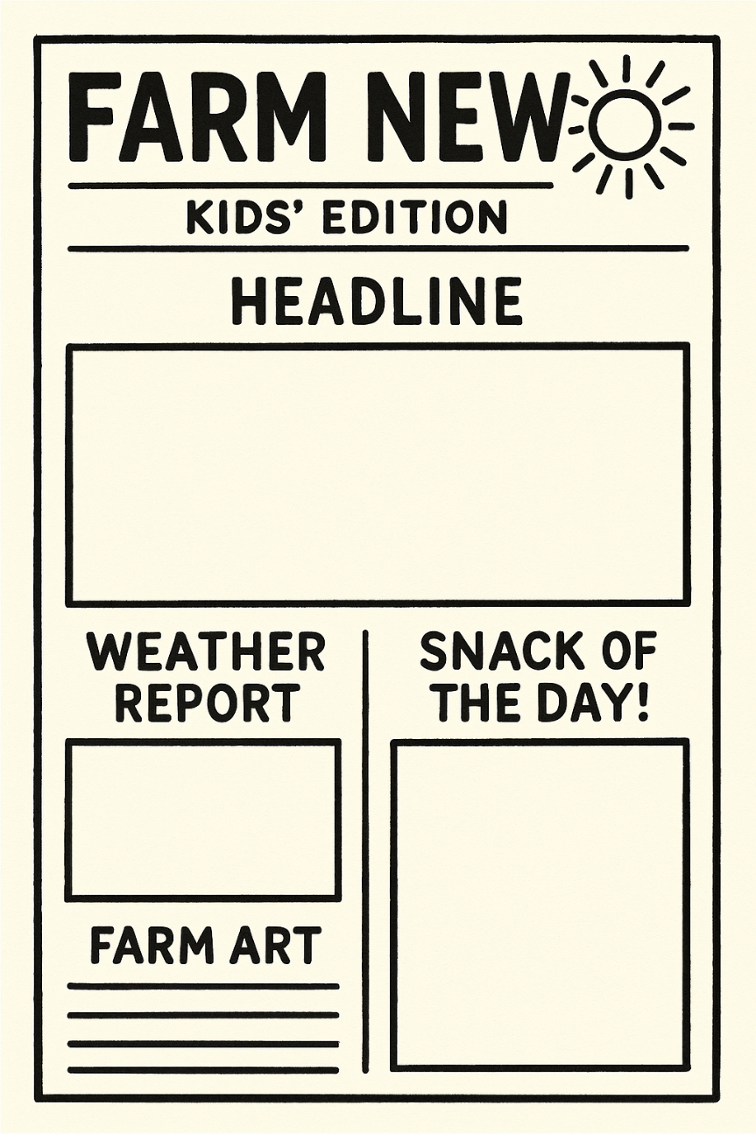
1. Sample Newspaper Sections

2. Activity Setup Planning Sheet
Use this worksheet to organize and deliver the newspaper-making activity for children.
- What age group are you targeting?
- How will children collect information (observation, short interviews, drawings)?
- Will they work individually or as a team (e.g., editor, reporter, artist)?
- How will you organize the activity space (tables, materials, quiet writing area)?
- How will you display or share the final newspaper (digital board, handouts, parent exhibition)?

Annex 20
This annex provides templates and setup guidance for implementing the 'Green Pledge Tree' activity. Children can write or draw personal environmental commitments on paper leaves, which are then hung or displayed on a symbolic tree. This helps reinforce collective action, individual responsibility, and a shared connection with nature.
1. Printable Leaf Templates
Use the templates below for children to write or draw their eco-pledges. Leaves can be printed on green paper or decorated with crayons or markers. Younger children can color the leaves or use stickers.
Sample prompts to print on or place next to the leaf station:
- I promise to...
- I will protect...
- I feel happy when I see...
- This is my green dream:
- I want to learn more about...
2. Setup Instructions
- Choose a display spot: tree branch in a pot, fence area, large board, or wall near entrance.
- Prepare the area with string, clothespins, or clips where leaves can be easily hung or attached.
- Print and cut out pledge leaves before the activity. Have extra blank leaves for creativity.
- Provide crayons, pens, stickers, and decorative supplies nearby.
- If the weather is good, allow children to place their leaves outdoors. Otherwise, create an indoor 'tree' from a drawn trunk or branches glued to a board.
3. Optional Variations
- Create seasonal versions (e.g., a snowflake wall in winter, flower circle in spring).
- Invite families or teachers to add their own leaves.
- Use the pledges to start a discussion circle about eco-action at home and school.

Annex 21
Card Drawn | Team’s Rating (1–3) | Official Score | Correct?  (✓/✗) | Notes / Justification
Example: Bottled Water | 1 | 3 | ✗ | Plastic pollution risk

Annex 22
 Green Choices
Offer tap water in reusable glass jugs | Serve breakfast with local seasonal fruit | Provide recycling bins in guest rooms
Use cloth napkins instead of disposable ones | Offer farm tours that  include eco- education | Compost kitchen waste
Use energy-efficient lighting | Encourage bike rentals for local exploration | Replace mini shampoo bottles with refillable  dispensers
Print menus on recycled paper | Source cheese and dairy from local  farms | Grow herbs for cooking on-site
Offer vegetarian options daily | Reuse greywater for irrigation | Train staff to explain  eco-practices to visitors

 Less Green Choices
Provide plastic water bottles to every guest | Print menus in color on glossy paper | Source cheese from distant imports
Import fruit out of season | Use single-use toiletries | Buy all herbs from supermarkets
Offer no recycling facilities | Promote car rentals only | Serve only meat- based dishes
Use disposable plastic cutlery | Use incandescent bulbs | Waste water in decorative fountains
Run farm tours without mentioning sustainability | Throw away all food waste | Avoid discussing eco- practices with visitors

Annex 23
 | Scenario 1: The Breakfast Buffet You manage a small eco-hotel. Guests expect variety, but much food ends up wasted. Options:  - Offer a full buffet with imported fruit and packaged items.  - Reduce variety, focusing on local seasonal products and smaller portions.  - Give guests a choice to pre-order meals the night before. | Scenario 2: The Farm Wedding A couple requests a wedding banquet at your agritourism farm. Options:  - Cater with imported delicacies to impress.  - Offer a local, seasonal menu showcasing farm produce.  - Mix both, but ensure leftovers are composted or donated.
Scenario 3: The Guest Toiletries  You run a countryside guesthouse. Guests ask for free toiletries. Options:  - Provide mini plastic bottles for each guest.  - Install refillable dispensers with eco- friendly soap.  - Offer no toiletries, suggesting guests bring their own. |  | Scenario 4: The Farm Tour Transport  You organize farm tours for tourists. Options:  - Use a small diesel bus to carry everyone.  - Encourage walking or cycling tours.  - Use an electric minivan but limit the number of tours.

Annex 24
Hotel Manager | Chef
Visitor/Guest | Local Farmer
Sustainability Officer

Annex 25
Green Hospitality Dilemma – Adaptation Plan
- Which dilemma did your group solve?
- What solution did you choose and why?
- How would you adapt this game for your own learners/customers?
- Which sustainability theme was most important today?

Annex 26
ROLE | Brief
Hotel Manager | Wants to attract eco-conscious guests but is concerned about costs.
Local Farmer | Wants to sell produce locally, needs fair prices
Guest | Wants comfort and convenience; not willing to sacrifice too much.
Sustainability Officer | Focused on maximizing eco-impact, even if costs rise.
Local Authority | Wants tourism growth but within environmental regulations.

Annex 27
Sample Story Prompts
“On our farm, we discovered a way to reduce waste by…”
“The guests at our eco-hotel were surprised to find that…”
“One morning, the village decided to change how they used water…”
“Our chef created a dish that taught visitors about…”
“When we switched to solar panels, the guests reacted by…”

Sample Twist Prompts
“But then a tourist asked, Why should I care about this?”
“A storm destroyed part of the garden — what did you do?”
“The children on the farm tour became bored. How did you re-engage them?”
“A competitor started offering unsustainable but cheaper options — how did you respond?”

Annex 28
Sample Menu Item Slips
  - Local seasonal vegetable soup
  - Imported strawberries in winter
  - Farm-made goat cheese salad
  - Beef steak with imported sauce
  - Solar-oven baked bread
  - Ice cream from local dairy
  - Vegan lentil stew
  - Bottled mineral water
  - Tap water in glass pitchers

Annex 29
Category 1: Easy (General Awareness)
(Designed for customers/visitors or younger learners)
- What color is most often associated with eco-friendly practices?
- True or False: Recycling reduces the need for new raw materials.
- Which is more sustainable: a reusable glass bottle or a single-use plastic bottle?
- What does “seasonal food” mean?
- Name one benefit of staying in a local farm guesthouse instead of a large hotel chain.
- Which uses less energy: turning off lights when leaving a room, or leaving them on?
- What symbol is commonly used for eco-friendly tourism? (Leaf, Tree, Globe)
- True or False: Composting can help reduce the amount of waste sent to landfills.
- Which is better for the environment: cycling to a farm or driving a car?
- What does the “Reduce, Reuse, Recycle” slogan encourage us to do first?
Category 2: Medium (Hospitality & Agritourism Focused)
(Designed for VET learners and agritourism workers)
- What is the main benefit of a “farm-to-table” restaurant?
- Which is more eco-friendly: serving bottled imported water or filtered tap water?
- Name two sustainable alternatives to single-use toiletries in hotels.
- Which energy source is renewable: coal, solar, or natural gas?
- Why is offering vegetarian or vegan options more sustainable than only meat dishes?
- True or False: Locally produced cheese usually has a lower carbon footprint than imported cheese.
- Which farming method protects biodiversity better: monoculture or crop rotation?
- What simple change in a hotel can save the most water: shorter showers, towel reuse, or new carpets?
- Why are electric minibuses or bicycles better for farm tours than diesel buses?
- Name one EU label or certification for eco-friendly hospitality services.
Category 3: Advanced (Trainer & Expert Level)
(Designed for VET trainers or advanced learners)
- What is the approximate percentage of food waste generated by the hospitality sector in the EU each year? (A: Around 12–15%)
- Define “greywater” and give one way it can be reused.
- What is a carbon footprint, and how can agritourism reduce it?
- Explain the environmental impact of importing out-of-season fruits compared to local seasonal produce.
- What is the EU’s Green Deal objective for climate neutrality? (A: Net zero emissions by 2050)
- Which uses more water: producing 1kg of beef or 1kg of lentils?
- Why is renewable energy installation in agritourism both an ecological and a marketing advantage?
- What is biodiversity, and why is it important for sustainable tourism?
- Give one example of circular economy practice in agritourism.
- Explain why eco-labeling (on menus or services) helps customers make better choices.

Annex 30
Scenario Slips
Vineyard Farm: Guests expect wine tasting and a sustainability lesson.
Dairy Farm: Families want cheese tasting and a tour of milking.
Eco-Lodge: Families staying overnight seek fun and eco-education.
Herb Farm: Visitors are interested in herbal teas and wellness.

Twist Cards
A storm damages part of the farm — adapt your activities.
Double the number of visitors arrive unexpectedly.
Half the planned menu items are unavailable.
Guests demand more entertainment than expected.

Annex 31
Eco-Action | Cost (Eco-Coins) | Benefit
Solar panels | 40 | Energy savings & eco-marketing
Composting system | 20 | Waste reduction, education
Bike rentals | 30 | Low-carbon guest transport
Local produce sourcing | 25 | Supports local economy
Eco-cleaning products | 15 | Cuts chemical pollution
Eco-awareness workshops | 20 | Visitor education
LED lighting | 10 | Quick energy savings

Annex 32
Clue Sheet 1 – Match the Practice to the Benefit
- Composting Cuts CO₂ emissions
- LED lighting Reduces food miles
- Bike rentals Reduces landfill waste
- Local produce Saves energy
Clue Sheet 2 – Unscramble the Words
- NERWABEEL
- YNEGRE
- OMCPOST
- ERUOT
Clue Sheet 3 – Final Riddle
“I save you money and the planet, I’m invisible but always there.
Without me, bills would rise. What am I?”
Answers
Clue Sheet 1 – Match the Practice to the Benefit
- Composting → Reduces landfill waste
- LED lighting → Saves energy
- Bike rentals → Cuts CO₂ emissions
- Local produce → Reduces food miles
Clue Sheet 2 – Unscramble the Words
- NERWABEEL → RENEWABLE
- YNEGRE → ENERGY
- OMCPOST → COMPOST
- ERUOT → TOUR
Clue Sheet 3 – Final Riddle
“I save you money and the planet, I’m invisible but always there.
Without me, bills would rise. What am I?”
→ Energy efficiency

Annex 33
Pitch Prompt Cards
Convince tourists to try your vegetarian farm-to-table dish.
Persuade guests to use bicycles instead of cars for farm tours.
Promote a stay in your eco-lodge powered by solar panels.
Encourage customers to attend your composting workshop.
Present your new refillable toiletry program to eco- conscious guests.

Annex 34
Role Cards (Staff)
Farmer offering seasonal tastings
Waiter promoting vegetarian options
Eco-guide explaining solar-powered facilities
Hotel receptionist explaining towel reuse policy

Guest Question Cards
“Why should I eat vegetarian if I want meat?” | “Is your tap water safe to drink?”
“Why don’t you give us free plastic bottles?” | “What makes your farm eco- friendly compared to others?”

Annex 35
Sample Jigsaw Pieces
Pieces must be cut and participants must tape them together in pairs.
Actions
Composting | LED Lighting | Bike Rentals | Local Produce
Vegetarian Menu | Solar Panels | Towel Reuse | Eco-Cleaning Products

Benefits
Less landfill waste | Energy savings | Lower carbon emissions | Lower water use
Reduced food miles | Renewable energy | Guest awareness | Cleaner environment

Annex 36
Sample Scavenger Hunt Clue Cards
Find a place where waste is reduced.
Find evidence of renewable energy use.
Find a way guests are encouraged to save water.
Find a local product on offer.
Find something that reduces plastic use.
Find an educational sign about nature or sustainability.

Score Sheet Template
Clue | Answer/Evidence | Points Awarded
Example: Waste reduction | Compost bin near kitchen | ✓

Annex 37
Heavy rain floods your eco- farm right before a large visitor group arrives. | Your eco-lodge runs out of local produce for tonight’s dinner.
A group of guests complains about the lack of bottled water. | Power outage hits your farm during an eco-event.
A bus of unexpected visitors arrives with no reservation.

Annex 38
Eco-Action Cards
Composting | Less landfill waste
LED lighting | Lower energy use
Bike rentals | Fewer car trips
Local produce | Lower food miles
Vegetarian menu | Less CO₂ emissions
Solar panels | Renewable energy source
Towel reuse policy | Less water used
Eco-cleaning products | Less chemical waste

Gap Cards
Reduced plastic waste
Increased biodiversity
Guest eco-awareness
Answers
Eco-Action Cards
Composting → Less landfill waste LED lighting → Lower energy use Bike rentals → Fewer car trips Local produce → Lower food miles
Vegetarian menu → Less CO₂ emissions Solar panels → Renewable energy source Towel reuse policy → Less water used
Eco-cleaning products → Less chemical waste



Annex 39



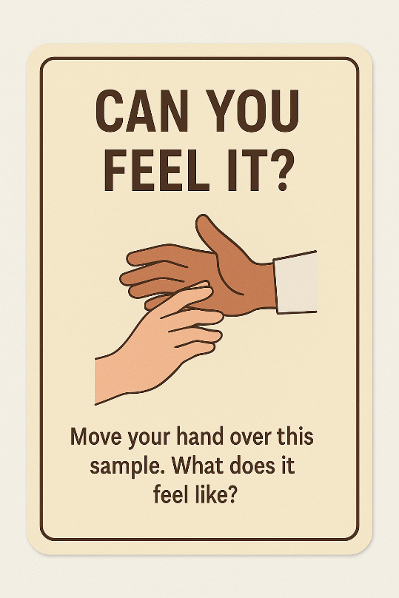
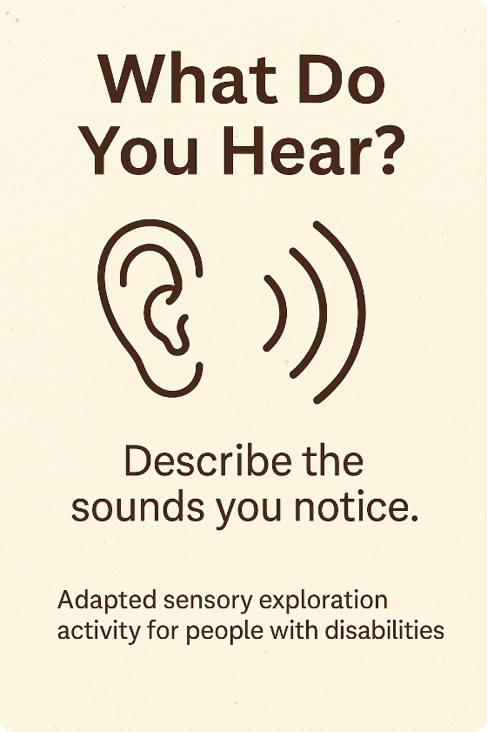

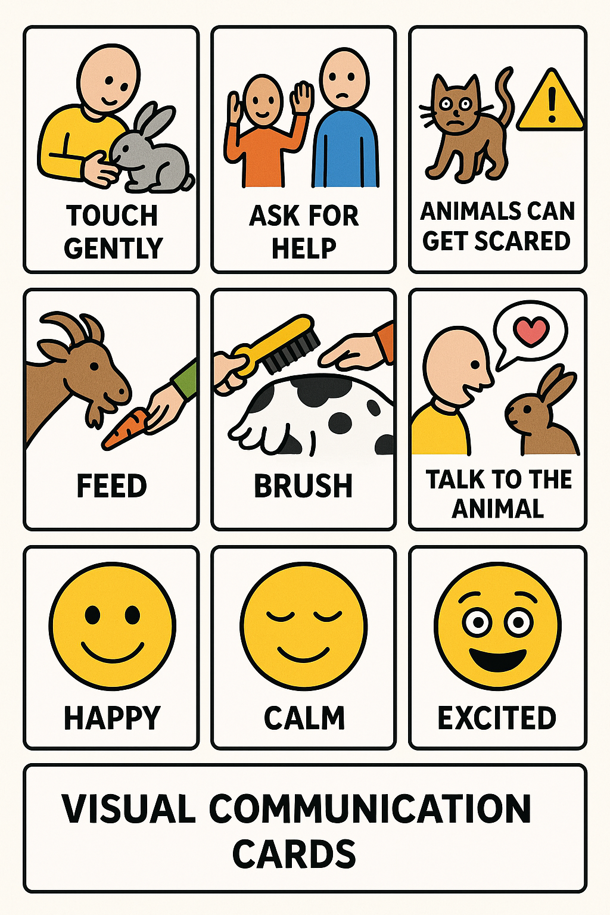
Annex 40

Annex 41
Use this planning sheet to design your own inclusive container gardening activity for individuals with disabilities. Plan how you will adapt the activity to ensure accessibility, enjoyment, and learning for all participants.
Theme or Focus of Activity
> ____________________________________________________________
Activity Planning Table
Step Planned Actions Time Resources Needed
Step 1
Step 2
Step 3
Step 4
Step 5
Accessibility Adaptations
List how you will adapt tools, materials, and instructions for participants with different needs:
> ____________________________________________________________
> ____________________________________________________________
Sustainability Considerations
List ways you will use sustainable materials or methods:
> ____________________________________________________________
> ____________________________________________________________
Implementation Plan
Location: ________________________________________
Season: _________________________________________
Required Materials: ______________________________
Potential Partners (e.g., local gardeners, suppliers): __________________

Annex 42
Sample Craft Ideas
- Nature Collage Boards
- Pinecone Bird Feeders
- Pressed Flower Bookmarks
- Painted Rock Farm Animals
Adaptive Art Tools Vendors & Resources
- Adaptive Art Tools – FlagHouse
  - Wide selection of art tools for individuals with physical and cognitive disabilities.
  - Link: https://www.flaghouse.com
- Art Supplies – Therapy Shoppe
  - Offers sensory-friendly and adaptive art supplies (grip brushes, loop scissors, etc.).
  - Link: https://www.therapyshoppe.com
- Adaptive Scissors and Art Tools – Special Supplies
  - Great for spring-loaded scissors, grip-friendly brushes, and visual timers.
  - Link: https://specialsupplies.com
- Enabling Devices – Art and Music Therapy Tools
  - Specializes in tools and gadgets for inclusive art, music, and therapy.
  - Link: https://enablingdevices.com
Printable Labels and Templates
- Canva – Free Label Templates
Provides a variety of customizable and printable label templates suitable for organizing art supplies and creating instructional materials.
Access Canva's Label Templates​avery.com+4Canva+4Teachers Pay Teachers+4
- Avery – Label Templates
Offers free downloadable templates for labels, cards, and more, compatible with Avery products and useful for creating organized and accessible craft stations.
Explore Avery's Templates​avery.com
- Teachers Pay Teachers – Art Supply Labels
Features a selection of art supply labels, including visual labels to help students and artists locate materials easily.
Find Art Supply Labels on TPT

Annex 43
Participant Reflection Sheet (Accessible)
- Visual options for how they felt (happy, tired, proud)
- Space for drawing or writing what they harvested
Example 1: Picture-Based Reflection Sheet
(Best for young children or non-verbal participants)
Title: My Harvesting Experience!
1. How did you feel today?
(Choose one or point to it)
😊 Happy 😐 Okay 😞 Tired 😲 Excited 😕 Confused
2. What did you pick today?
(Choose or circle the pictures)

🍓 Strawberry 🍅 Tomato Lettuce 🫘 Beans 🌽 Corn
3. Draw something you remember!
🖍️ (Big blank box for drawing)

4. Would you like to do it again?
👍 Yes 👎 No 😐 Maybe

✏️ Example 2: Simple Written & Symbol Support Sheet
(For participants who can read/write with some support)
Title: My Time on the Farm
- Today I felt:
☐ Happy
☐ Calm
☐ A little tired
☐ Excited
☐ Overwhelmed
- I picked:
☐ Tomatoes
☐ Lettuce
☐ Strawberries
☐ Other: ___________
- Something I liked:

- One thing that was hard:

- Next time I want to:
☐ Pick more
☐ Try something new
☐ Help my friend
☐ Just watch

🗣️ Example 3: Symbol-Supported Choice Board
(For use with AAC users or people with complex communication needs)
🌾 My Harvesting Day
🔲 I liked being outdoors
🔲 I liked touching the plants
🔲 I liked using tools
🔲 I liked being with people
🔲 I want to do this again!
Choose your favorite part:
🖼️ (Include visual symbols/photos for)
- Picking
- Holding basket
- Seeing animals
- Talking with helper
- Sitting and resting

Annex 44
Purpose of this sheet:
This planning sheet will help you design a bug hotel activity for your agritourism site that attracts pollinators, supports biodiversity, and engages visitors in a fun and educational way.
Bug Hotel Steps – Checklist
Choose a safe location – sheltered from wind, close to plants and flowers.
- Select a structure – small wooden crate or frame.
- Fill with varied habitats – bamboo for bees, pinecones for ladybirds, straw for beetles, clay for solitary wasps.
- Secure materials – ensure all items are stable and weather-resistant.
- Add signage – explain the purpose to visitors and share interesting facts.
Your Plan
1. Location for Bug Hotel:

2. Materials to Use (preferably local/recycled):

3. Visitor Engagement Ideas:

4. Cultural/Historical Links:

Sustainability Considerations
How will you ensure this activity uses sustainable, reusable, and local materials?

Evaluation Reflection
How will this activity:
- Create positive emotions for visitors?
- Provide educational value about biodiversity?
- Use sustainable/local materials?
- Add value to the visitor experience?

Annex 45
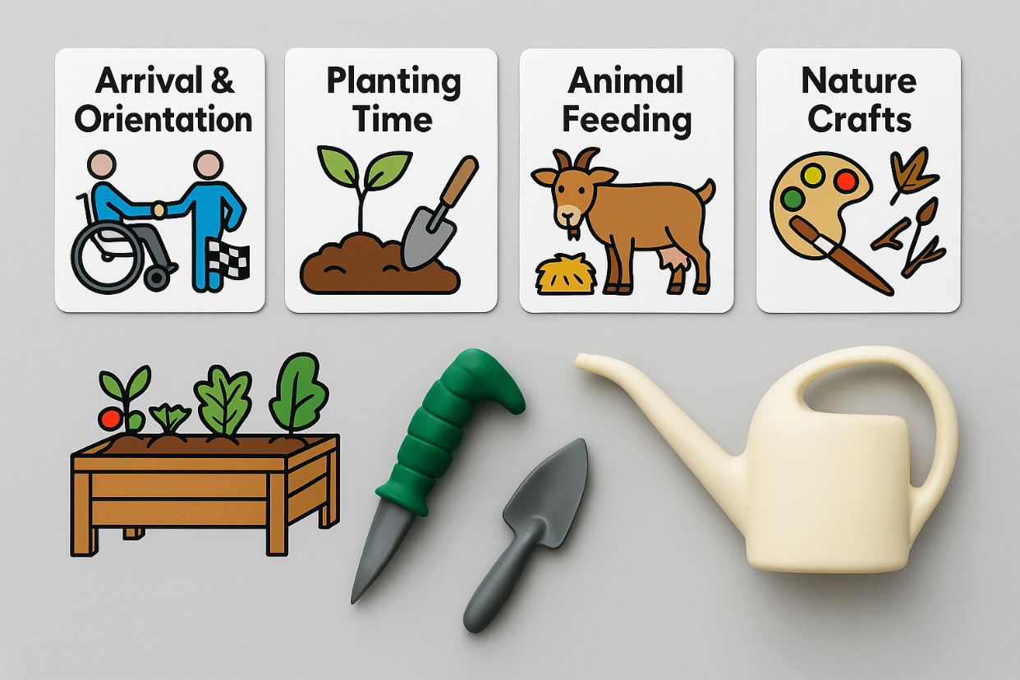

Annex 46
1. Activity Sequence for the Day:

2. Adaptations Needed (tools, seating, communication):

3. Materials Required (ready-to-use):

4. Visitor Engagement Strategies:

5. Cultural/Historical Elements to Include:

Sustainability Considerations
How will you use farm resources, local materials, or eco-friendly supplies in your activities?

Evaluation Reflection
How will this activity:
- Create positive emotions for visitors?
- Provide educational value about farming or sustainability?
- Use sustainable/local materials?
- Add value to the visitor experience?

Annex 47
Purpose:
To provide agritourism workers with clear and simple guidelines for safely and effectively running eco-crafting sessions with visitors of all abilities.
Before the Session
- Prepare all materials in advance (natural items, recycled materials, tools).
- Check adaptive tools are available for participants who need them.
- Set up tables at comfortable heights for both seated and standing participants.
- Organise materials into labelled baskets or trays for easy access.
- Display an example craft piece for inspiration.
Safety Guidelines
- Use only non-toxic glue and paints.
- Keep scissors and sharp tools supervised and provide adaptive versions where possible.
- Avoid materials that may cause allergic reactions (check with visitors beforehand).
- Ensure all walkways are clear to avoid trips or falls.
- Keep handwashing facilities or wipes available.
Inclusive Setup Tips
- Provide visual instruction cards showing each step of the craft.
- Use tactile examples for visitors with visual impairments.
- Offer a variety of materials so participants can choose by colour, texture, or scent.
- Encourage teamwork by pairing participants.
During the Activity
- Welcome visitors and explain the craft in simple steps.
- Offer assistance without taking over the participant’s work.
- Highlight the environmental and cultural value of using local and recycled materials.
- Encourage creativity—there is no “wrong” way to complete the craft.
After the Activity
- Invite participants to display their creations in a shared space.
- Take photos (with permission) for social media or a visitor memory wall.
- Lead a short reflection by asking:
  - What did you enjoy most?
  - What new thing did you learn?
  - How will you remember this experience?

Annex 48
Frame # | Sketch/Image | Description (What’s happening?) | Audio/Narration Text | Notes (e.g., camera angle, emotion, accessibility help)
1 | 📷 [Draw or paste image] | Arriving at the farm gate | “Welcome to Sunny Path Farm!” | Wide shot, smiling faces, wheelchair-accessible entrance
2 | 📷 [Draw or paste image] | Feeding the chickens | “These chickens love their breakfast!” | Close-up, use tripod, soft clucking sounds
3 | 📷 [Draw or paste image] | Picking strawberries | “I found the biggest berry ever!” | Mid-shot, assistance provided, bright colors
4 | 📷 [Draw or paste image] | Group sharing moment | “We had so much fun today.” | Group shot, natural lighting, smiling faces
5 | 📷 [Draw or paste image] | Farm goodbye sign | “See you next time at the farm!” | Fade-out, gentle music or nature sounds

Annex 49
Sample Script (Excerpt)
Title: Sunny Farm Adventure
Scene 1: The Missing Eggs
Characters:
- Narrator
- Farmer Joe
- Hen
- Goat
- Pig
Narrator: (Excited, animated)
It’s a bright, sunny morning on Sunny Farm! The birds are chirping, the sun is shining, and Farmer Joe is ready for his day. But something is wrong…
Farmer Joe: (Stumbling out of the farmhouse, looking around)
Hmm, something doesn’t feel right today. Where’s my basket? Oh no! I’ve forgotten to collect the eggs! (Gasps) But wait... the chickens are nowhere to be seen!
Hen: (Trots in from stage left, flapping her wings)
Cluck, cluck! Good morning, Farmer Joe! I’m sorry, but I can’t help you today!
Farmer Joe: (Confused)
What do you mean? Where are all the eggs?
Hen: (Laughs)
Well, I decided to take a little break from egg-laying today!
Narrator:
Farmer Joe scratches his head. He thinks and thinks, trying to figure out where the eggs could be…
Farmer Joe: (Worried, pacing)
Oh dear, I can’t find the eggs anywhere! What will I do?
Goat: (Gently enters, munching on some imaginary grass)
Baaa! Don’t worry, Farmer Joe, I know where they might be!
Farmer Joe: (Perking up)
You do? Where?
Goat: (Munching)
Well, I saw them rolling around in the barn earlier! But I couldn’t resist a snack!
Narrator:
Farmer Joe smiles. At least someone is having a good breakfast today! He heads to the barn with Goat by his side, hoping the eggs are there...
Scene 2: The Egg Hunt in the Barn
(End of excerpt – the story would continue with Farmer Joe’s search, encountering more farm animals along the way, each offering a clue until the final egg discovery.)
This script can be adjusted to meet the abilities and preferences of participants, allowing flexibility in dialogue, props, and movements.
Role Accessibility Options
In the Farm Tales on Stage training, roles can be customized to accommodate different abilities. Below are examples of how roles can be adapted for participants with various disabilities. The goal is to ensure that every participant can engage in a way that feels comfortable and meaningful to them.
1. Narrator Roles (Verbal/Non-Verbal Communication)
Role Overview:
The narrator tells the story or guides the audience through the performance.
- Verbal Participants:
  - Standard Role: Read or memorize lines from the script. This can be adapted to the participant’s pace (e.g., chunking lines).
  - Modified Role: Use a microphone or assistive devices to speak, or provide pre-recorded lines that the participant can play during the performance.
- Non-Verbal Participants:
  - Alternative Role: Use sign language (if applicable), picture cards, or visual cues (like pointing to a large visual storyboard).
  - Assistive Devices: If the participant uses an AAC (augmentative and alternative communication) device, they can type or select words to narrate the story. For example, a speech-generating device might say the lines while the participant performs other actions.
2. Animal/Character Roles (Movement & Expression)
Role Overview:
These roles involve embodying different farm animals or characters from the story, using gestures, movement, or vocalizations to represent the animal or character.
- Physical Disabilities:
  - Wheelchair-Accessible Roles: Participants in wheelchairs can still play dynamic roles such as farmer, animal, or storyteller. For example, a participant might play a sheep and can hold a stuffed animal or plush toy while performing gentle movements.
  - Adaptive Movement: If mobility is limited, participants can use props, such as wheeled carts or padded cushions, to simulate animals like a rabbit hopping or a pig rolling.
  - Seated Roles: Seated participants can portray characters who sit or interact with other characters from a seated position, such as a wise owl on a tree branch, or a mother hen in the nest.
- Non-Mobility Movement (Limited Movement or No Movement):
  - Puppetry or Mask Roles: Participants who have difficulty with body movement can portray animals through puppets or masks, controlled by hand or by mouth. This allows the participant to still be part of the performance without needing to move around physically.
- Visual Impairment Adaptations:
  - Tactile Cues: For participants who are visually impaired, create tactile objects or textures for them to hold or interact with during the performance (e.g., a soft "woolly" sheep doll for the sheep role). Their participation can be in sound, movement, and tactile expression.
3. Group Roles (Teamwork & Collaboration)
Role Overview:
Some roles involve working as part of a team to carry out activities, such as gathering food, tending animals, or planting seeds.
- Collaborative Role Play:
  - Participants can work together in pairs or small groups. For example, Farmer Joe and the Farmer’s Helper can work together to harvest crops. If a participant cannot carry or lift, they can assist in the decision-making or organizing of the scene.
  - Task Adaptation: For physical tasks, adapt props for accessibility, like using lightweight or larger items for easier handling, or delegate non-physical tasks like directing the audience or narrating parts of the scene.
- Silent Group Roles (Non-Verbal Communication):
  - If verbal expression is difficult, participants can focus on visual or gestural roles. They can communicate through body language (like pointing or using simple hand signals) to show action or intent in a scene, such as planting seeds or leading animals.
4. Special Roles (Technological & Creative Participation)
Role Overview:
For participants interested in roles that involve technology or creative input rather than acting.
- Sound and Music Roles:
  - Participants can play roles related to sound effects, such as playing a musical instrument, creating background sounds (e.g., animal noises or weather sounds), or managing an audio system. This could involve creating the sound of wind, rain, or a barnyard using instruments like maracas, bells, or tambourines.
- Props & Costume Design:
  - If the participant prefers a more behind-the-scenes role, they can be involved in designing costumes or creating props. Using adaptive scissors, glue sticks, or Velcro, they can help create farm-themed costumes and props such as vegetable baskets, hay bales, or animal masks.
5. Audience-Engagement Roles (Interactive & Sensory Roles)
Role Overview:
Participants can have roles interacting with the audience during or after the performance, depending on their interests and abilities.
- Interactive Audience Member:
  - Some participants may prefer to engage with the audience as a guide during the performance. For instance, if a participant is able to interact verbally, they can ask the audience to help act out parts of the play (like pretending to "plant" crops or "feed" animals).
- Sensory Engagement:
  - For those who may not speak or move much, they can still participate by engaging the audience through sensory elements. They might distribute tactile props, such as a basket of plastic fruits, or pass around farm-themed scented items (e.g., lavender, hay).
General Adaptation Tips:
- Encouragement of Non-Verbal Communication: Not all participants need to speak; they can use gestures, sign language, or assistive devices to express themselves.
- Pre-Rehearsal Role Selection: Let participants choose roles based on comfort and interest, ensuring they feel involved from the start.
- Buddy System: Pair participants who might need additional support with a peer, caregiver, or assistant for physical tasks or to help with cueing during the performance.

Annex 50
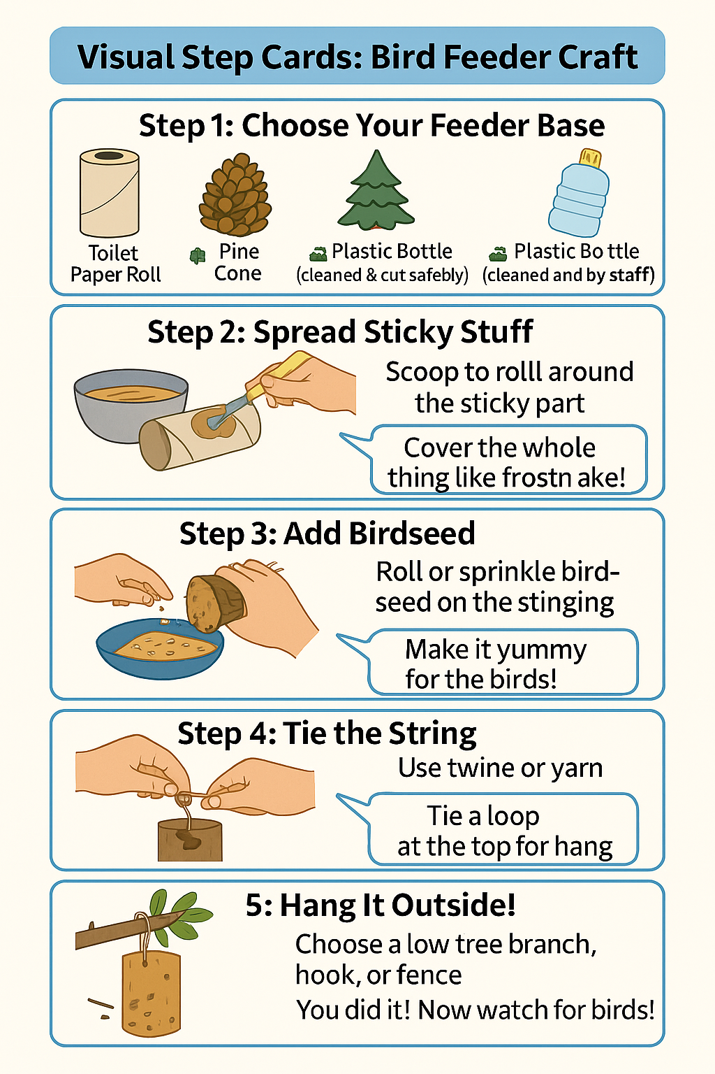

Annex 51
Title: “Hay Bale Adventure Course – Layout”
[ Start Line ]
|
┌─────────────┴─────────────┐
│ │
▼ ▼
[ Hay Bale Tunnel ] [ Step-Over Bales ]
│ │
▼ ▼
[ Ramp Access ] [ Sensory Flag Station ]
│ │
└──────┐ ┌──────┘
▼ ▼
[ Wheelchair Loop ]
│ │
▼ ▼
[ Bell Ring Station ] [ Animal Sound Box ]
│ │
▼ ▼
[ Balance Beam Path ] ←──┐
│ │
▼ │
[ Finish Line ] ◄───┘
Key Elements:
- Hay Bale Tunnel – Crawl or roll through (wheelchair users bypass using ramp path)
- Step-Over Bales – Low bales to step or roll over
- Ramp Access – For crossover or wheelchair-friendly navigation
- Sensory Flag Station – Participants touch or wave a brightly colored or textured flag
- Wheelchair Loop – Flat circular route around part of the course for mobility access
- Bell Ring Station – Ring a bell or chime before moving on
- Animal Sound Box – Press button for random animal sounds (adds fun & sensory engagement)
- Balance Beam Path – Wide balance path (with optional handrails or support aides)

Annex 52
Each card includes:
- A large image
- Simple text (ALL CAPS)
- Optional tactile or color-coded elements
1. START LINE
🟢
🧍‍♂️🚶‍♀️
TEXT:
READY? LET'S BEGIN!
Visual: Person standing at a starting flag or line
Color Code: Green Border
2. STEP OVER
⬆️🟫⬇️
👣
TEXT:
STEP OVER THE HAY!
Visual: Feet stepping over a hay bale
Alternative: Raised texture line for tactile cue
3. GO AROUND
↪️🟫↩️
🚶‍♂️
TEXT:
GO AROUND THE BALE!
Visual: Arrows curving around hay bale
Color Code: Orange Border
4. RAMP UP
🧑‍🦽⬆️📦
🦯
TEXT:
ROLL OR WALK UP THE RAMP
Visual: Wheelchair on a ramp or person walking with a cane up incline
Color Code: Blue Border
5. TOUCH THE FLAG
🚩🖐️
TEXT:
TOUCH THE RED FLAG!
Visual: Hand reaching for a flag
Add a real flag or tactile element on the card
6. SPIN IN A CIRCLE (Fun bonus activity)
🔄🕺
TEXT:
SPIN SLOWLY IN A CIRCLE
Visual: Dancing figure spinning
Color Code: Yellow Border
7. FINISH LINE
🏁👏
🎉
TEXT:
YOU DID IT! HIGH FIVE!
Visual: Finish banner and clapping hands

Annex 53
Ingredients You Need:
(Use symbols or pictures next to each)
- 🥣 2 cups organic flour
- 💧 ¾ cup warm water
- 🧂 1 tsp salt
- 🍞 1 tsp dry yeast
- 🧈 1 tbsp organic butter or olive oil
🔄 Step-by-Step Instructions:
Step 1: Wash Hands
🖐️ 💦
Picture: Hands under running water
Text: Clean hands before you start!
Step 2: Add Flour + Salt
🥣 ➕🧂
Picture: Bowl + spoon + flour
Text: Put flour and salt in a big bowl.
Step 3: Add Yeast + Warm Water
💧➕🍞
Picture: Pouring water from cup into bowl
Text: Add warm water and dry yeast. Mix gently.
Step 4: Add Oil or Butter
🧈➕🥣
Picture: Spoon adding butter or oil
Text: Put in your oil or soft butter. Stir again.
Step 5: Mix Everything
🌀
Picture: Spoon mixing bowl
Text: Use a spoon or your hands to mix the dough.
Step 6: Knead the Dough
✋👊🌀
Picture: Hands folding dough
Text: Press and fold the dough for 5–10 minutes.
Step 7: Shape Your Dough
🎨🍞
Picture: Shaped dough into rolls or hearts
Text: Make fun shapes – like balls, hearts, or braids!
Step 8: Let It Rest
🕒🍞🛏️
Picture: Dough in bowl covered with a towel
Text: Let the dough rest and grow for 10–15 minutes.
Step 9: Ready to Bake!
🔥👩‍🍳
Picture: Oven or baking tray
Text: Your dough is ready for baking (with help from an adult)!

Annex 54
Each label card is:
- A5 size (half a standard sheet of paper)
- Includes:
  - Large text (bold, sans serif font like Arial or OpenDyslexic)
  - High-contrast image or icon
  - Optional space for Braille/raised symbol

Annex 55
Supporting Accessibility in Dough-Making Activities
This list includes suggested adaptive tools to accommodate participants with physical, cognitive, or sensory challenges. These tools help create a more inclusive, comfortable, and empowering baking experience.
1. Mixing Tools
Tool | Description | Use Case
Easy-Grip Mixing Spoons | Large-handled, ergonomic spoons | For participants with weak grip or limited hand strength
Two-Handled Mixing Bowls | Bowls with grips on both sides | Provides extra stability during stirring
Non-slip Bowl Mats | Silicone or rubber mats under bowls | Prevents slipping and sliding while mixing
2. Kneading & Dough Tools
Tool | Description | Use Case
Textured Rolling Pins | Large-handled or rolling guides | Helps with shaping if kneading is too difficult
Dough Press or Stamp | Presses dough into shapes without needing force | For participants with fine motor limitations
Adaptive Dough Scraper | Lightweight with padded grip | Eases handling of dough without strain
3. Positioning and Stability Aids
Tool | Description | Use Case
Adjustable-Height Tables | Tables can be lowered for seated work | Wheelchair-friendly or for those who prefer sitting
Anti-Fatigue Mats | Cushioned standing mats | Helpful for participants with joint sensitivity or fatigue
Non-slip Footrests | Foot support when sitting | Improves posture and balance during tasks

4. Visual and Sensory Aids
Tool | Description | Use Case
Visual Recipe Cards | Step-by-step image-based instructions | Supports participants with cognitive or language processing challenges
Color-Coded Utensils | Bright colors for easy identification | Useful for visual tracking and learning sequences
Tactile Measurement Cups | Braille or raised number markers | Helpful for blind or visually impaired participants

5. Hygiene & Comfort Aids
Tool | Description | Use Case
Easy-on Aprons with Velcro | No ties or knots required | Great for participants with limited hand mobility
Foam-Handled Soap Dispensers | Easy press-down dispensers | Encourages handwashing independence
Adaptive Towels with Clips | Towels clipped to clothing or apron | Keeps hands dry without needing to reach frequently

Annex 56
1. Whole Wheat Bread
- Label Design:
  - A simple illustration of a loaf of whole wheat bread with a wheat stalk.
  - Large bold text that reads "Whole Wheat Bread" with a green organic symbol (leaf).
  - Small text below: "Certified Organic"
- Label Color Scheme:
  - Earthy tones: brown and green to represent the natural ingredients.
2. Rosemary Focaccia
- Label Design:
  - Illustration of a round focaccia bread with sprigs of rosemary.
  - Large bold text that reads "Rosemary Focaccia" with a sprig of rosemary next to the name.
  - Small text below: "Made with Organic Ingredients"
- Label Color Scheme:
  - Soft green and beige for an earthy and fresh feel.
3. Seeded Multigrain Bread
- Label Design:
  - Illustration of a loaf with various seeds (flax, sunflower, sesame) scattered across the top.
  - Large bold text: "Seeded Multigrain Bread"
  - Small text: "100% Organic & Whole Grains"
- Label Color Scheme:
  - Yellow and brown tones to highlight the grains and seeds.
4. Vegan Cinnamon Roll
- Label Design:
  - Illustration of a cinnamon roll with a sprinkle of cinnamon and a swirl pattern.
  - Large bold text: "Vegan Cinnamon Roll"
  - Small text: "Dairy-Free, Organic Ingredients"
- Label Color Scheme:
  - Warm browns and creamy whites to evoke the warmth of cinnamon and comfort.
5. Gluten-Free Banana Bread
- Label Design:
  - Illustration of a loaf of banana bread with banana slices on top.
  - Large bold text: "Gluten-Free Banana Bread"
  - Small text: "Made with Organic, Gluten-Free Flour"
- Label Color Scheme:
  - Yellow for banana and a natural beige background for a healthy, warm appearance.
6. Artisan Sourdough
- Label Design:
  - Illustration of a round, crusty sourdough loaf with a few cracks in the crust.
  - Large bold text: "Artisan Sourdough"
  - Small text: "Organic Ingredients, Naturally Leavened"
- Label Color Scheme:
  - A rustic orange and tan palette to give a hand-crafted, traditional feel.
Visual Layout Example for Each Label
- Illustration: On the left side of the label, large, clear, simple illustrations to represent the product.
- Product Name (Large Bold Text): Centered at the top with large, easy-to-read text.
- Organic Certification and Additional Information (Small Text): Below the product name in smaller font, possibly with a leaf symbol or certification mark for easy identification.
- Color Scheme: Earth tones, soft pastels, or natural shades to convey organic, handmade, or natural qualities.

Annex 57
Step 1: Identify the Product
Visual:
Image of different types of bread or baked goods (e.g., round loaves, baguettes, rolls).
Instruction:
Look at the bread. What type is it?
- Is it a loaf, roll, or baguette?
- Use the matching cards to help identify the correct product.
Step 2: Select the Right Label
Visual:
Image of pre-printed organic labels with large text and a picture of bread.
Instruction:
Pick the label that matches your bread.
- Does the bread look like the one on the label?
- Gently peel the label off its sheet.
Step 3: Attach the Label
Visual:
Image showing a hand placing a label on the top of a paper bag with a loaf of bread inside.
Instruction:
Stick the label on the top of the paper bag.
- Place the label where everyone can see it clearly.
- Press gently to make sure it sticks well.
Step 4: Prepare the Packaging
Visual:
Image of a person gently placing a loaf of bread into a paper bag, with string or a ribbon on the side.
Instruction:
Open the bag and gently place the bread inside.
- Be careful not to squish the bread.
- Make sure the bread fits inside the bag comfortably.
Step 5: Close the Bag
Visual:
Image of a person tying a string around the top of the bag to seal it.
Instruction:
Use the string to tie the top of the bag.
- Wrap the string around the top of the bag and tie it securely.
- You can also use tape if it is easier.
Step 6: Display the Product
Visual:
Image of a bakery display table with neatly packaged bread and labeled products.
Instruction:
Place the packaged bread on the table where everyone can see it.
- Make sure the label is visible.
- Your bread is ready for sale or display!
Tips for Success
- Take your time: There’s no rush when labeling and packaging.
- Ask for help if you need it: A buddy or staff member can always assist.
- Check for mistakes: Make sure the label matches the product and the packaging is secure.

Annex 58
Card 1: Mixing the Dough
- Image: An illustration of a large bowl with hands swirling in a circular motion to represent stirring ingredients.
- Instructions:
"Let’s start by mixing the dough! Move your arms in big circles like you're stirring a giant bowl of ingredients. Keep the rhythm with the music. You can move your body side to side as you stir."
Card 2: Kneading the Dough
- Image: Two hands pressing into a ball of dough, with gentle elbow bends to show the pressing motion.
- Instructions:
"Time to knead the dough! Press your hands together as though you're squishing and folding the dough. You can squat down or stand tall, whichever feels best for you. Move with the beat as you knead."
Card 3: Shaping the Loaf
- Image: Two hands shaping dough into a round loaf or loaf shape.
- Instructions:
"Now, we shape the bread! Use your hands to form the dough into a round or oval shape, like a loaf. Lift your arms up to the sky as you shape your bread. Show us your best bread shape!"
Card 4: Baking the Bread
- Image: A loaf of bread in an oven, with heat waves or glowing lines to show the baking process.
- Instructions:
"The bread is baking! Slowly raise your arms above your head and make a soft "baking" motion. Imagine the heat from the oven as the bread rises. Hold your arms high like the bread is almost done baking."
Card 5: The Bread is Ready!
- Image: A golden, freshly baked loaf being pulled from the oven.
- Instructions:
"The bread is ready! Pretend to take the bread out of the oven. Gently hold your bread (with both hands) and sway it side to side to show it's warm and fresh. Dance and celebrate your bread!"

Annex 59
1. Warm-Up (Gentle, Calming, Stretching Music)
These songs are slower-paced to help participants relax and gently warm up their bodies.
- "Banana Pancakes" by Jack Johnson
  - Tempo: Slow, relaxing
  - Mood: Calm and cheerful, perfect for light stretching and easy movements.
- "Here Comes the Sun" by The Beatles
  - Tempo: Slow to medium
  - Mood: Uplifting and positive, great for gradually warming up and preparing for movement.
- "Better Together" by Jack Johnson
  - Tempo: Soft and soothing
  - Mood: Warm and gentle, ideal for stretching and easing into the day.
2. Main Activity (Rhythmic, Energizing Music)
These songs have more upbeat tempos to keep the energy up during the "Bread Dance!" steps like mixing, kneading, and shaping.
- "Happy" by Pharrell Williams
  - Tempo: Upbeat, lively
  - Mood: Fun and energetic, great for encouraging movement and creating a joyful atmosphere.
- "Can't Stop the Feeling!" by Justin Timberlake
  - Tempo: Fast and bouncy
  - Mood: Fun and danceable, perfect for active movements and creative interpretation of the "Bread Dance."
- "Uptown Funk" by Mark Ronson ft. Bruno Mars
  - Tempo: Fast, funky rhythm
  - Mood: Energizing and lively, ideal for the more dynamic and interactive parts of the dance, like kneading and shaping.
3. Cool-Down (Calming, Relaxing Music)
These songs are slower and more peaceful, perfect for winding down and allowing participants to cool down from the energetic movements.
- "Three Little Birds" by Bob Marley
  - Tempo: Slow, calming
  - Mood: Relaxing and reassuring, ideal for a gentle cool-down and reflective moment.
- "Imagine" by John Lennon
  - Tempo: Slow, peaceful
  - Mood: Reflective and soothing, encouraging participants to slow down and stretch gently.
- "Somewhere Over the Rainbow" by Israel Kamakawiwo'ole
  - Tempo: Slow and peaceful
  - Mood: Dreamy and calming, perfect for a quiet reflection after a fun and active session.

Annex 60
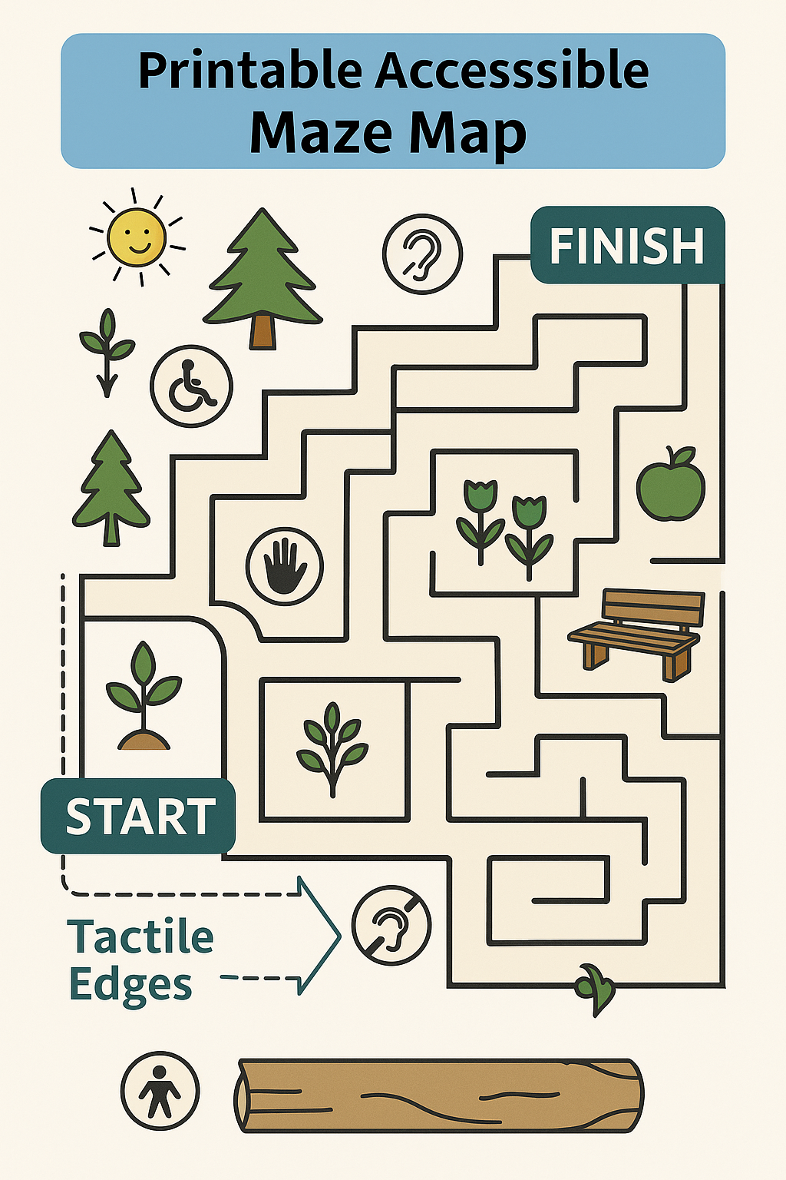

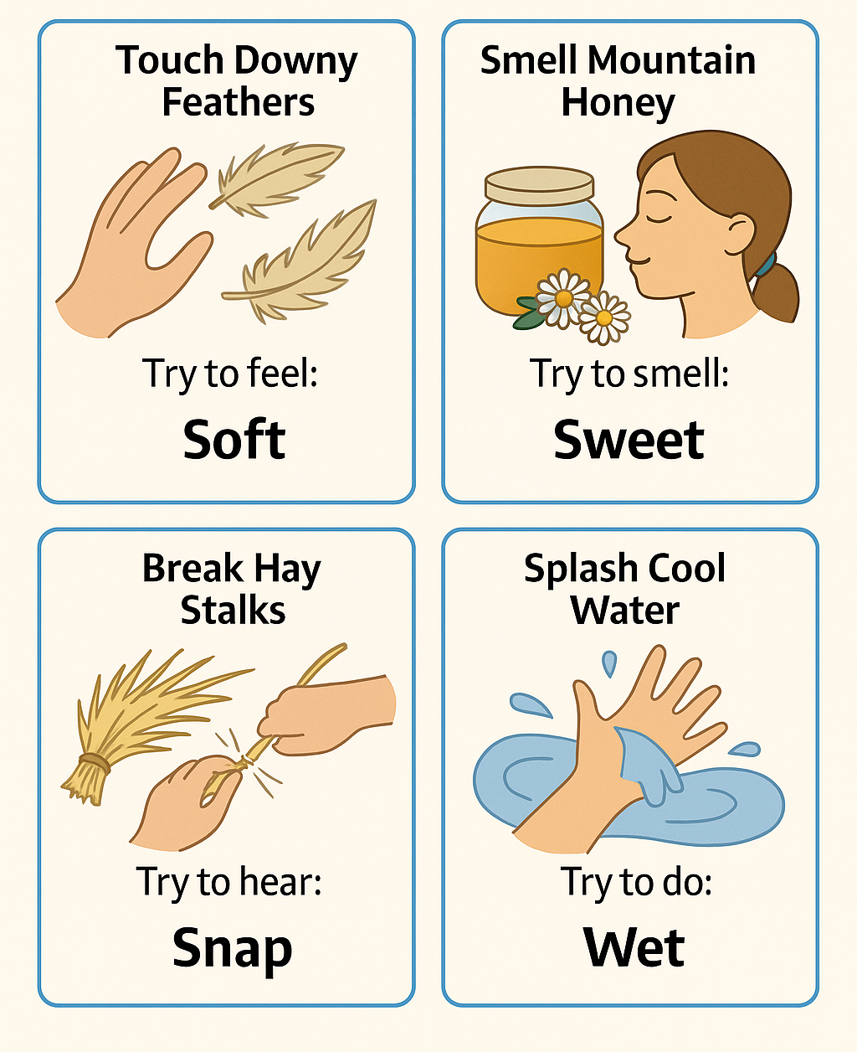
Annex 61

Annex 62
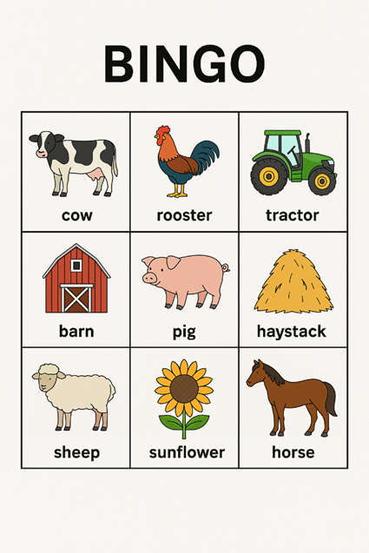

Alternative Formats for Accessibility:
- Each square includes:
  - A large image or emoji.
  - A simple word label in large print.
  - Optionally, a braille label or tactile icon.

Annex 63
Card Pair | Image Description | Label
1 | Picture of a cow | "Cow"
2 | Picture of a tractor | "Tractor"
3 | Picture of a chicken | "Chicken"
4 | Picture of a barn | "Barn"
5 | Picture of a sheep | "Sheep"
6 | Picture of a horse | "Horse"
7 | Picture of a pig | "Pig"
8 | Picture of a duck | "Duck"
9 | Picture of a hay bale | "Hay"
10 | Picture of a fence | "Fence"
11 | Picture of a wheelbarrow | "Wheelbarrow"
12 | Picture of a watering can | "Watering Can"

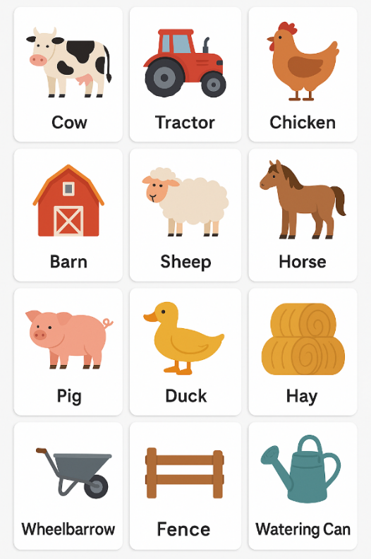

Accessibility Tips:
- Use high-contrast images and large, bold fonts.
- Include braille or tactile textures (optional for low vision).
- You can add sound buttons or QR codes to play matching farm noises.
Use Velcro backing if attaching to a felt board or magnetic surface.

Annex 64
What Are Bees?
- Bees are small insects.
- They have 3 parts to their body:
  - Head
  - Thorax (middle part)
  - Abdomen (back part)
Parts of a Bee
- Head:
  - Eyes to see.
  - Antennae to smell and feel.
- Wings:
  - Bees have 2 pairs of wings to fly.
- Stinger:
  - A bee can sting when it feels scared or in danger.
  - Bees only sting once.
Types of Bees in a Hive
There are 3 types of bees in a hive:
- Queen Bee
  - The mother of all the bees.
  - Only one queen in the hive.
- Worker Bees
  - Female bees that do all the work.
  - They make honey, build the hive, and take care of the baby bees.
- Drone Bees
  - Male bees.
  - Their job is to mate with the queen.
What Do Bees Do?
- Make Honey
  - Bees collect nectar from flowers.
  - They bring it back to the hive and turn it into honey.
- Pollinate Flowers
  - Bees fly from flower to flower.
  - When they do, they carry pollen from one flower to another.
  - This helps flowers grow and make fruit.
Why Are Bees Important?
- Bees help plants grow by moving pollen between them.
- Without bees, many plants, fruits, and vegetables could not grow.
- Bees are important for our food!
Fun Bee Facts
- Bees can fly at speeds of up to 15 miles per hour!
- A single bee can make 1/12th of a teaspoon of honey in its lifetime.
- Bees communicate with each other by doing a dance called the “waggle dance.”
How to Stay Safe Around Bees
- Don’t disturb bees.
- Stay calm if you see a bee.
- Don’t swat at them – just let them go.
- If a bee stings you, wash the sting area with water and use ice to help with pain.

Annex 65
1. Bee Facts Visual Guide
A picture guide with simple text to explain important bee facts. The guide can be used by the facilitator to show participants, or each participant can have a personal copy for reference.
- Example:
  - The Queen Bee: [Image of a large bee with a crown] "The queen lays all the eggs."
  - Worker Bees: [Image of smaller bees working] "Worker bees gather pollen and make honey."
  - Drones: [Image of a bee with wings highlighted] "Drones help the queen mate."
Tip: Use tactile elements (e.g., velcro or raised images) for participants with vision impairments.
2. Communication Boards/PECS (Picture Exchange Communication System)
A set of images that represent common actions or needs that participants can use to express themselves during the program. For example, a participant may point to an image of a bee if they want to ask a question about bees.
- Example Symbols:
  - "More" (Image of two hands reaching forward)
  - "Help" (Image of a hand raised)
  - "Bee" (Picture of a bee)
  - "Stop" (Image of a hand raised in a stop gesture)
Tip: Ensure that the symbols are large, clear, and easy to understand. A laminated board or cards can be used to help participants point to the images.

Annex 66
1. Tactile Models of Bees and Hive Parts
A set of models that participants can touch and explore, helping to reinforce learning through tactile experiences.
- Example:
  - Bee Model: A 3D model of a bee that participants can feel, with raised sections for different parts of the bee (wings, body, and legs).
  - Hive Model: A tactile model of a beehive, where participants can feel the comb, cells, and structure of the hive.
Tip: Make sure materials are safe for all participants (non-toxic, easy to clean).
2. Sensory Support Tools
These tools help participants with sensory sensitivities to manage their sensory experience throughout the day.
- Example:
  - Noise-Canceling Headphones: For those sensitive to sound, headphones can block out excess noise.
  - Fidget Tools: Small, textured items like soft balls or fabric squares to help participants focus and self-regulate.
  - Soothing Visuals: Slow-moving video of nature or calming bee-related animations projected on a screen to help calm participants during breaks.
Tip: Always check with participants or caregivers about what types of sensory support they prefer.
3. Word Cards for Common Questions
Word cards that participants can hold up to ask or answer questions during the program. This can help with participants who are non-verbal or who need additional time to formulate their thoughts.
- Example:
  - "What is this?" (Image of a person asking a question)
  - "Can I touch?" (Image of a hand reaching out)
  - "I like this!" (Image of a happy face)
  - "I don’t understand" (Image of a confused face)
Tip: Make sure each card is laminated for durability and has clear, high-contrast text.
4. Audio Support for Visual Information
For participants with visual impairments, provide audio recordings of important information and explanations during the program. These recordings can be synced with the visual schedule and bee facts guide.
- Example:
  - An audio clip that explains the role of the queen bee when the participant touches the corresponding picture.
  - Audio descriptions of the different parts of the hive during the hive viewing.
Tip: Provide adjustable volume and a pause function to allow participants to engage at their own pace.

Annex 67
Green Hospitality Action Plan - Group Activity Worksheet
Instructions: In groups of 3-5, complete this worksheet in 20 minutes. Discuss each section briefly and write down your group's ideas and action points on the flipchart page provided. Be concise and practical. You may assign a note-taker to record your responses.
- Vision C Commitment
What is your group's sustainability mission? Who will lead the green efforts?

- Energy Efficiency
List 2-3 ways to reduce energy use or adopt renewable energy.

- Water Conservation
How can your business conserve water effectively?

- Waste Management
What steps can you take to reduce, reuse, and recycle waste?

- Sustainable Food C Agriculture
How will you promote local, organic, or seasonal food?

- Eco-Friendly Transportation
Suggest ways to reduce transportation emissions.

- Green Building C Materials
What sustainable materials or designs can you use?

- Guest Engagement C Education
How will you involve and educate guests in your green practices?

- Monitoring C Evaluation
How will you track your progress and improve over time?

- Partnerships C Certifications
List potential partners or certifications to pursue.

Annex 68
1. | What is the main goal of green hospitality? | Tick √
a. | Increase luxury services
b. | Reduce environmental impact
c. | Expand hotel chains
D | Promote urban tourism
2. | Which of the following is an example of a green practice? | Tick √
a. | Using single-use plastics
b. | Installing solar panels
c. | Offering imported bottled water
d. | Running air conditioning all day
3. | How does green hospitality benefit agritourism? | Tick √
a. | Increases pesticide use
b. | Reduces visitor numbers
c. | Supports sustainable farming and education
d. | Focuses only on profit
4. | What is a common feature of eco-certified accommodations | Tick √
a. | Unlimited towel service
b. | Daily linen changes
c. | Energy-efficient systems
d. | Imported food menus
5. | Which action can travellers take to support green hospitality? | Tick √
a. | Leave lights on when leaving a room
b. | Use disposable cutlery
c. | Bring reusable water bottles
d. | Request daily room cleaning

Green Hospitality C Agritourism Quiz (answer key)
1. What is the main goal of green hospitality?
Answer B. Reduce environmental impact.
2. Which of the following is an example of a green practice?
Answer B. Installing solar panels.
3. How does green hospitality benefit agritourism?
Answer C. Supports sustainable farming and education.
4. What is a common feature of eco - certified accommodations?
Answer C. Energy- efficient systems.
5. Which action can travellers take to support green hospitality?
Answer C. Bring reusable water bottles.

Annex 69
1. | Which of the following is the most effective way for a farm stay to reduce its carbon footprint? | Tick √
a. | Offering guests plastic water bottles
b. | Installing solar panels and using renewable energy
c. | Providing daily towel and linen changes
D | Using diesel generators for backup power
2. | What is a low-carbon way to provide meals at an agritourism site? | Tick √
a. | Import gourmet ingredients from overseas
b. | Offer fast food options
c. | Serve seasonal, locally grown produce
d. | Provide only packaged snacks
3. | Which building material is best for reducing carbon emissions in eco-lodges? | Tick √
a. | Concrete
b. | Locally sourced timber
c. | Plastic panels
d. | Steel
4. | How can guests help reduce carbon emissions during their stay? | Tick √
a. | Leave lights and heating on all day
b. | Drive to every nearby attraction
c. | Participate in farm activities and walk or cycle locally
d. | Request daily room cleaning
5. | What is a fun, low-carbon activity that agritourism sites can offer? | Tick √
a. | Helicopter tours
b. | Tractor racing
c. | Farm-to-table cooking classes
d. | Indoor air-conditioned gaming rooms

Reducing Carbon Footprint Quiz Answer Key
1. Which of the following is the most effective way for a farm stay to reduce its carbon footprint?
Answer B. Installing solar panels and using renewable energy.
2. What is a low- carbon way to provide meals at an agritourism site?
Answer C. Serve seasonal, locally grown produce.
3. Which building material is best for reducing carbon emissions in eco - lodges?
Answer B. Locally sourced timber.
4. How can guests help reduce carbon emissions during their stay?
Answer C. Participate in farm activities and walk or cycle locally.
5. What is a fun, low- carbon activity that agritourism sites can offer?
Answer C. Farm- to- table cooking classes.

Annex 70
1. | What is the main goal of green marketing? | Tick √
a. | To reduce advertising costs
b. | To promote environmentally friendly products and practices
c. | To increase product shelf life
D | To make packaging more colourful
2. | Which of the following is an example of green marketing? | Tick √
a. | Offering a discount on bulk purchases
b. | Using celebrity endorsements
c. | Advertising a product made from recycled materials
d. | Launching a new flavour of soda
3. | What does the term “eco-label” refer to? | Tick √
a. | A price tag for organic food
b. | A label that shows a product is environmentally certified
c. | A barcode for tracking emissions
d. | A sticker used for branding
4. | Which of these is a benefit of green marketing for businesses? | Tick √
a. | Leave lights and heating on all day
b. | Reduced customer loyalty
c. | Improved brand image
d. | Increased packaging waste
5. | What is the “triple bottom line” in sustainability? | Tick √
a. | Profit, promotion, and packaging
b. | People, planet, and profit
c. | Price, product, and place
d. | Reduce, reuse, recycle

Green Marketing Quiz Answer Key
1. What is the main goal of green marketing?
Answer B. To promote environmentally friendly products and practices
2. Which of the following is an example of green marketing?
Answer C. Advertising a product made from recycled materials.
3. What does the term “eco - label” refer to?
Answer B. A label that shows a product is environmentally certified.
4. Which of these is a benefit of green marketing for businesses?
Answer C. Improved brand image.
5. What is the “triple bottom line” in sustainability?
Answer B. People, planet, and profit

Annex 71
1. | What is one benefit of sourcing food locally? | Tick √
a. | Higher transportation costs
b. | Reduced carbon footprint
c. | Limited availability
D | Increased packaging
2. | Which of the following is a sustainable packaging option? | Tick √
a. | Styrofoam
b. | Plastic wrap
c. | Compostable containers
d. | Aluminium foil
3. | What is the best way to reduce food waste? | Tick √
a. | Over-ordering ingredients
b. | Ignoring expiration dates
c. | Planning portion sizes
d. | Discarding leftovers
4. | Which practice supports sustainable seafood? | Tick √
a. | Buying endangered species
b. | Choosing MSC-certified products
c. | Importing exotic fish
d. | Fishing without limits
5. | Why is menu planning important for sustainability? | Tick √
a. | It increases food waste
b. | It reduces ingredient use
c. | It helps manage inventory and reduce waste
d. | It complicates ordering

Sustainable Food Practices Quiz Answer Key
1. What is one benefit of sourcing food locally?
Answer B. Reduced carbon footprint.
2. Which of the following is a sustainable packaging option?
Answer C. Compostable containers.
3. What is the best way to reduce food waste?
Answer C. Planning portion sizes.
4. Which practice supports sustainable seafood?
Answer B. Choosing MSC- certified products.
5. Why is menu planning important for sustainability?
Answer C. It helps manage inventory and reduce waste.

Annex 72
1. | Which of the following is a renewable energy source? | Tick √
a. | Coal
b. | Natural gas
c. | Solar
D | Nuclear
2. | What is the main benefit of using renewable energy in business? | Tick √
a. | Higher emissions
b. | Increased energy waste
c. | Reduced environmental impact
d. | Higher costs
3. | Which technology converts sunlight directly into electricity? | Tick √
a. | Wind turbine
b. | Geothermal pump
c. | Photovoltaic pane
d. | Biomass boiler
4. | What is a common barrier to adopting renewable energy in businesses? | Tick √
a. | Lack of sunlight
b. | High initial investment
c. | Too much wind
d. | Low electricity demand
5. | Which of the following helps reduce energy costs? | Tick √
a. | Leaving lights on
b. | Using outdated equipment
c. | Conducting energy audits
d. | Ignoring energy bills

Renewable Energy Solutions Quiz Answer Key
1. Which of the following is a renewable energy source?
Answer C. Solar
2. What is the main benefit of using renewable energy in business?
Answer C. Reduced environmental impact.
3. Which technology converts sunlight directly into electricity?
Answer C. Photovoltaic panel.
4. What is a common barrier to adopting renewable energy in businesses?
Answer B. High initial investment.
5. Which of the following helps reduce energy costs?
Answer C. Conducting energy audits.

Annex 73
1. | Which of the following is an example of eco-friendly transportation? | Tick √
a. | Diesel-powered tour bus
b. | Electric shuttle
c. | Private jet
D | Gasoline rental car
2. | What is a benefit of using bicycles for local travel in tourism? | Tick √
a. | Increases fuel consumption
b. | Reduces traffic congestion and emissions
c. | Requires expensive infrastructure
d. | Limits tourist mobility
3. | How can businesses reduce the carbon footprint of supply deliveries? | Tick √
a. | Order supplies daily
b. | Use local suppliers and consolidate deliveries
c. | Import goods from overseas
d. | Use air freight for speed
4. | Which transport method has the highest carbon emissions per passenger? | Tick √
a. | Train
b. | Electric car
c. | Airplane
d. | Bicycle
5. | What is a strategy to encourage guests to use public transport? | Tick √
a. | Provide free parking
b. | Offer shuttle service from transit hubs
c. | Recommend car rentals
d. | Avoid giving directions

Renewable Energy Solutions Quiz Answer Key
1. Which of the following is an example of eco - friendly transportation?
Answer B. Electric shuttle.
2. What is a benefit of using bicycles for local travel in tourism?
Answer B. Reduces traffic congestion and emissions.
3. How can businesses reduce the carbon footprint of supply deliveries?
Answer B. Use local suppliers and consolidate deliveries.
4. Which transport method has the highest carbon emissions per passenger?
Answer C. Airplane
5. What is a strategy to encourage guests to use public transport?
Answer B. Offer shuttle service from transit hubs.

Annex 74
1. | Which of the following is a good example of community engagement? | Tick √
a. | Ignoring local customs
b. | Hiring staff from the local area
c. | Importing all supplies
D | Avoiding local partnerships
2. | What is one way to educate visitors about green hospitality? | Tick √
a. | Provide no information
b. | Use posters and signage
c. | Discourage questions
d. | Hide sustainability practices
3. | Which of these supports local economic development? | Tick √
a. | Buying imported goods
b. | Using only online suppliers
c. | Partnering with local producers
d. | Avoiding local markets
4. | How can a business reduce its environmental impact? | Tick √
a. | Waste water
b. | Use single-use plastics
c. | Implement recycling programs
d. | Keep lights on all day
5. | Why is educating guests about sustainability important? | Tick √
a. | It increases waste
b. | It reduces awareness
c. | It encourages responsible behaviour
d. | It confuses visitors

Community Engagement and Education Quiz Answer Key
1. Which of the following is a good example of community engagement?
Answer B. Hiring staff from the local area.
2. What is one way to educate visitors about green hospitality?
Answer B. Use posters and signage.
3. Which of these supports local economic development?
Answer C. Partnering with local producers.
4. How can a business reduce its environmental impact?
Answer C. Implement recycling programs.
5. Why is educating guests about sustainability important?
Answer C. It encourages responsible behaviour.

Annex 75
1. | What is a key feature of a green event? | Tick √
a. | Single-use plastic decorations
b. | Locally sourced food and materials
c. | Unlimited printed flyers
D | No waste management plan
2. | Which of the following helps reduce the carbon footprint of an event? | Tick √
a. | Encouraging carpooling or public transport
b. | Providing bottled water for all guests
c. | Using diesel generators
d. | Hosting events in remote locations
3. | How can you promote sustainability at a local event? | Tick √
a. | Avoiding local suppliers
b. | Ignoring recycling practices
c. | Partnering with eco-conscious vendors
d. | Using disposable tableware
4. | What is an example of a low-impact event activity? | Tick √
a. | Fireworks display
b. | Virtual guest speakers
c. | Helicopter rides
d. | Imported catering services
5. | Why is it important to involve the local community in green events? | Tick √
a. | It increases waste
b. | It reduces participation
c. | It fosters local support and sustainability
d. | It complicates logistics

Green Event Planning Quiz Answer Key
1. What is a key feature of a green event?
Answer B. Locally sourced food and reusable materials.
2. Which of the following helps reduce the carbon footprint of an event?
Answer B. Digital tickets and signage.
3. How can you promote sustainability at a local event?
Answer B. Partner with local vendors and artists.
4. What is an example of a low- impact event activity?
Answer B. Shuttle buses and bike parking.
5. Why is it important to involve the local community in green events?
Answer B. To reduce environmental impact and raise awareness.

Annex 76
1. | What is the primary goal of water conservation? | Tick √
a. | Increase water bills
b. | Reduce water usage and waste
c. | Promote water sports
D | None of the above
2. | Which of the following is a water-saving technique? | Tick √
a. | Leaving taps running
b. | Using low-flow fixtures
c. | Watering lawns at noon
d. | Ignoring leaks
3. | Drip irrigation is effective because it: | Tick √
a. | Floods the field
b. | Uses large amounts of water
c. | Delivers water directly to plant roots
d. | Requires no maintenance
4. | Which sector benefits most from water conservation in agritourism? | Tick √
a. | Entertainment
b. | Agriculture
c. | Fashion
d. | Technology
5. | Rainwater harvesting involves: | Tick √
a. | Disposing of rainwater
b. | Collecting and storing rainwater for reuse
c. | Using rainwater for swimming pools
d. | Ignoring rainfall

Water Conservation Quiz Answer Key
1. What is the primary goal of water conservation?
Answer B. Reduce water usage and waste.
2. Which of the following is a water-saving technique?
Answer B. Using low-flow fixtures
3. Drip irrigation is effective because it:
Answer C. Delivers water directly to plant roots.
4. Which sector benefits most from water conservation in agritourism?
Answer B. Agriculture
5. Rainwater harvesting involves:
Answer B. Collecting and storing rainwater for reuse.

Annex 77
1. | What is the main purpose of waste management? | Tick √
a. | To increase landfill sites
b. | To reduce and manage waste effectively
c. | To promote littering
D | None of the above
2. | Which of the following is a waste reduction strategy? | Tick √
a. | Single-use plastics
b. | Recycling and composting
c. | Burning waste
d. | Ignoring waste
3. | In agritourism, waste can be reduced by: | Tick √
a. | Providing disposable items
b. | Educating visitors on recycling
c. | Using non-recyclable materials
d. | Avoiding waste separation
4. | What is a benefit of reducing waste in agritourism? | Tick √
a. | Increased pollution
b. | Higher operational costs
c. | Improved sustainability
d. | More waste generation
5. | Which of the following helps in educating visitors about waste reduction? | Tick √
a. | No signage
b. | Clear recycling instructions
c. | Hidden bins
d. | Lack of information

Waste Management Quiz Answer Key
1. What is the main purpose of waste management?
Answer b. To reduce and manage waste effectively.
2. Which of the following is a waste reduction strategy?
Answer b. Recycling and composting.
3. In agritourism, waste can be reduced by:
Answer b. Educating visitors on recycling.
4. What is a benefit of reducing waste in agritourism?
Answer c. Improved sustainability.
5. Which of the following helps in educating visitors about waste reduction?
Answer b. Clear recycling instructions.

Annex 78
1. | What is biodiversity? | Tick √
a. | The variety of plant and animal life in a particular habitat
b. | The number of people in a city
c. | The amount of rainfall in a region
D | The diversity of buildings in an area
2. | Why is biodiversity important? | Tick √
a. | It reduces the need for agriculture
b. | It supports ecosystem services and resilience
c. | It increases pollution
d. | It limits food production
3. | Which of the following is a threat to biodiversity? | Tick √
a. | Habitat destruction
b. | Organic farming
c. | Wildlife sanctuaries
d. | Reforestation
4. | How can businesses help conserve biodiversity? | Tick √
a. | By using more plastic packaging
b. | By supporting monoculture farming
c. | By reducing habitat destruction and pollution
d. | By increasing fossil fuel use
5. | What is an example of a biodiversity-friendly practice? | Tick √
a. | Deforestation
b. | Planting native species
c. | Overfishing
d. | Urban sprawl

Bio-diversity Conservation Quiz Answer Key
1. What is biodiversity?
Answer A. The variety of plant and animal life in a particular habitat
2. Why is biodiversity important?
Answer B. It supports ecosystem services and resilience.
3. Which of the following is a threat to biodiversity?
Answer A. Habitat destruction.
4. How can businesses help conserve biodiversity?
Answer C. By reducing habitat destruction and pollution
5. What is an example of a biodiversity- friendly practice?
Answer B. Planting native species.

Annex 79
1. | What is the primary goal of green building design? | Tick √
a. | Reduce construction costs
b. | Improve aesthetic appeal
c. | Minimize environmental impact
D | Increase building height
2. | Which of the following is a feature of green buildings? | Tick √
a. | High energy consumption
b. | Use of non-renewable materials
c. | Efficient water usage
d. | Lack of insulation
3. | What is a common renewable energy source used in green buildings? | Tick √
a. | Coal
b. | Solar power
c. | Diesel
d. | Natural gas
4. | Which certification is commonly associated with green buildings? | Tick √
a. | ISO 9001
b. | LEED
c. | OSHA
d. | FDA
5. | What is one benefit of green building design? | Tick √
a. | Increased pollution
b. | Higher utility bills
c. | Improved indoor air quality
d. | Reduced daylight access

Green Building Design Quiz Answer Key
1. What is the primary goal of green building design?
Answer C. Minimize environmental impact.
2. Which of the following is a feature of green buildings?
Answer C. Efficient water usage.
3. What is a common renewable energy source used in green buildings?
Answer B. Solar power.
4. Which certification is commonly associated with green buildings?
Answer B. LEED
5. What is one benefit of green building design?
Answer C. Improved indoor air quality.

Annex 80
1. | What is the main goal of sustainable landscaping? | Tick √
a. | Increase water usage
b. | Promote biodiversity and reduce environmental impact
c. | Use synthetic fertilizers
D | Remove native plants
2. | Which of the following is a sustainable landscaping practice? | Tick √
a. | Planting invasive species
b. | Using chemical pesticides
c. | Composting organic waste
d. | Overwatering lawns
3. | What type of plants are best suited for sustainable landscaping? | Tick √
a. | Exotic plants
b. | Native and drought-tolerant plants
c. | High-maintenance flowers
d. | Non-flowering shrubs
4. | How can mulching benefit sustainable landscaping? | Tick √
a. | Increases soil erosion
b. | Reduces water retention
c. | Helps retain moisture and suppress weeds
d. | Attracts pests
5. | Why is it important to reduce lawn areas in sustainable landscaping? | Tick √
a. | Lawns are easy to maintain
b. | Lawns require less water
c. | Lawns support biodiversity
d. | Lawns consume high water and chemical inputs

Sustainable Landscaping Quiz Answer Key
1. What is the main goal of sustainable landscaping?
Answer b. Promote biodiversity and reduce environmental impact.
2. Which of the following is a sustainable landscaping practice?
Answer c. Composting organic waste.
3. What type of plants are best suited for sustainable landscaping?
Answer b. Native and drought- tolerant plants.
4. How can mulching benefit sustainable landscaping?
Answer c. Helps retain moisture and suppress weed.
5. Why is it important to reduce lawn areas in sustainable landscaping?
Answer d. Lawns consume high water and chemical input.

Annex 81
1. | What is the primary goal of Green Hospitality Certification? | Tick √
a. | Increase profits through marketing
b. | Reduce environmental impact and promote sustainability
c. | Improve customer service ratings
D | Comply with tax regulations
2. | Which of the following is typically a requirement for Green Certification? | Tick √
a. | Offering 24-hour room service
b. | Using only local suppliers
c. | Implementing energy and water conservation measures
d. | Providing luxury amenities
3. | One benefit of Green Certification for a hospitality business is: | Tick √
a. | Higher staff turnover
b. | Increased utility costs
c. | Enhanced brand reputation
d. | Reduced guest satisfaction
4. | Visitors are more likely to choose a certified green business because: | Tick √
a. | It offers cheaper rates
b. | It aligns with their environmental values
c. | It has more entertainment options
d. | It is government-owned
5. | Which of the following is NOT a typical area assessed in Green Certification? | Tick √
a. | Waste management
b. | Staff uniforms
c. | Energy efficiency
d. | Water conservation

Green Hospitality Certification Quiz Answer Key
1. What is the primary goal of Green Hospitality Certification?
Answer B. Reduce environmental impact and promote sustainability.
2. Which of the following is typically a requirement for Green Certification?
Answer C. Implementing energy and water conservation measures.
3. One benefit of Green Certification for a hospitality business is:
Answer C. Enhanced brand reputation.
4. Visitors are more likely to choose a certified green business because:
Answer B. It aligns with their environmental values.
5. Which of the following is NOT a typical area assessed in Green Certification?
Answer B. Staff uniforms.

Annex 82
1. | What is the main goal of sustainable tourism? | Tick √
a. | Maximize tourist numbers
b. | Minimize environmental and cultural impact
c. | Increase luxury offerings
D | Focus only on economic growth
2. | Which of the following is a key principle of sustainable tourism? | Tick √
a. | Building more resorts in protected areas
b. | Encouraging short-term profits
c. | Respecting local cultures and communities
d. | Promoting mass tourism
3. | The UNWTO’s SDGs are designed to: | Tick √
a. | Increase tourism taxes
b. | Provide travel insurance
c. | Promote global sustainable development
d. | Limit international travel
4. | Which SDG is most directly related to climate action in tourism? | Tick √
a. | SDG 1 – No Poverty
b. | SDG 13 – Climate Action
c. | SDG 4 – Quality Education
d. | SDG 8 – Decent Work and Economic Growth
5. | A sustainable tourism business is likely to: | Tick √
a. | Use single-use plastics for convenience
b. | Employ only international staff
c. | Support local suppliers and reduce waste
d. | Focus only on luxury travellers

Sustainable Tourism Practices Quiz Answer Key
1. What is the main goal of sustainable tourism?
Answer B. Minimize environmental and cultural impact.
2. Which of the following is a key principle of sustainable tourism?
Answer C. Respecting local cultures and communities.
3. The UNWTO’s SDGs are designed to:
Answer C. Promote global sustainable development.
4. Which SDG is most directly related to climate action in tourism?
Answer B. SDG 13 – Climate Action
5. A sustainable tourism business is likely to:
Answer C. Support local suppliers and reduce waste.

Annex 83
1. | What is one primary benefit of using smart thermostats in hospitality settings? | Tick √
a. | Increase room service orders
b. | Reduce energy consumption
c. | Improve guest entertainment options
D | Track employee attendance
2. | Which of the following technologies helps reduce food waste in hotel kitchens? | Tick √
a. | Virtual reality tours
b. | AI-powered inventory management systems
c. | High-speed internet
d. | Smart TVs
3. | What is a key feature of green building management systems (BMS)? | Tick √
a. | Automated lighting and HVAC control
b. | Guest loyalty tracking
c. | Online booking integration
d. | Social media marketing
4. | Which of these is a sustainable benefit of digital check-in systems? | Tick √
a. | Increases upselling opportunities
b. | Reduces paper usage and front desk congestion
c. | Enhances minibar sales
d. | Improves room cleaning speed
5. | What role does water-saving technology play in green hospitality? | Tick √
a. | Increases guest satisfaction scores
b. | Reduces operational costs and environmental impact
c. | Enhances Wi-Fi connectivity
d. | Improves laundry turnaround time

Sustainable Tourism Practices Quiz Answer Key
1. What is one primary benefit of using smart thermostats in hospitality settings?
Answer b. Reduce energy consumption.
2. Which of the following technologies helps reduce food waste in hotel kitchens?
Answer b – AI-powered inventory management systems.
3. What is a key feature of green building management systems (BMS)?
Answer a – Automated l ighting and HVAC control.
4. Which of these is a sustainable benefit of digital check-in systems?
Answer b – Reduces paper usage and front desk congestion.
5. What role does water- saving technology play in green hospitality?
Answer b – Reduces operational costs and environmental impact.

Annex 84
1. | Why is guest engagement important in green practices? | Tick √
a. | It reduces staff workload
b. | It enhances guest satisfaction and environmental impact
c. | It increases room rates
D | It shortens guest stays
2. | Which of the following is an effective way to encourage guests to participate in green practices? | Tick √
a. | Mandatory participation in all programs
b. | Offering incentives for eco-friendly behaviour
c. | Avoiding communication about sustainability
d. | Limiting guest choices
3. | What is a common barrier to guest engagement in sustainability? | Tick √
a. | Too many green options
b. | Lack of awareness or understanding
c. | High guest motivation
d. | Overuse of digital tools
4. | Which of the following is a green practice guests can easily engage in? | Tick √
a. | Using disposable toiletries
b. | Leaving lights and AC on when leaving the room
c. | Participating in towel and linen reuse programs
d. | Requesting daily room cleaning
5. | What role does staff play in promoting guest engagement in green practices? | Tick √
a. | Ignoring guest questions
b. | Enforcing rules strictly
c. | Educating and encouraging guests
d. | Avoiding sustainability topics

Guest Engagement in Green Practices Quiz Answer Key
1. Why is guest engagement important in green practices?
Answer b. It enhances guest satisfaction and environmental impact.
2. Which of the following is an effective way to encourage guests to participate in green practices?
Answer b. Offering incentives for eco-friendly behaviour.
3. What is a common barrier to guest engagement in sustainability?
Answer b. Lack of awareness or understanding.
4. Which of the following is a green practice guests can easily engage in?
Answer c. High guest motivation.
5. What role does staff play in promoting guest engagement in green practices?
Answer c. Educating and encouraging guests.

Annex 85
1. | How can energy-efficient lighting benefit a hospitality business financially? | Tick √
a. | Increases maintenance costs
b. | Reduces electricity bills
c. | Requires frequent replacements
D | Increases in guest complaints
2. | Which of the following is a financial benefit of reducing water usage in hospitality operations? | Tick √
a. | Higher laundry costs
b. | Increased water bills
c. | Lower utility expenses
d. | Reduced guest satisfaction
3. | Which of the following green practices can lead to long-term cost savings? | Tick √
a. | Using single-use plastics
b. | Installing solar panels
c. | Offering unlimited laundry service
d. | Printing all guest communications
4. | Why might investing in staff sustainability training save money? | Tick √
a. | Staff will demand higher wages
b. | It reduces staff turnover
c. | It improves compliance and reduces waste
d. | It increases marketing costs
5. | How can waste reduction strategies impact a business financially? | Tick √
a. | Increase disposal fees
b. | Reduce purchasing and disposal costs
c. | Require more storage space
d. | Increase food waste

Financial Benefits of Green Hospitality Quiz Answer Key
1. How can energy- efficient lighting benefit a hospitality business financially?
Answer b – Reduces electricity bills.
2. Which of the following is a financial benefit of reducing water usage in hospitality operations?
Answer c – Lower utility expenses.
3. Which of the following green practices can lead to long - term cost savings?
Answer b – Installing solar panels.
4. Why might investing in staff sustainability training save money?
Answer c – It improves compliance and reduces waste.
5. How can waste reduction strategies impact a business financially?
Answer b – Reduce purchasing and disposal costs.

Annex 86
1. | Why is continuous improvement important in green hospitality? | Tick √
a. | It helps maintain the status quo
b. | b. It ensures compliance with outdated regulations
c. | It drives innovation and enhances sustainability performance
D | It reduces the need for staff training
2. | What is one way to measure progress in green hospitality initiatives? | Tick √
a. | Guest complaints
b. | Staff turnover
c. | Sustainability audits and performance metrics
d. | Number of social media followers
3. | Which of the following supports continuous improvement? | Tick √
a. | Ignoring feedback
b. | Regularly reviewing and updating practices
c. | Avoiding new technologies
d. | Relying solely on past successes
4. | How can staff contribute to continuous improvement in sustainability? | Tick √
a. | By resisting change
b. | By reporting inefficiencies and suggesting improvements
c. | By avoiding training
d. | By focusing only on their assigned tasks
5. | What role does guest feedback play in continuous improvement? | Tick √
a. | It is irrelevant to sustainability
b. | It helps identify areas for enhancement
c. | It should be ignored
d. | It only affects marketing strategies

Continuous Improvement in Green Hospitality Quiz Answer Key
1. Why is continuous improvement important in green hospitality?
Answer c – It drives innovation and enhances sustainability performance.
2. What is one way to measure progress in green hospitality initiatives?
Answer c – Sustainability audits and performance metrics.
3. Which of the following supports continuous improvement?
Answer b – Regularly reviewing and updating practices.
4. How can staff contribute to continuous improvement in sustainability?
Answer b – By reporting inefficiencies and suggesting improvements.
5. What role does guest feedback play in continuous improvement?
Answer b – It helps identify areas for enhancement.

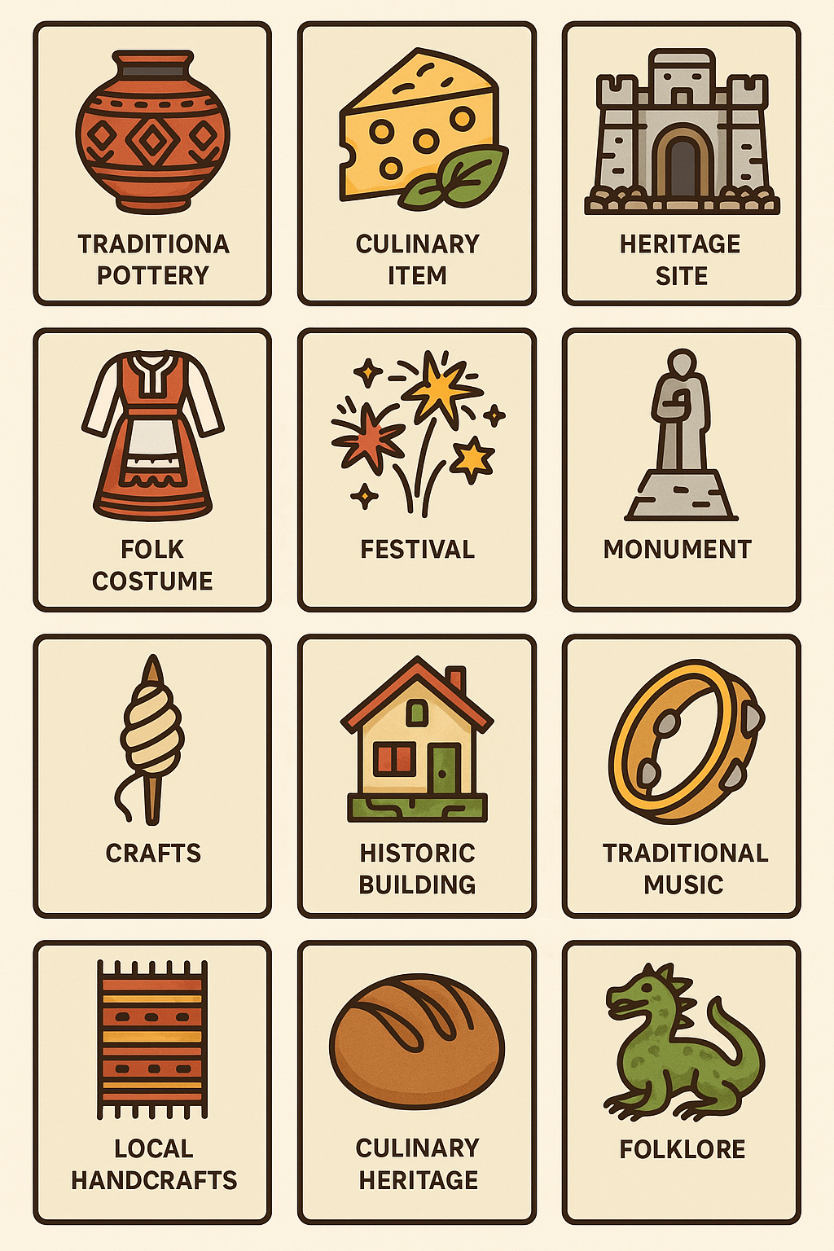
Annex 87

Annex 88
This planning sheet helps agritourism workers design a culturally and historically inspired visitor route or experience. It encourages consideration of sensory, educational, and sustainability elements that enhance the authenticity of the agritourism site.
1. Route Title & Theme
Give your route a name and a short description that highlights its cultural and historical focus.
Route Name:
Theme/Storyline (e.g., “A Journey Through Traditional Crafts”):
2. Key Stops on the Route
Identify 3–4 stops along the route. For each stop, describe the cultural or historical feature, the visitor activity, and the intended sensory engagement (e.g., sight, smell, touch).
Stop 1:
- Cultural/Heritage Feature: ____________________________
- Visitor Activity: ____________________________
- Sensory Engagement: ____________________________
Stop 2:
- Cultural/Heritage Feature: ____________________________
- Visitor Activity: ____________________________
- Sensory Engagement: ____________________________
Stop 3:
- Cultural/Heritage Feature: ____________________________
- Visitor Activity: ____________________________
- Sensory Engagement: ____________________________
3. Materials & Sustainability
List any local or recycled materials needed to set up or present the route. Indicate how these choices promote sustainability.
• Materials: ____________________________
• Sustainability Practices: ____________________________
4. Visitor Experience Goals
What do you want adult visitors to feel, learn, and take away from this route? Include cultural, historical, and emotional engagement aspects.
• Goals: ____________________________
5. Notes & Improvements
Add any ideas for enhancing or adapting the experience in future implementations.
• Notes: ____________________________

Annex 89
Craft Type | E.g., Pottery, Weaving, Wood Carving
Workshop Title | Creative and inviting title for the activity
Workshop Goal | What experience or knowledge will participants gain?
Cultural/Historical Significance | Describe the local story, tradition, or heritage element linked to this craft
Duration | Total time required (e.g., 30, 60, 90 minutes)
Target Audience | Adults, couples, families, or specific groups
Workshop Setup and Location | Where will it take place? Indoors, outdoors, farm corner, etc.
Materials Needed | List tools, natural or recycled materials, and supplies. Prefer locally available options.
Step-by-Step Workshop Flow | Outline the main steps: Introduction – Demo – Hands-on – Wrap-up
Facilitator Role | What should the trainer or artisan do at each stage?
Visitor Interaction & Takeaway | How do visitors participate, what can they create/take home?
Sustainability Practices | How is the workshop eco-friendly or using low-waste methods?

Annex 90
This worksheet helps participants in order to plan how to use all parts of ingredients in a zero-waste, heritage-inspired cooking activity.
Ingredient | Usually Discarded Part | Proposed Use | Cultural/Historical Link (if any)
Instructions: Fill in this sheet while designing your dish. Think about local traditions, food history, and how every part of the ingredient can be used or preserved.

Annex 91
Use this template to design an eco-cultural walking trail that combines natural beauty, local stories, and sensory engagement for adult visitors. Aim for a balance between environmental features and cultural heritage stops.
1. Trail Overview
Trail Name: ____________________________________________
Location/Area: ________________________________________
Estimated Walking Time: ________________________________
Seasonal Availability: _________________________________
2. Trail Map Sketch (optional visual)
Use this space to draw or attach your trail route. Indicate start/end points and major stops.
[Attach Map Here or Sketch Below]
_____________________________________________________
_____________________________________________________
_____________________________________________________
_____________________________________________________
Stop # | Title of Stop | Description (Cultural/Environmental) | Sensory Element (e.g. smell, sound, touch) | Visitor Action or Prompt
1
2
3
4
5
3. Trail Stops and Descriptions
4. Sustainability Measures
List actions taken to ensure the trail is environmentally and culturally sustainable (e.g. signage with recycled materials, trail maintenance, partnerships with locals).
_____________________________________________________
_____________________________________________________
5. Local Collaboration
Identify artisans, historians, farmers, or other local stakeholders involved in the trail:
_____________________________________________________
_____________________________________________________

Annex 92
1. Brand Name and Tagline
Brand Name: ____________________________________________
Tagline/Slogan: _________________________________________
2. Core Values and Messages
What does the brand stand for? (e.g., local food, traditional crafts, eco trails)
_____________________________________________________
_____________________________________________________
3. Logo Design Sketch (optional visual)
Attach or sketch your logo below.
[Attach Logo Here or Sketch Below]
_____________________________________________________
_____________________________________________________
4. Visitor Experience Connection
How will your brand emotionally and sensorially connect with visitors?
- Sights: ___________________________________________
- Sounds: __________________________________________
- Smells: __________________________________________
- Local stories: ____________________________________
5. Integration with Local Culture and Environment
How does your brand promote sustainability and celebrate local heritage?
_____________________________________________________
_____________________________________________________

Annex 93
1. Event Overview
Event Title: ___________________________________________
Theme/Slogan (e.g., 'Flavours of the Hills', 'From Soil to Spoon'): __________________
Proposed Date/Time: ___________________________________
Location (e.g., farm courtyard, village square): __________________
Target Audience (e.g., tourists, locals, families): _______________
Expected Number of Visitors: ___________________________
2. Featured Local Products & Producers
List 2–3 representative local products and the producers or artisans involved. Include the story behind each product.
1.Product: Producer: Story:
3. Cultural Storytelling Elements
Describe the narratives to be shared during the event (e.g., traditions, legends, history of ingredients or recipes).
________________________________________________________________________
________________________________________________________________________
4. Sustainability Measures
Mark all that apply and add custom actions if relevant.
☐ All ingredients sourced locally and seasonally
☐ Minimal packaging or compostable/reusable containers
☐ Zero-waste kitchen or food preservation methods (e.g., pickling, drying)
☐ Composting or animal feed reuse for leftovers
☐ Community volunteer involvement
Other practices: ____________________________________________________
5. Booth Setup and Visitor Experience
Sketch or describe your booth/table layout and how visitors will move through the tasting experience.
• Number of booths: ____________
• Layout sketch (can be drawn on the back):
• Will you use signs or posters? (Annex 8): Yes / No
• How will you tell product stories to visitors? (e.g., printed cards, verbal explanations, QR codes):
________________________________________________________________________
6. Promotion and Guest Invitation
How will you promote the event to ensure local engagement and tourism visibility?
☐ Flyers in local community
☐ Social media (Instagram, Facebook)
☐ Tourist information center
☐ Local school, hotel, or municipality collaboration
Other: ____________________________________________________
7. Final Plan – Implementation Reflection
What would make this event unique at your farm or village? What support would you need to implement it?

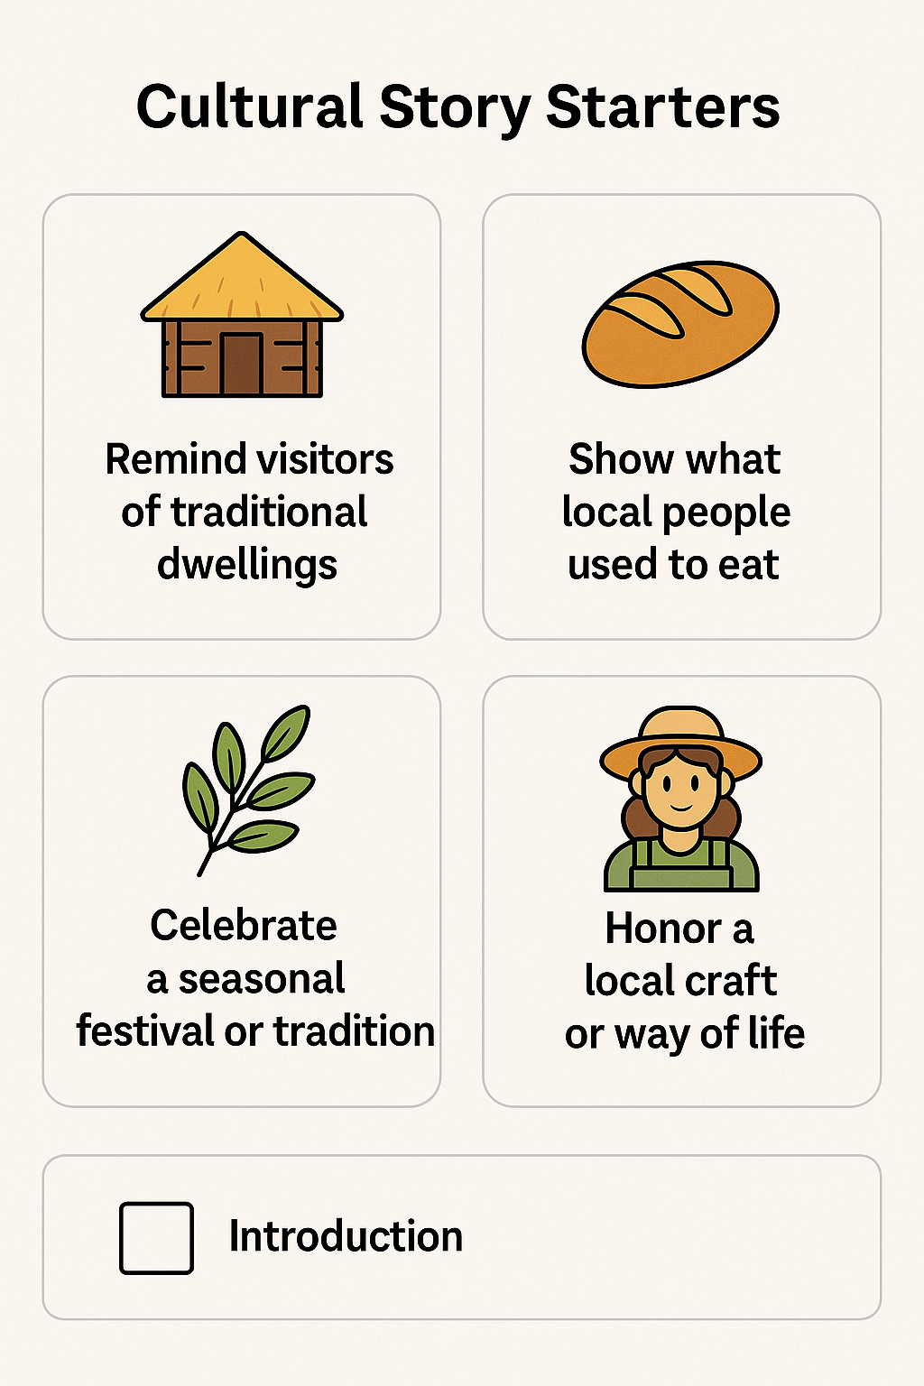
Annex 94

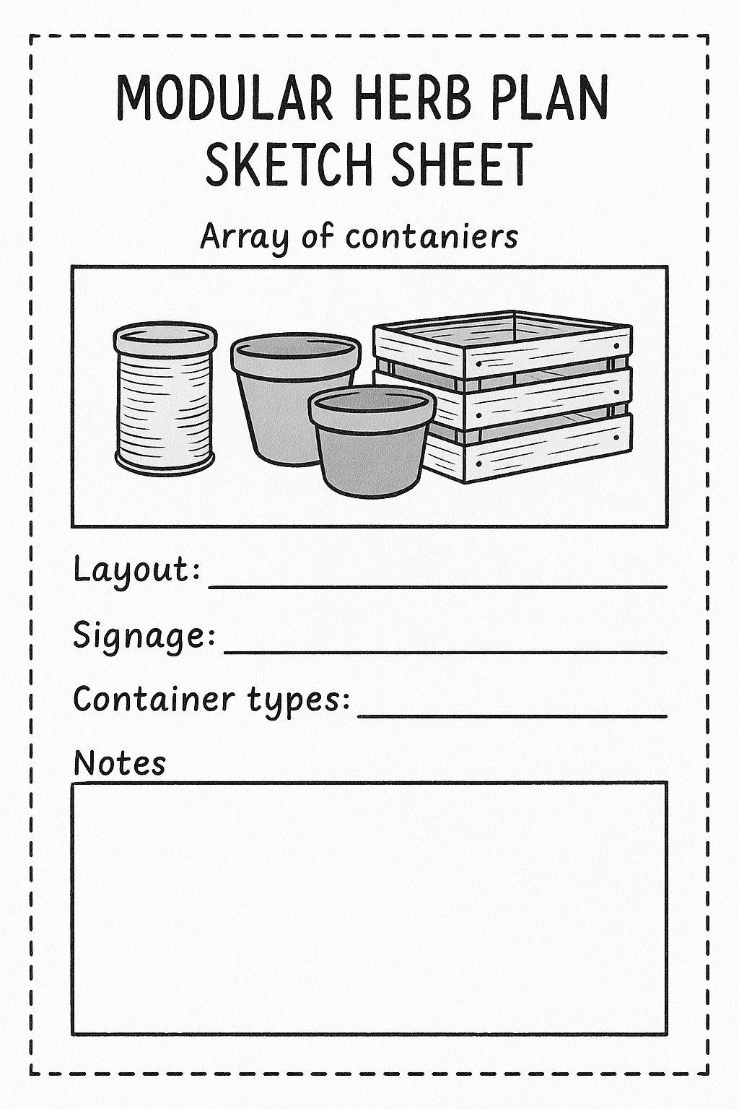
Annex 95

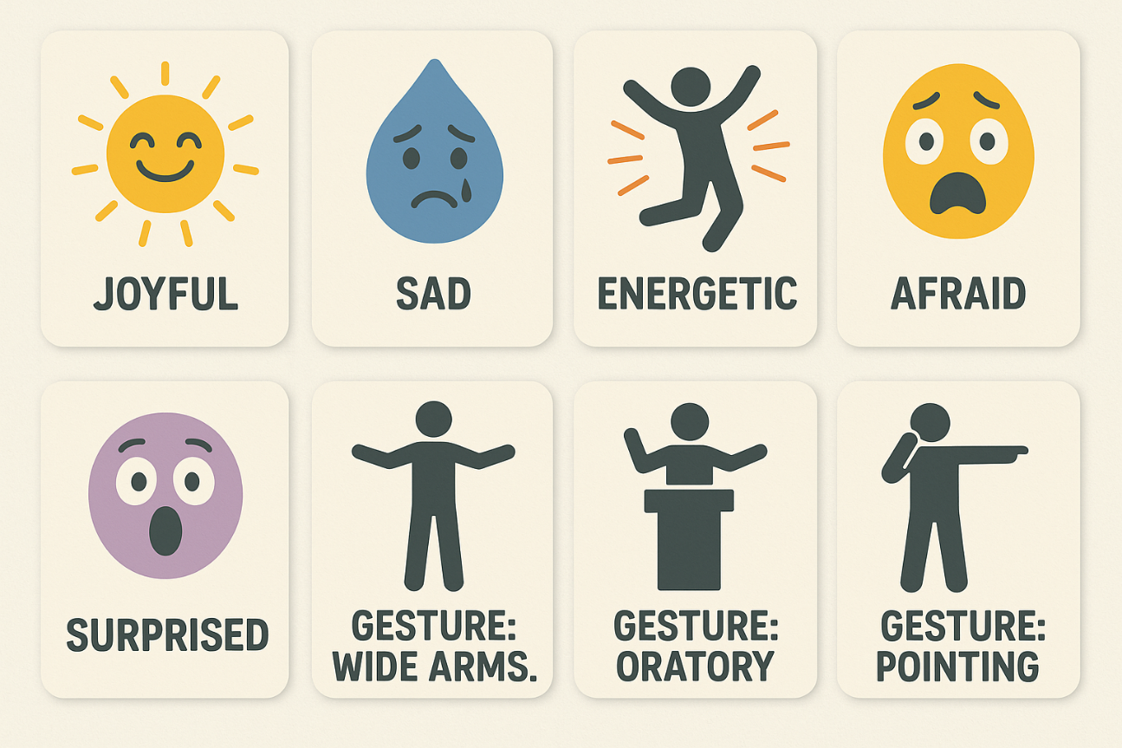
Annex 96

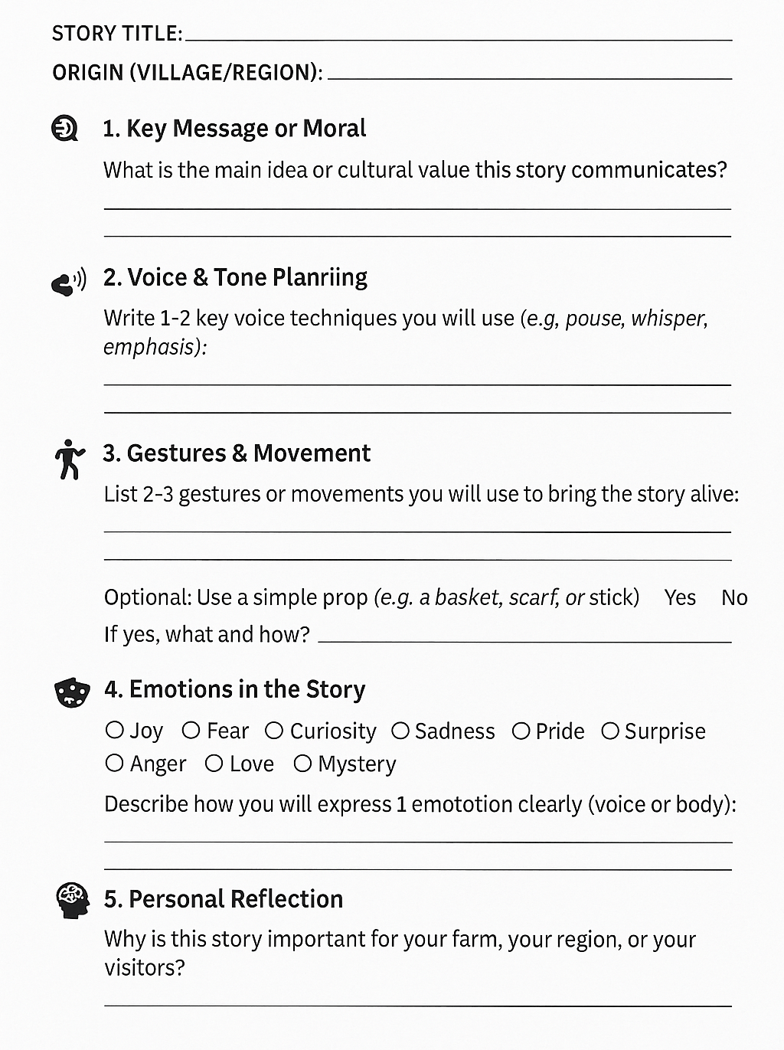
Annex 97

Annex 98
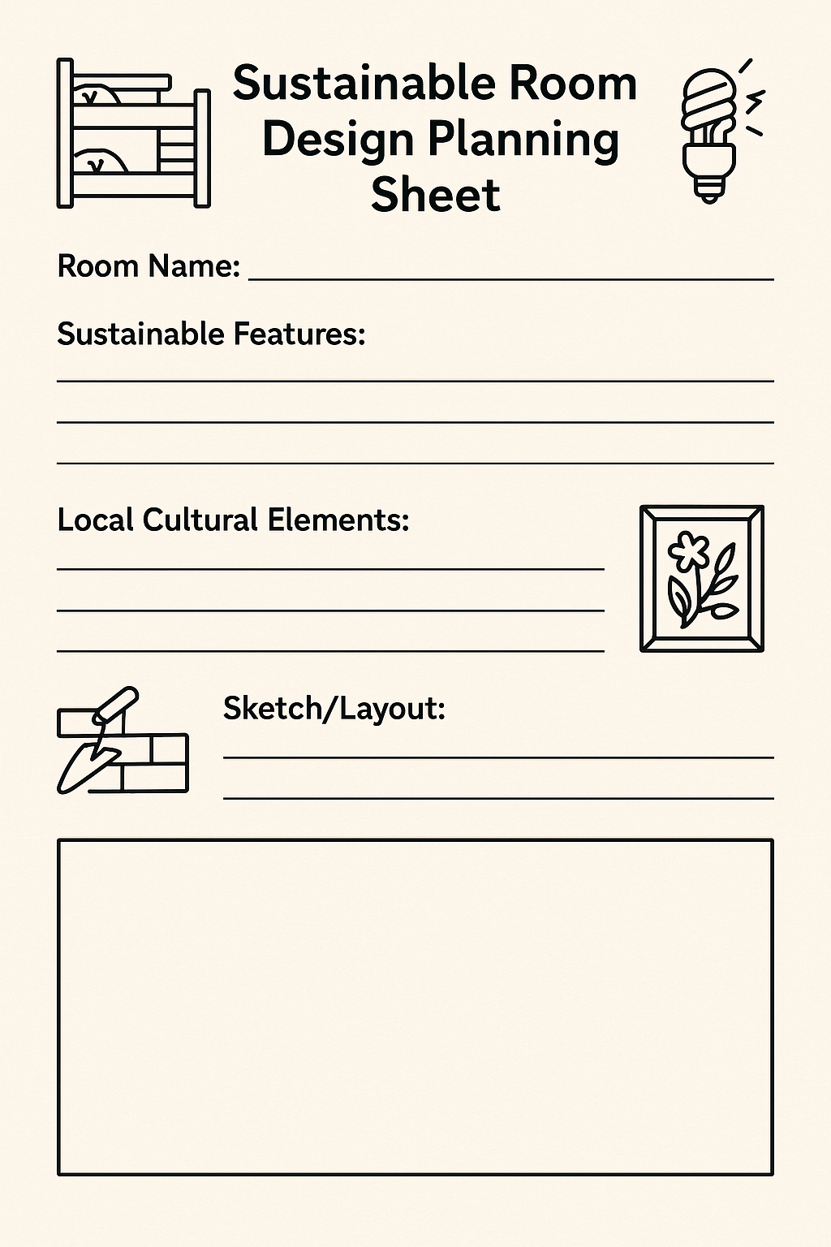

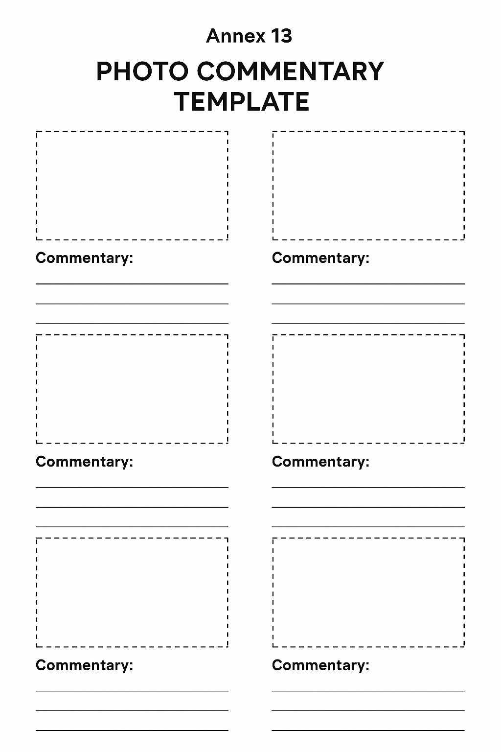
Annex 99

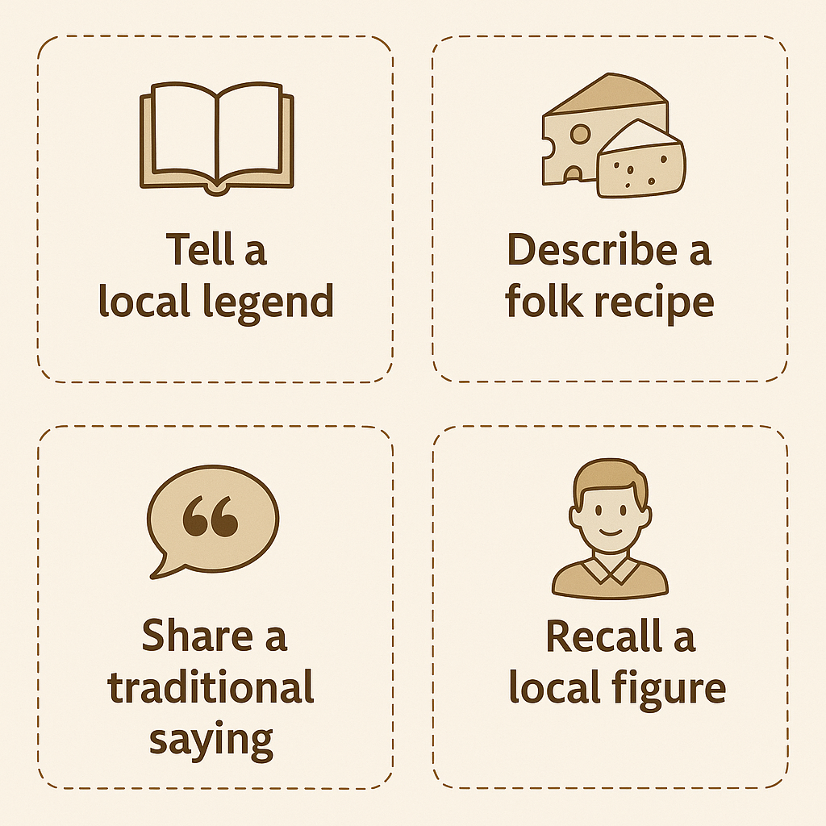
Annex 100

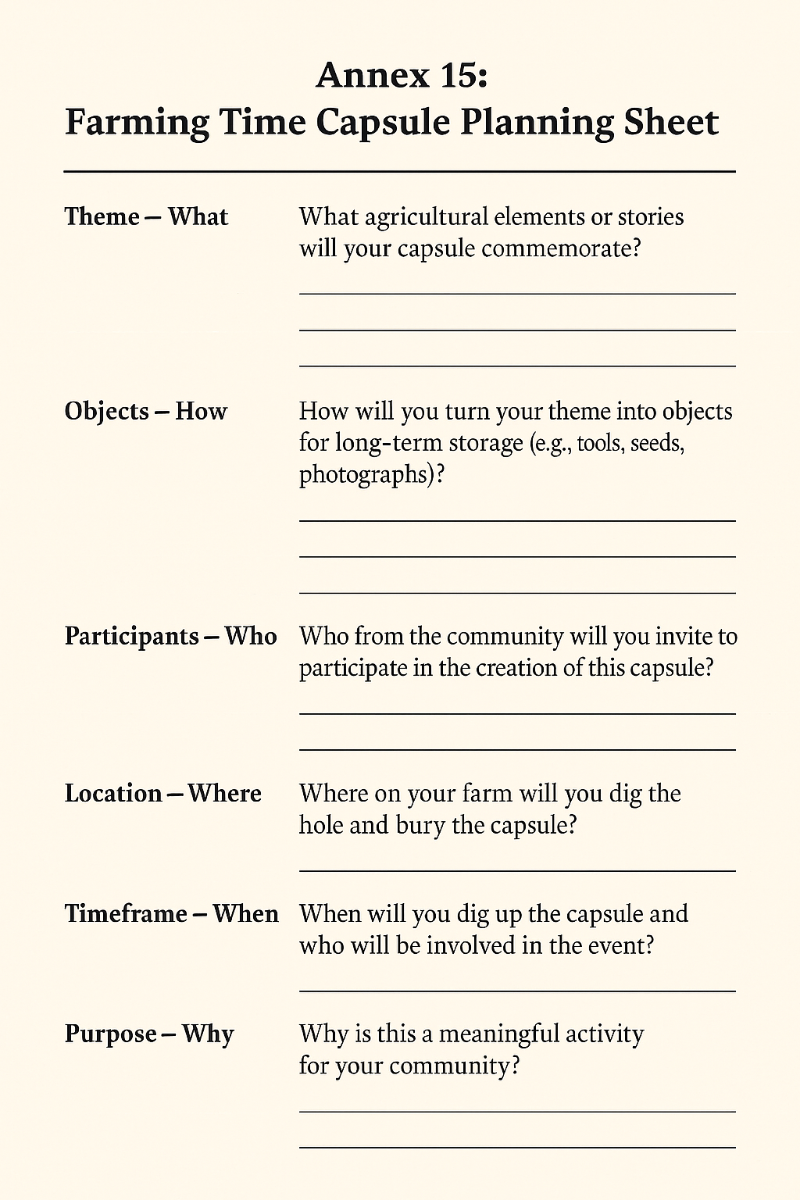
Annex 101

Annex 102
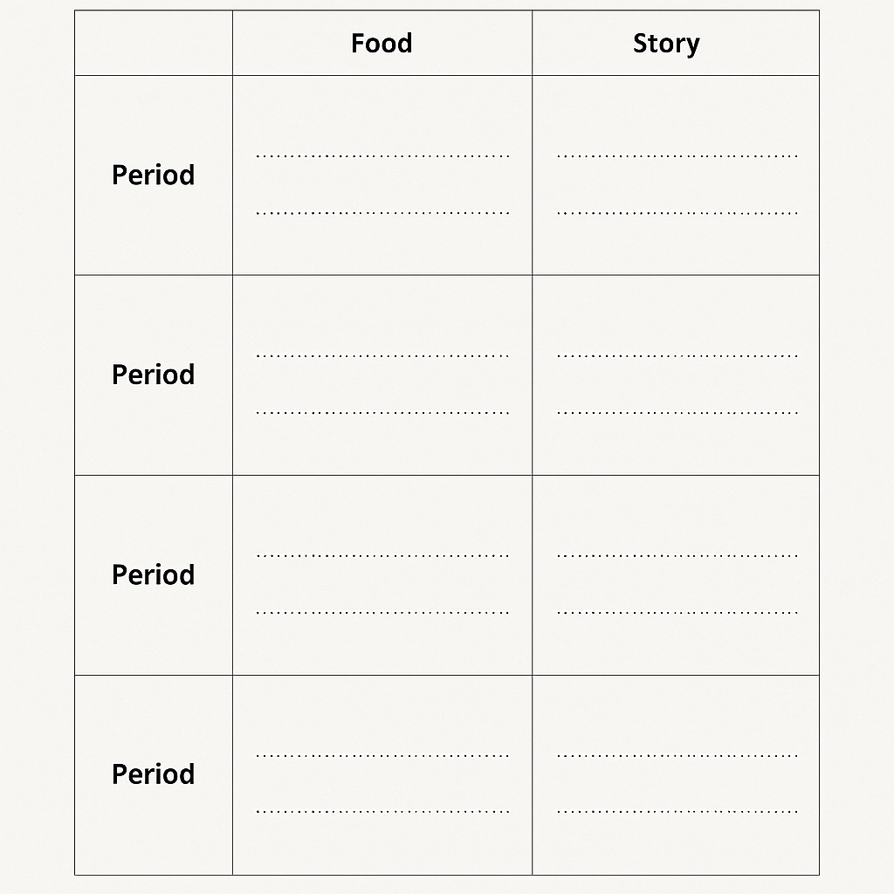

Annex 103
Name of Learner/Team: ________________________________________
Date: __________________

1. Dish Name
The title you will present to visitors

2. Region & Cultural Story
Where is this dish from? Share a short historical or cultural note.

3. Seasonal Ingredients & Producers
List 3–5 main ingredients, noting when they are in season and the producer/source.
Ingredient | Season | Producer / Source

4. Sustainability Practices
How will you make the cooking activity eco-friendly?
☐ Local sourcing
☐ Seasonal menu
☐ Waste minimisation / composting
☐ Reusable or compostable serving items
Other: _____________________________________

5. Visitor Engagement Steps
List the simple ways you will involve visitors during the activity.

6. Equipment & Setup
What minimal equipment will you need to run this outdoors?

7. Short Story / Presentation Script
Write a few sentences you will say while cooking to connect visitors to the dish’s culture and history.

Annex 104
Role Descriptions with Guidance
1. Receptionist & General Enquiries
Main task: Be the first point of contact for visitors, make them feel welcome, and understand their needs.
Key actions:
- Greet visitors with a smile and a warm introduction: “Welcome to [Region name]! How can I help you make the most of your visit?”
- Ask open-ended questions to understand their interests (e.g., culture, nature, food).
- Provide general information: local weather, opening hours of attractions, public transport options.
- Direct visitors to the appropriate specialist (route advisor, product seller, cultural guide).
- Tips: Always make eye contact, speak clearly, and maintain a friendly tone. Avoid overwhelming visitors with too much information at once.
2. Route Advisor
Main task: Recommend cultural and nature-based itineraries tailored to visitors’ interests and time available.
Key actions:
- Offer 1–2 route options that match their preferences and timeframe (e.g., “If you have 3 hours, I suggest our ‘Heritage Walk’ past the old mill and chapel”).
- Explain how to reach each site (map, public transport, walking directions).
- Include sustainable travel tips (e.g., carry a reusable bottle, use local guides, avoid leaving litter).
- Highlight points of cultural and historical interest along the route (monuments, traditional farms, legends).
- Tips: Use a map or brochure to point out locations visually — it makes it easier for visitors to remember.
3. Local Product Seller
Main task: Showcase and promote locally produced items, explaining their cultural significance and origin.
Key actions:
- Introduce the product and where it comes from (e.g., “This honey is from hives in the nearby mountain village, made using traditional beekeeping methods”).
- Explain any historical or cultural relevance (e.g., “This herb tea recipe has been passed down for generations as a winter remedy”).
- Suggest related activities for visitors (farm tours, craft workshops, tasting sessions).
- Tips: Let visitors touch or smell products if appropriate. Offer small samples if possible.
4. Cultural Guide
Main task: Share engaging stories, traditions, and local knowledge that make visitors feel connected to the region’s identity.
Key actions:
- Tell short, vivid stories or legends linked to a place, product, or tradition (2–3 minutes).
- Recommend cultural events, festivals, or demonstrations happening during the visitor’s stay.
- Explain how visitors can respectfully participate in traditions (e.g., dress codes for religious sites, etiquette during events).
- Tips: Use expressive voice and body language to make your story memorable. Invite visitors to ask questions.
Visitor Scenario Cards with Context
Scenario 1: “We’d like to spend half a day exploring the countryside and visiting a cultural site. Where should we go and how do we get there?”
➡ Aim: Route Advisor explains at least one sustainable route with cultural stops and practical directions.
Scenario 2: “We want to buy gifts for friends that are eco-friendly and made locally. What do you suggest?”
➡ Aim: Local Product Seller presents 2–3 options, highlighting cultural value and sustainability.
Scenario 3: “We’re here for a weekend and want to taste the region’s traditional dishes. Where can we go?”
➡ Aim: Receptionist & Cultural Guide work together to recommend authentic food experiences and tell their stories.
Scenario 4: “We have children with us. Can you recommend an activity that combines nature and history?”
➡ Aim: Route Advisor suggests family-friendly routes or sites, Cultural Guide adds a related local legend.
Scenario 5: “We’re interested in sustainable farming and want to see it in action. Any suggestions?”
➡ Aim: Local Product Seller & Route Advisor suggest farm visits, sustainability tours, or seasonal workshops.

Annex 105
Learner / Team Name: ______________________________________
Date: ___________________

1. Product or Service Concept
What will you create or offer using wild forest fruits or other natural resources?

2. Cultural and Historical Connection
What is the traditional or historical link between this product/service and your region?

3. Sustainable Resource Use
Which sustainable practices will you follow to ensure the ecosystem is preserved?
☐ Harvest only what is needed
☐ Leave resources for wildlife
☐ Avoid damaging plants during harvest
☐ Use recyclable or compostable packaging
Other: _____________________________________

4. Production Process
Describe the main steps in producing or delivering your product/service.

5. Community Involvement
Who will participate? (local workers, artisans, farmers, youth groups, cooperatives)

6. Target Market
Who will buy or use your product/service? (tourists, locals, hotels, restaurants)

7. Marketing & Visitor Engagement
How will you promote it and make it engaging for tourists?

8. Social Benefits
How will your idea benefit the community (jobs, cultural preservation, education)?

9. Challenges & Solutions
What obstacles could you face and how will you address them?

Annex 106
Instructions for Learners
Use this sheet to plan an annual calendar of events for your agritourism site. Include cultural traditions, agricultural activities, and sustainable practices that will attract and engage adult visitors. Think about seasonality, authenticity, and how each event connects to local history.

1. Seasonal Event Brainstorming Table
Month / Season | Event Name | Cultural / Historical Connection | Sustainable Practices | Visitor Engagement Ideas
January / Winter
February
March / Spring
April
May
June / Summer
July
August
September / Autumn
October
November
December / Winter

2. Highlighted Seasonal Event
Select one event from your table and describe it in more detail.
Event Name: _________________________________________
Description:

Why it’s important for cultural heritage:

How it promotes sustainability:

Visitor activities:

Annex 107
1. Theme of Your Game Corner
Choose a clear theme that connects your chosen objects and activities.
Examples: “Village Kitchen of the Past,” “Tools of the Field,” “Flavours of the Forest”
My Theme: _______________________________________________
2. Station Planning Table
Station Type | Item / Object / Ingredient | Clues or Questions for Visitors | Cultural / Historical Connection | Sustainability Aspect
Guess
Touch
Taste

3. Visitor Engagement Ideas
How will you make the experience fun and interactive? (e.g., small prizes, storytelling, photos, tokens)

4. Setup Checklist
Tick when ready:
☐ Table and tablecloth
☐ Object cards
☐ Cloth bag for “Touch” station
☐ Sealed tasting samples
☐ Printed station signage
☐ Score sheet
5. Hosting Script
Write a short welcome and rule explanation (3–4 sentences).

6. My Implementation Plan
Where will I use this game corner? ____________________________________
When will I implement it? ____________________________________________
What materials will I need from local sources? __________________________

